

Step-by-Step Guide to Completing the University Housing Application for Spring


Navigate to the Housing Portal

You can get to the housing portal by pasting the following link into your web browser: go.unl.edu/housing-portal



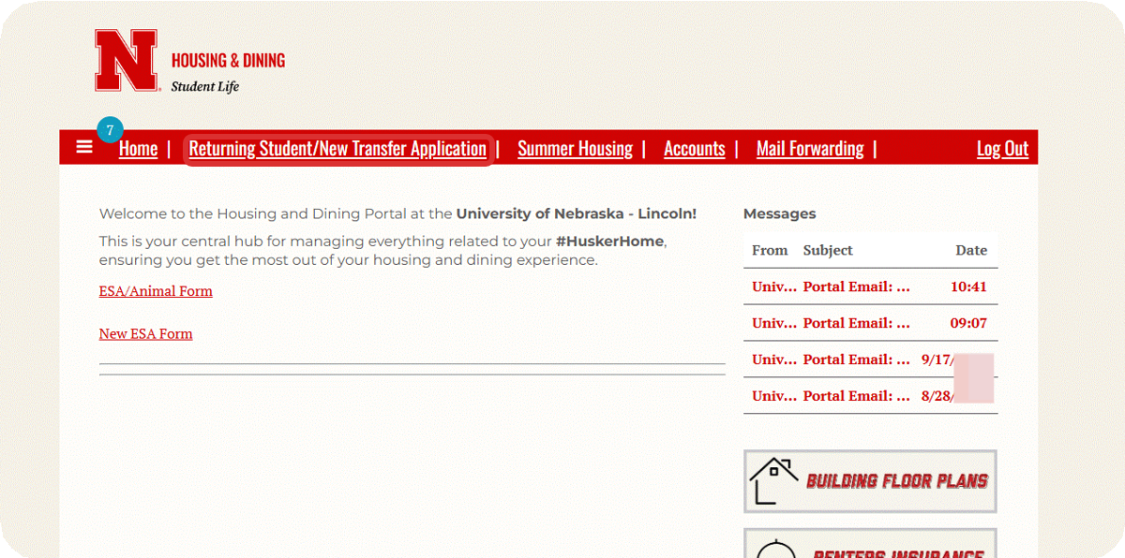
Click on Returning Student/New Transfer Application at the top of the page.
1
2

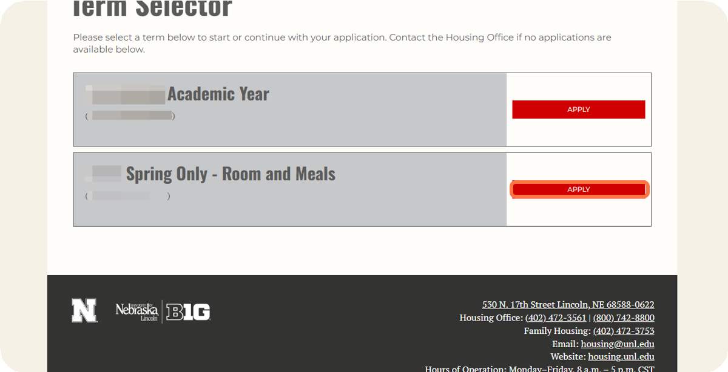
Click on Apply for Spring Only - Room and Meals.

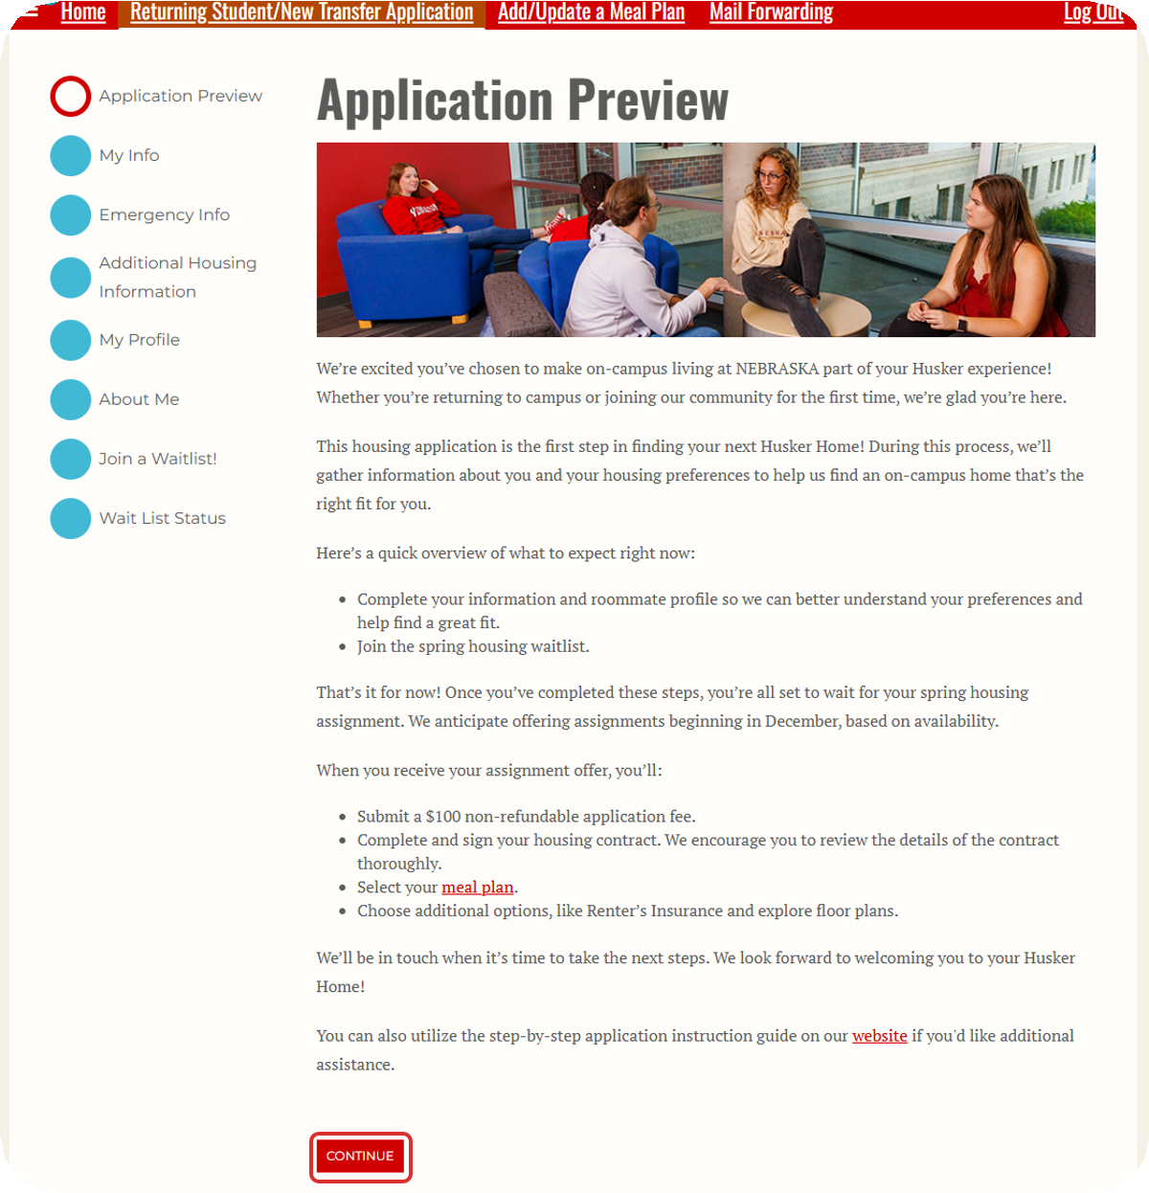
Read through the introduction, then click continue.
3

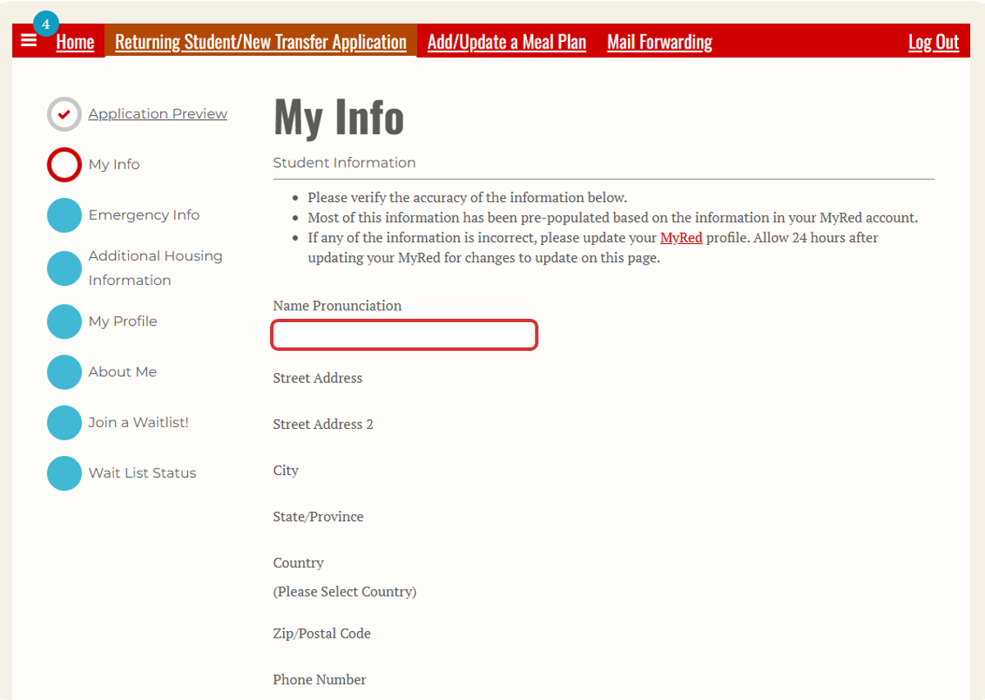
Review the personal information that was imported from MyRed into your Housing Application.
5

4
If any of the information is incorrect, you can update it in MyRed before returning to the housing application.
Optionally, you can answer the Name Pronunciation question if you would like to provide a more phonetic spelling of your name.

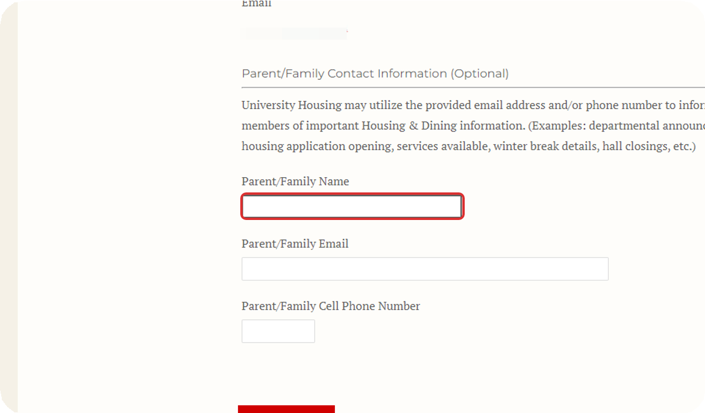
Provide Parent/Family Contact Information (Optional).

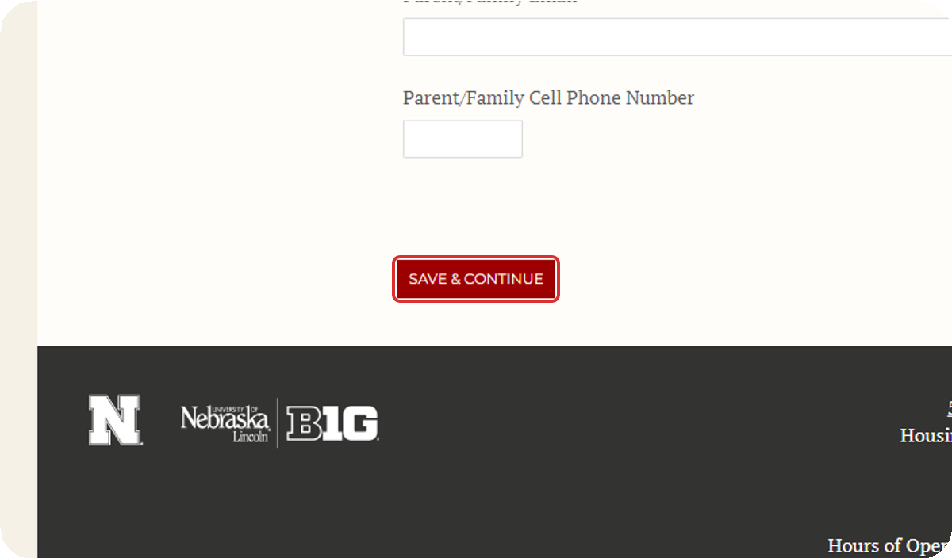
Click on Save & Continue.
6
After confirming that all of the information on this page is correct, click Save & Continue to move to the next page.
7

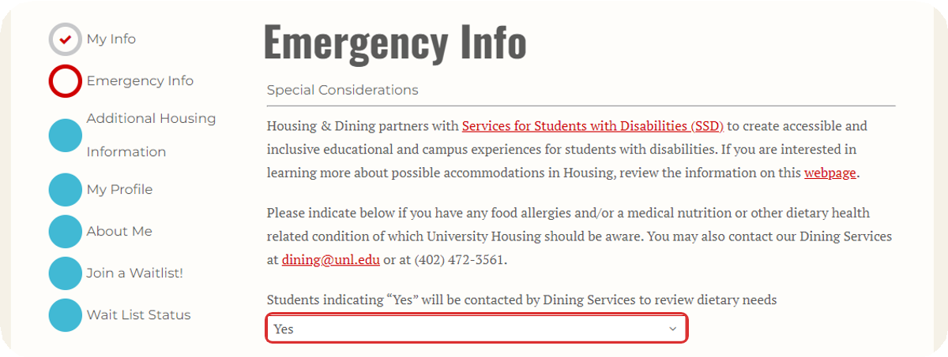
Indicate whether you would like to be contacted by Dining Services to review your dietary needs.

8
You can also review the available information about housing and dining accommodations for students with disabilities here.

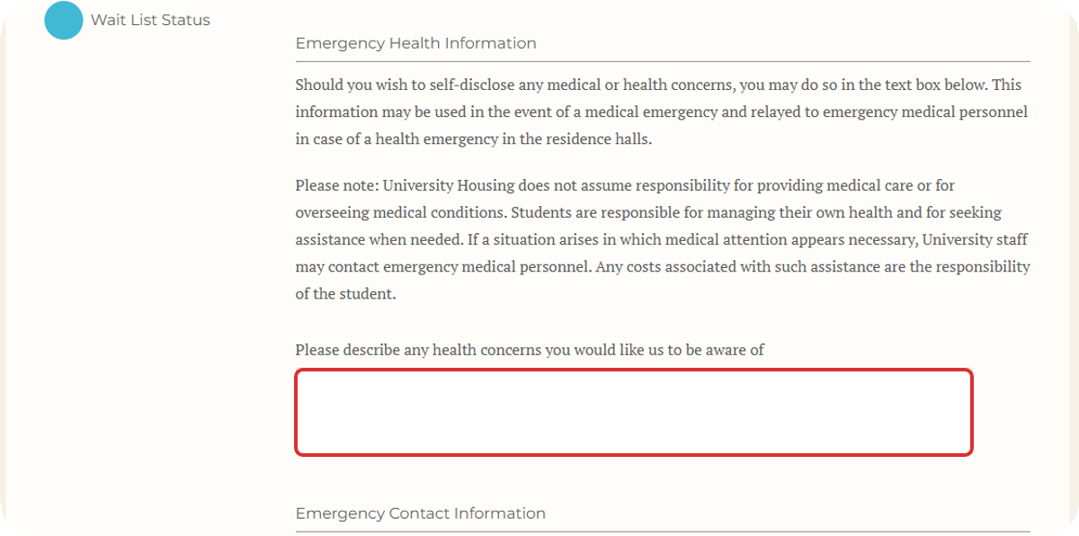
Add Emergency Health Information (Optional).
If there is any information that you would like us to be aware of in case of an emergency, you can indicate it on this page.

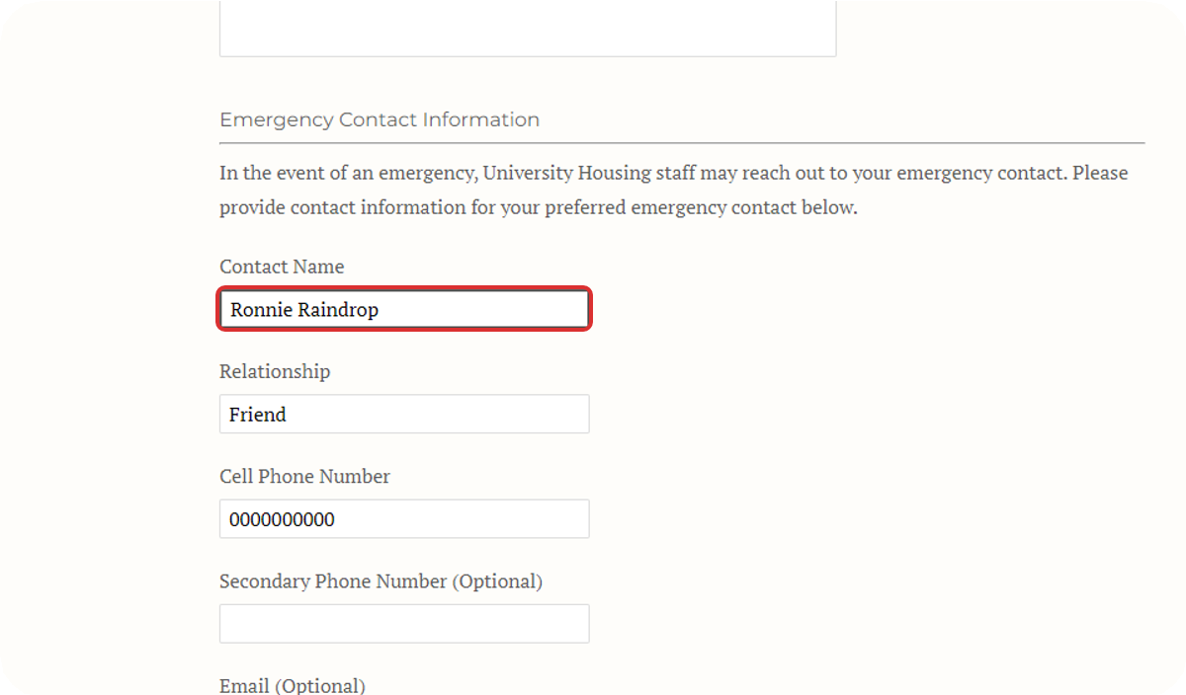
Add emergency contact information.
9
You must provide contact information for the person you would like us to contact in case of an emergency.

10

If you are under 18 years old, your emergency contact must be your parent or legal guardian.

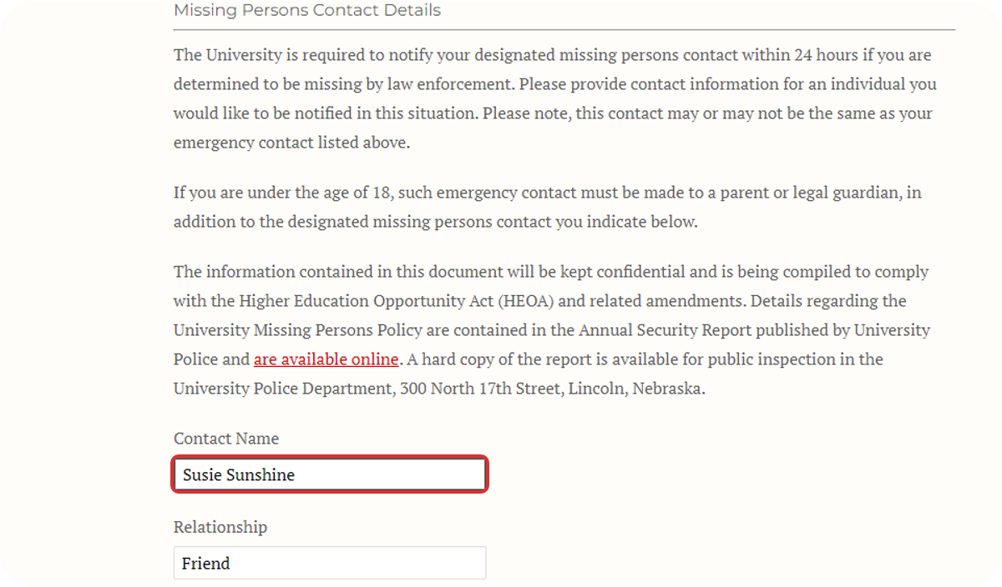
Provide Missing Persons Contact Information.
You must provide contact information for the person you would like us to contact in the event that you go missing. This could be the same person or a different person from your emergency contact.

11
If you are under 18 years old, your missing persons contact must be your parent or legal guardian.

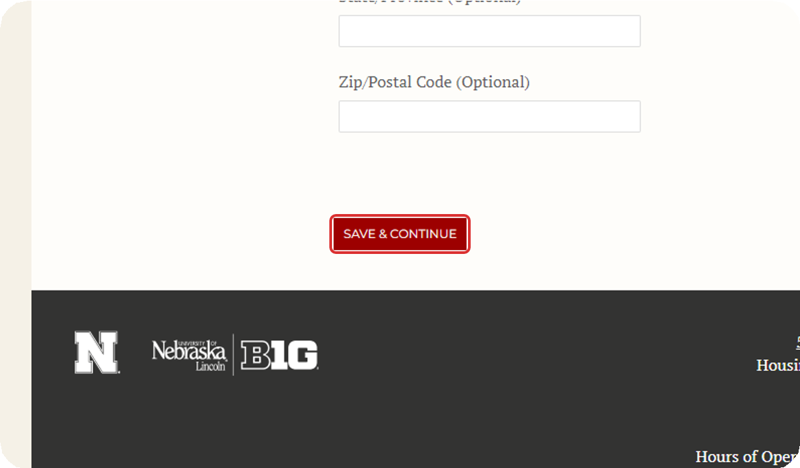
Click on Save & Continue.
After providing your emergency health information, emergency contact, and missing persons contact, click Save & Continue to move to the next page.

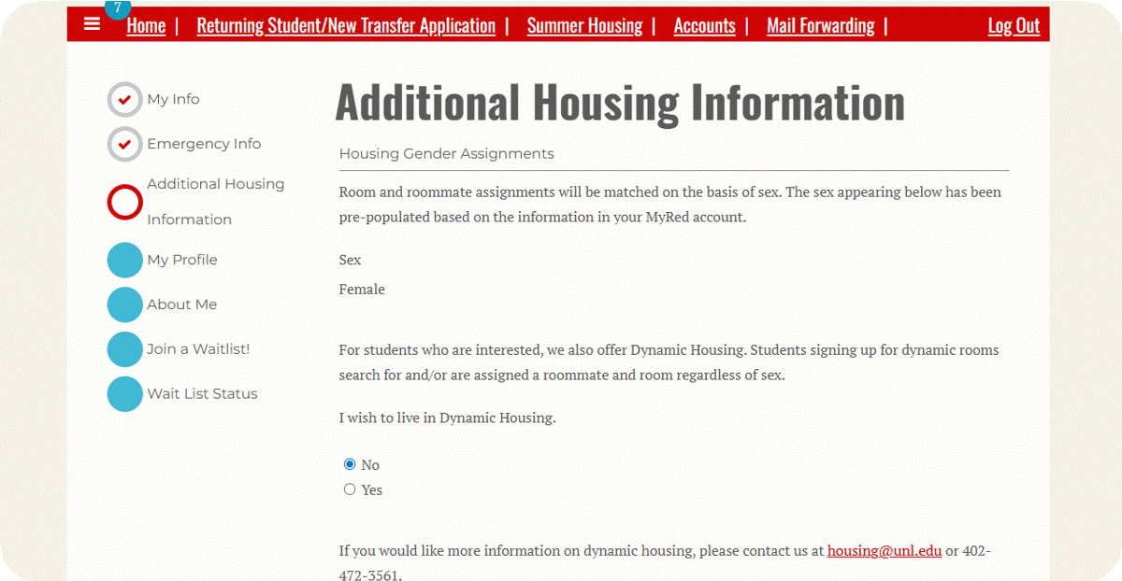
Review Dynamic Housing information.
12
If you opt in to Dynamic Housing, you will be assigned with other roommates in Dynamic Housing, regardless of sex.

13
If you do not opt into Dynamic Housing, you will be assigned with other roommates of your same sex.

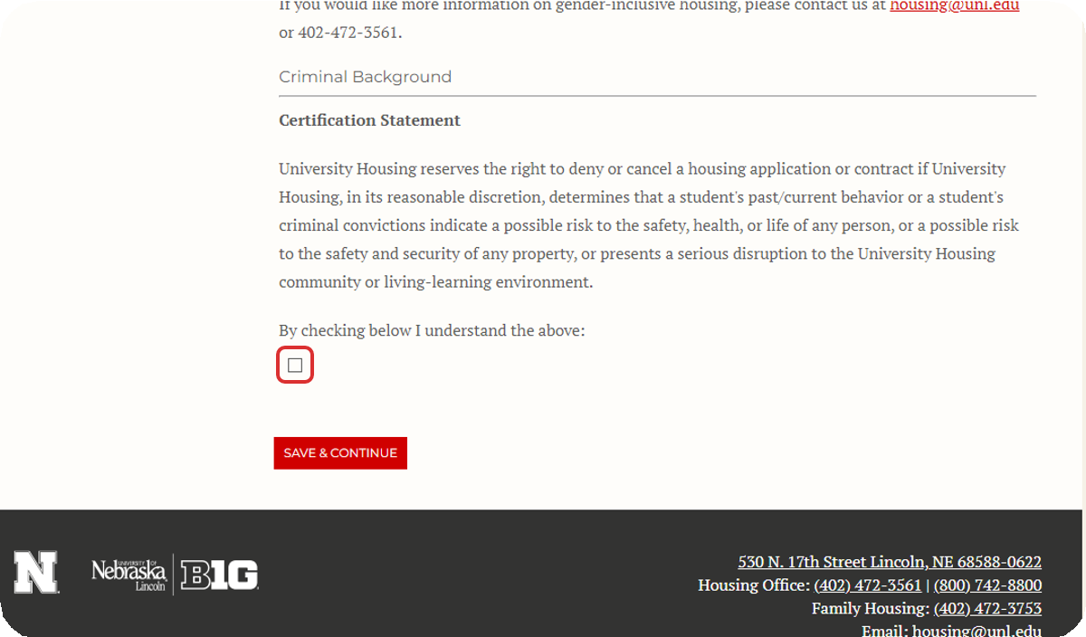
Read the Criminal Background Certification Statement, and Check the Box to Agree.

14

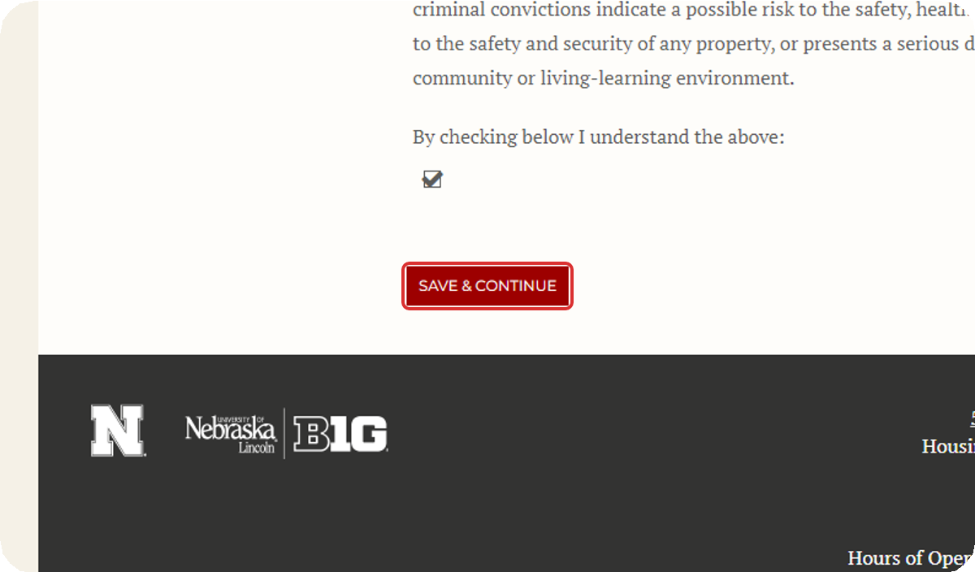
Click on Save & Continue.
After agreeing to the Criminal Background Certification Statement, click Save & Continue to move to the next page.

Complete the Dynamic Housing Community Agreement (Dynamic Housing Only).
15
If you opted into Dynamic Housing, read through the Dynamic Housing Community Agreement and check the box to agree.
If you do not agree to the Community Agreement, then you can click "Additional Housing Information" in the navigation bar on the left to return to the previous page and opt out of Dynamic Housing.
After checking the box, click Save & Continue to move to the next page.
If you have not opted into Dynamic Housing, you will skip this page automatically and move to the next step.

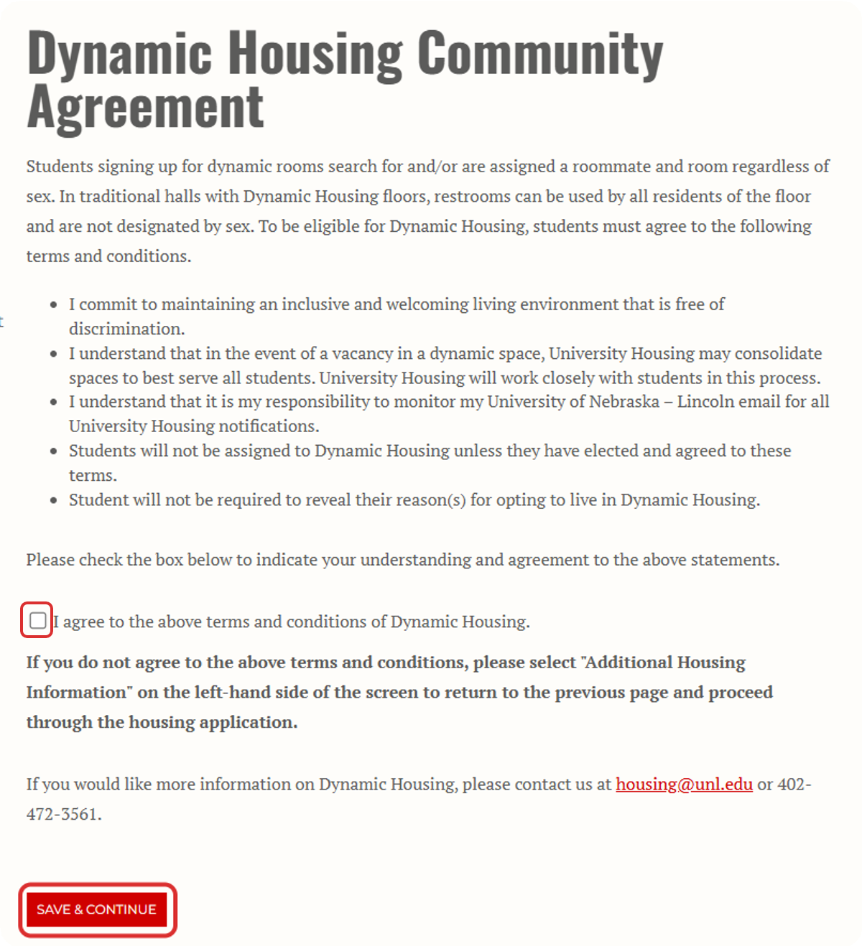

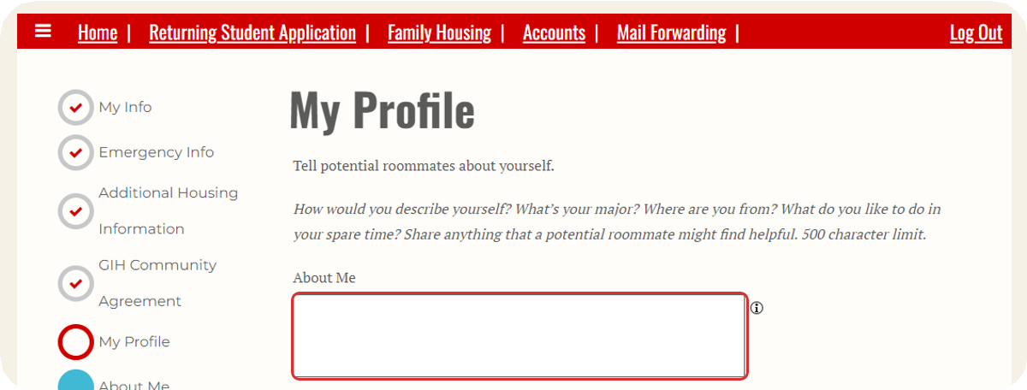
Fill Out Your Roommate Profile.
16
This gives you an opportunity to share a little bit about yourself to help you be matched with the best possible roommate.

17
Please Note: The roommate find-er will not be open for the Spring semester. University Housing will attempt to make the best possible roommate matches with the space that is available.

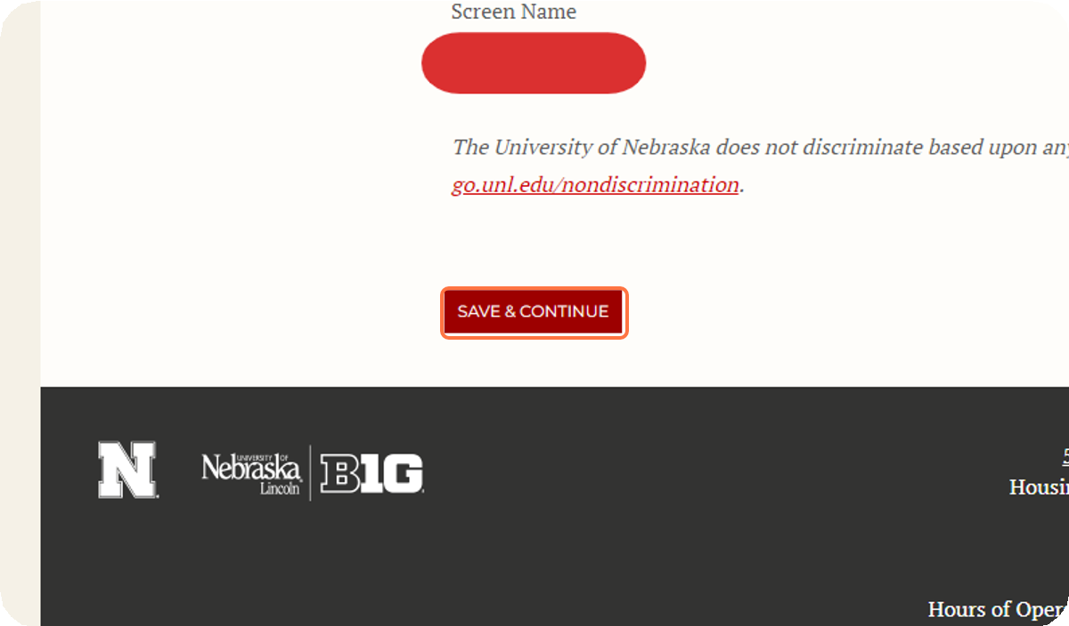
Click Save & Continue.
After completing your roommate profile, click Save & Continue to move to the next page.

18

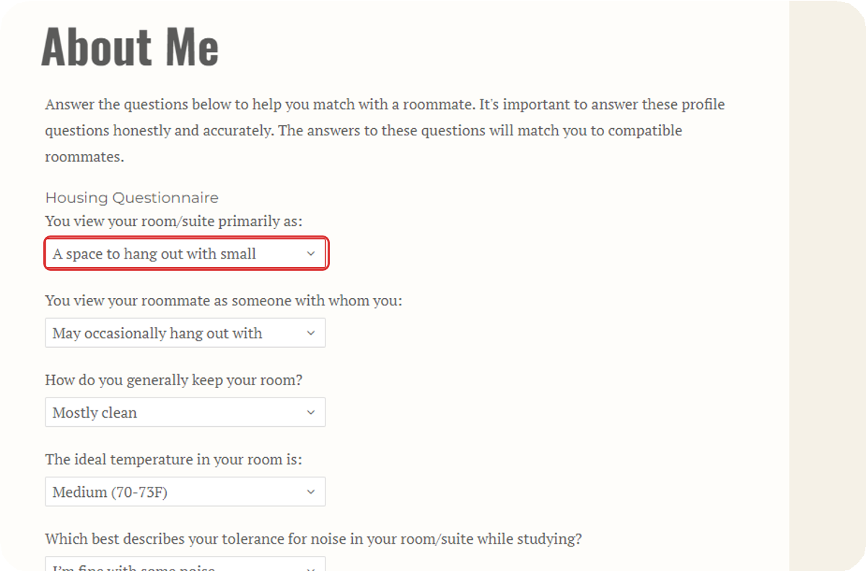
Fill Out the Roommate Matching Questionnaire.
These questions about your lifestyle and preferences for your room and roommates will help us to match you with the roommates that will be a good fit for you.
You must answer all of the questions.

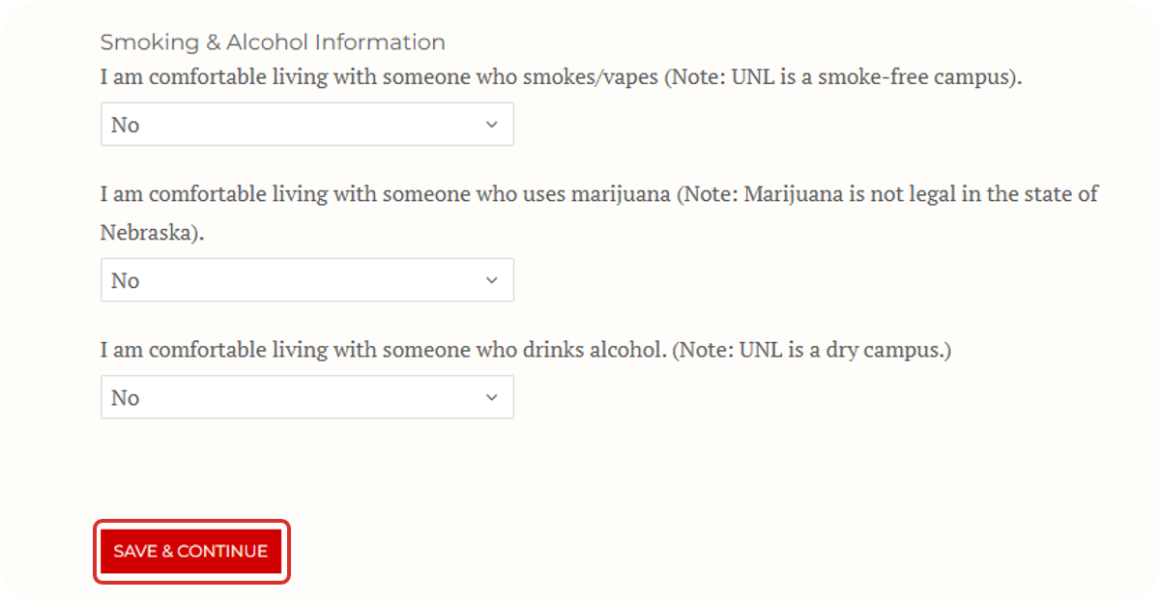
Click on Save & Continue.
19
After completing all of the roommate matching questionnaire, click Save & Continue to move to the next page.

20

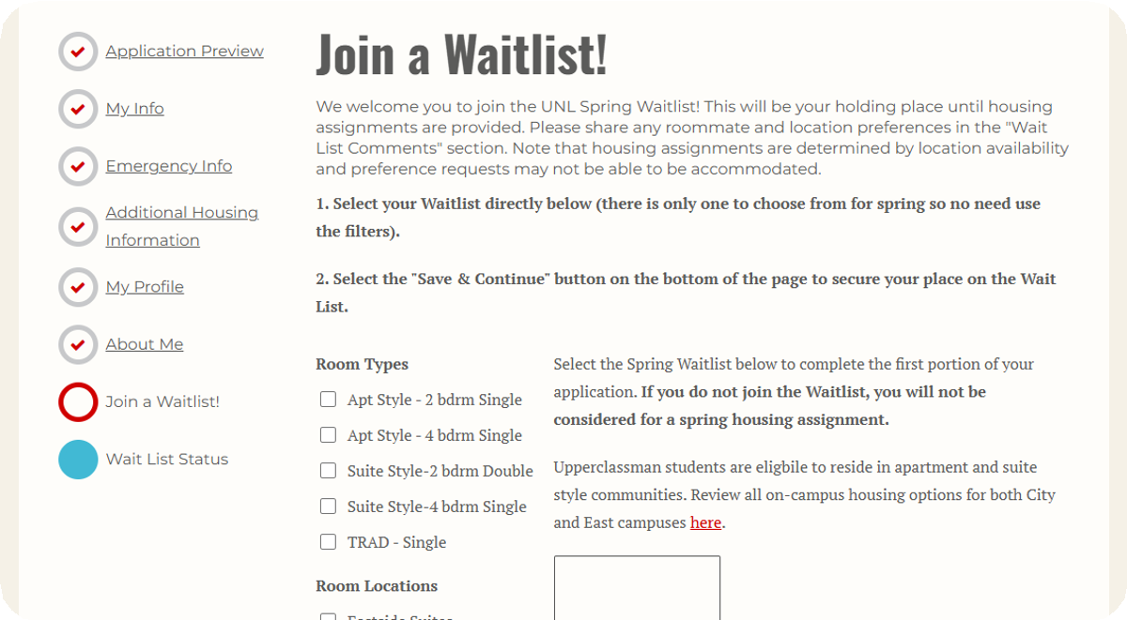
Join the Spring Waitlist.
At this point in the application, you will add yourself to the Spring Housing Waitlist.

21
Please ignore the room type and room location filters. Any selections you make using those filters will not be visible to University Housing Staff.

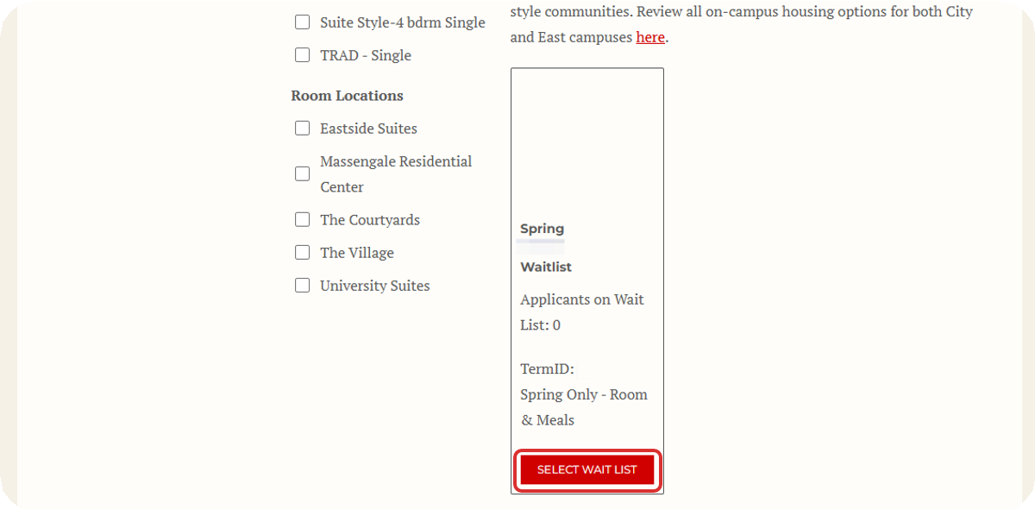
Click on Select Wait List.
There is only one waitlist for Spring housing. It is called "Spring Waitlist".
Click "Select Wait List" and then scroll to the bottom of the page.

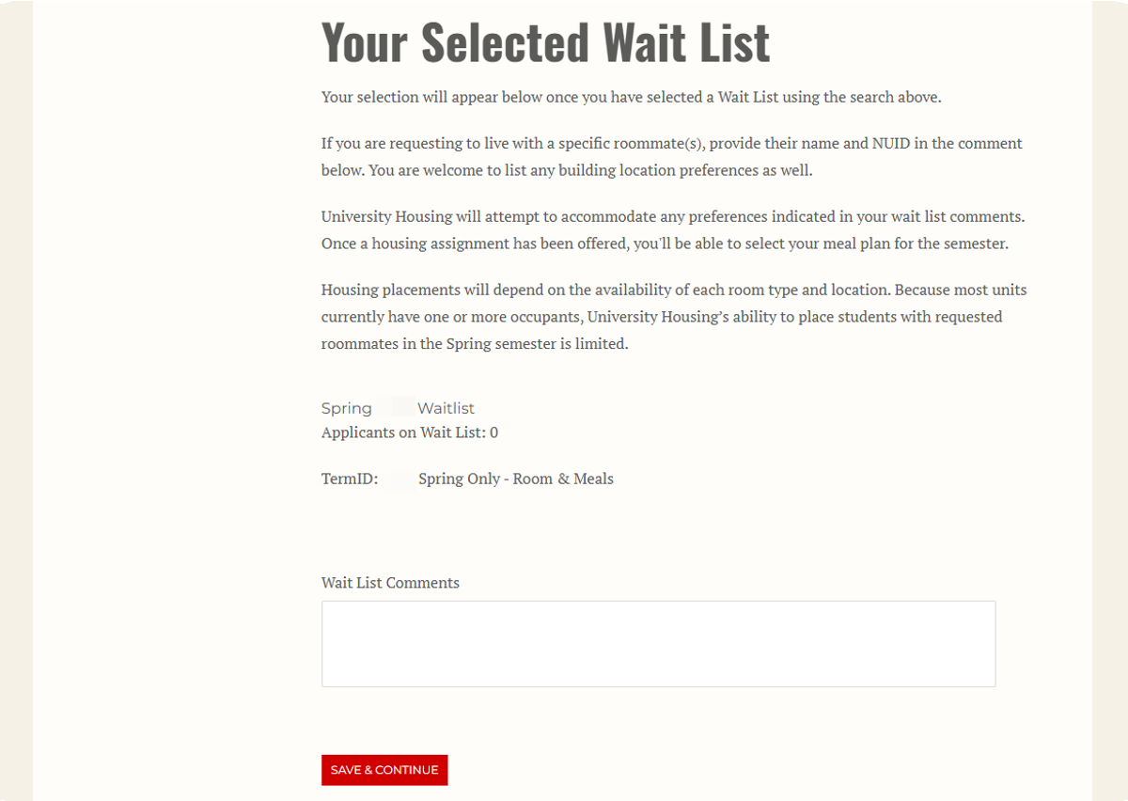
Add Comments Regarding Your Preference for Housing Placement.
22
If you would like a particular building, room type, or roommates, please indicate that in the Wait List Comments. If you have no preference regarding your placement, you do not have to add a comment.
23
Please note that availability in on-campus housing for Spring is limited. University Housing will attempt to meet students' preferences for buildings, room
types, and roommates, but there may not be availability to meet every student's request.
Our first priority is providing you with a safe and comfortable place to live, and we are confident that we can provide you with an excellent residential experience in any of our halls, even if it does not match your preferences provided here.

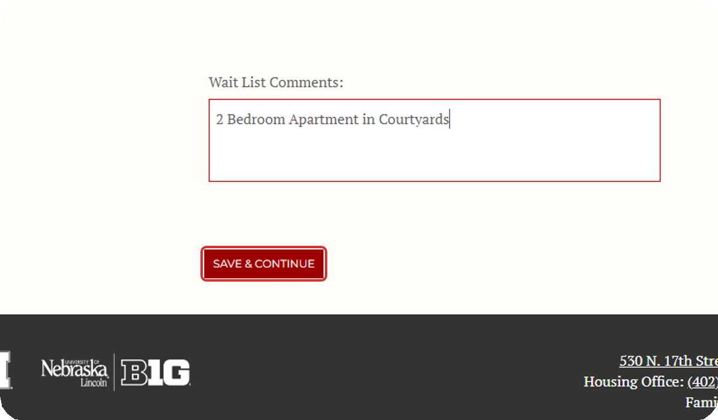
Click on Save & Continue.
After clicking "Select Wait List" and adding any comments regarding your housing preferences, click Save & Continue to move to the next page.

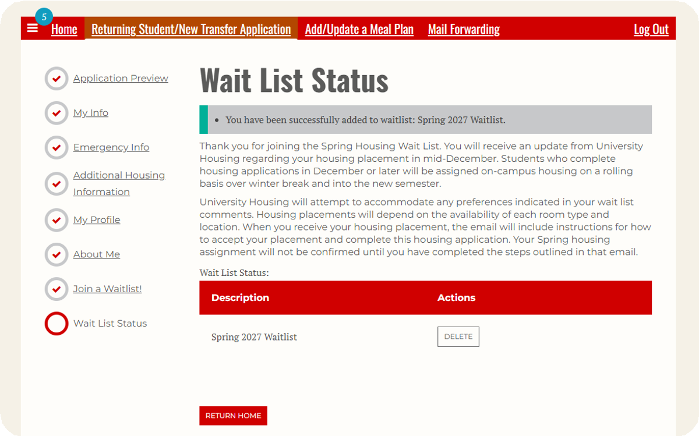
You Have Joined the Waitlist!
24
On this page, you should see a green notification bar that

25
says, "You have been successfully added to waitlist: Spring Waitlist".
You will also receive a confirmation email to your Huskers email address that you have been added to the waitlist.

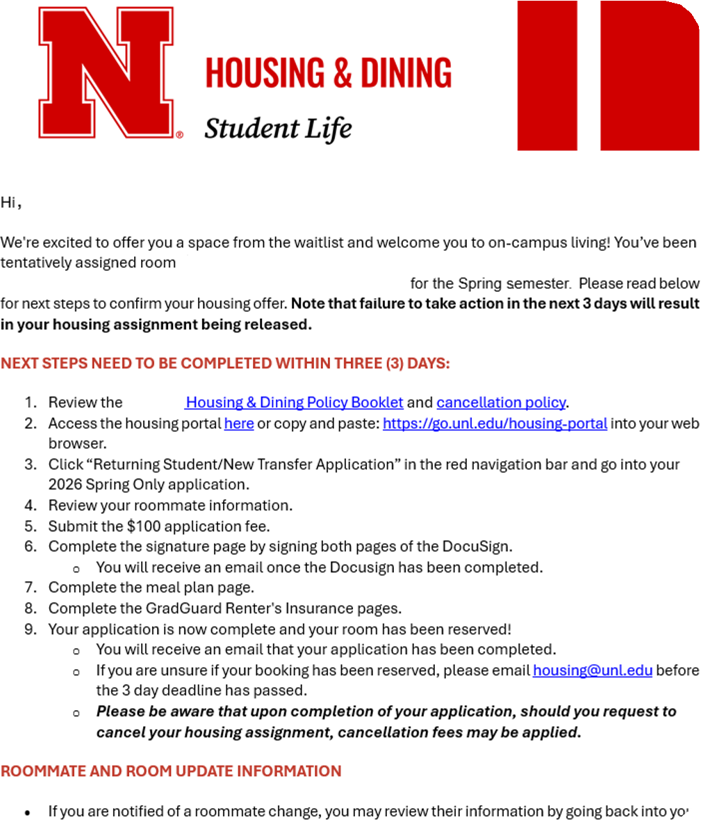
Wait to Be Notified of Your Housing Assignment.
You will receive an email from housing@unl.edu when you have received a tentative housing assignment for Spring.

26
Your housing assignment will not be finalized until you complete the housing application by following the steps in that email, which are also explained below.

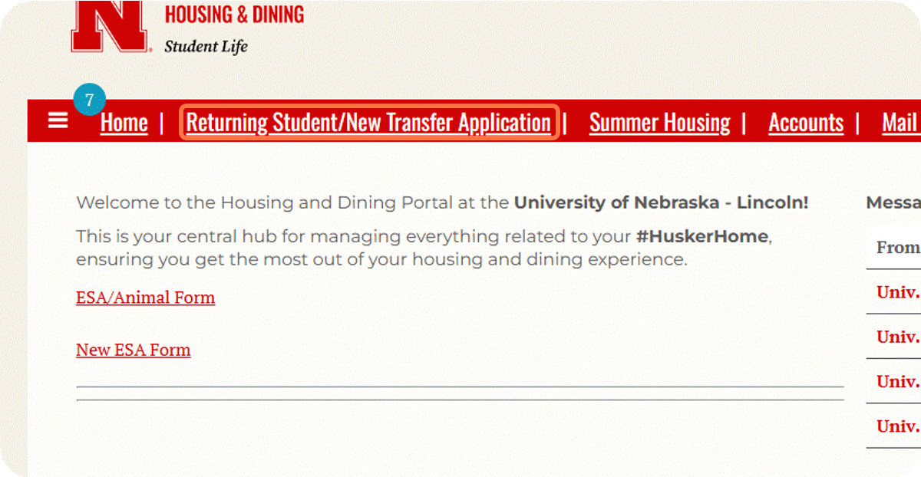
Click on Returning Student Application.
Once you have received your housing assignment, return to the housing portal and go back to the Returning Student/New Transfer Application.

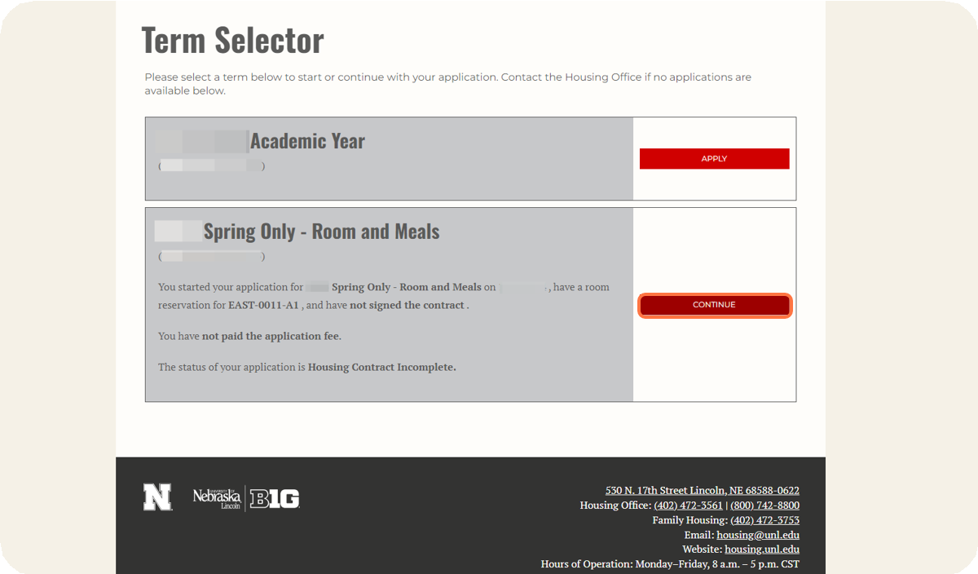
Click on Continue for Spring Only - Room and Meals.
27

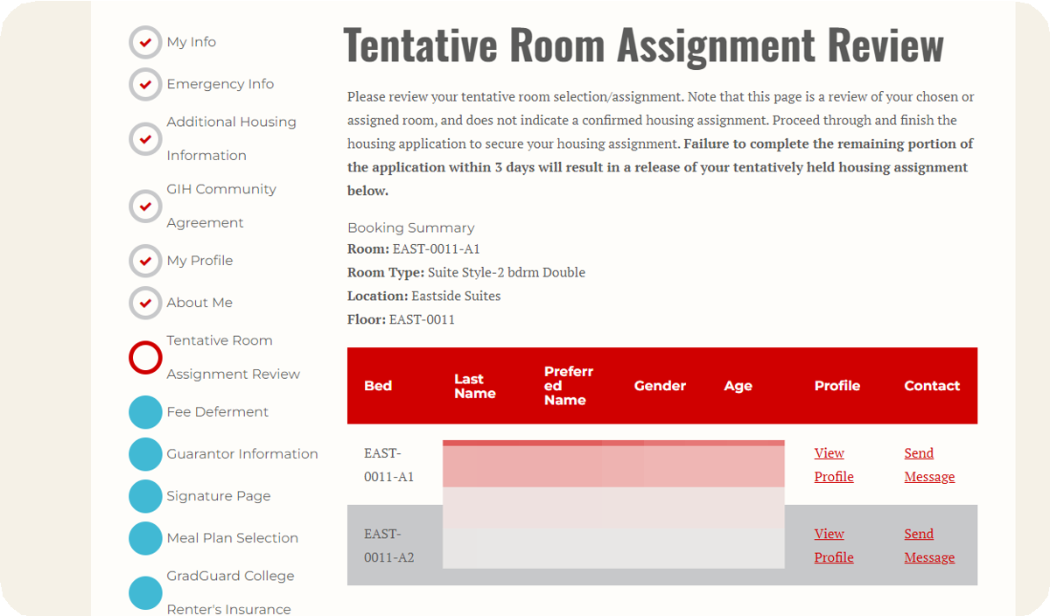
Review your Tentative Room Assignment.

28

29
On this page, you will see the room that you have been assigned to and your roommate(s). After reviewing your assignment, click Save & Continue to move to the next page.

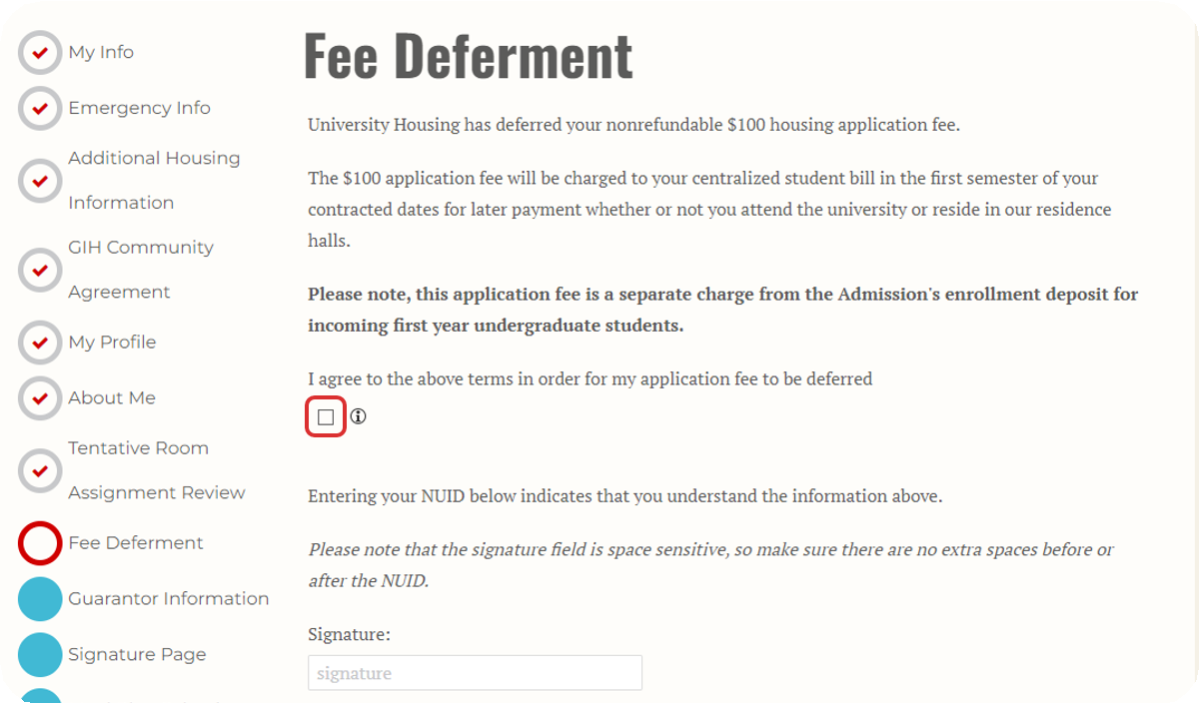
Pay the Housing Application Fee or Complete the Fee Deferment Agreement.
If you have deferred your enrollment fee when you were admitted to the university, your Housing Application Fee will also be deferred. The $100 charge will be added to your spring bill in January.
All other students will skip this page and move to the step below.

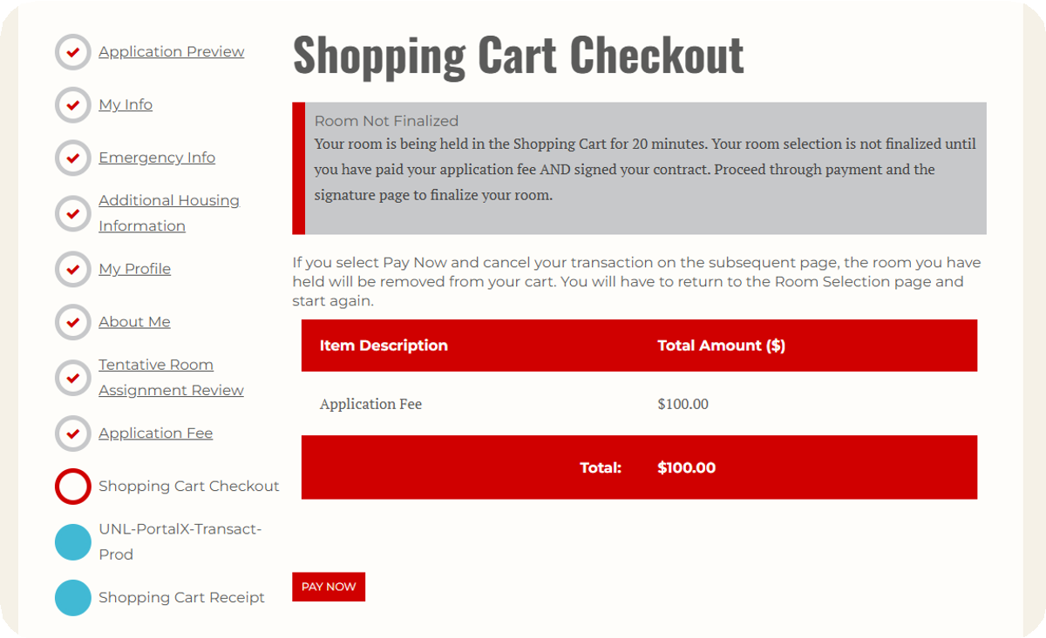
Pay the Housing Application Fee.
30
If your application fee is not deferred, you will reach the "Shopping Cart Checkout" page where you will see the $100.00 application fee.

31
Click Pay Now to navigate to the CashNet website and pay the fee.

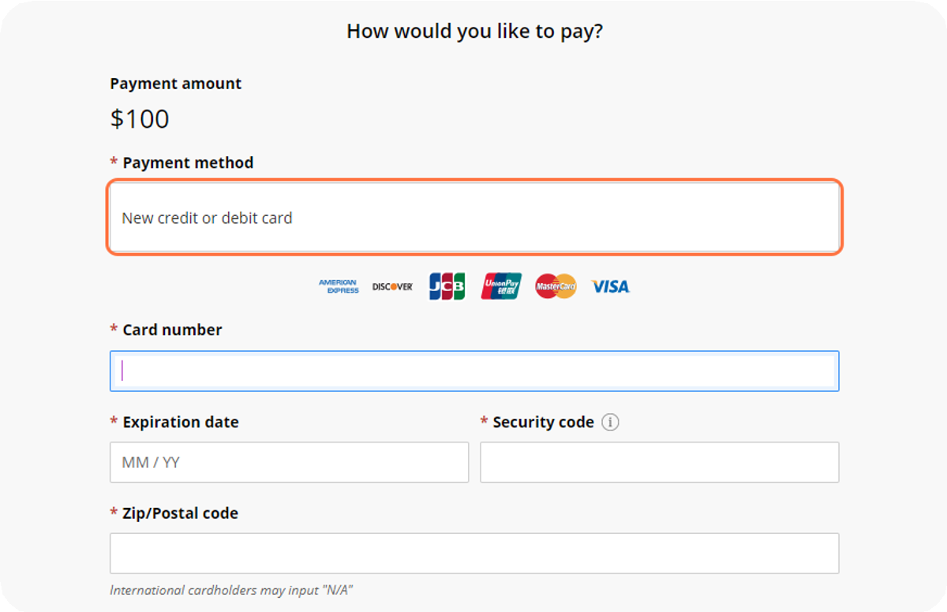
Pay the Housing Application Fee.
On the CashNet website, you will enter your credit or debit card information to pay the $100.00 housing application fee.

32
After paying the fee, you will automatically return to the housing portal to complete your housing application.

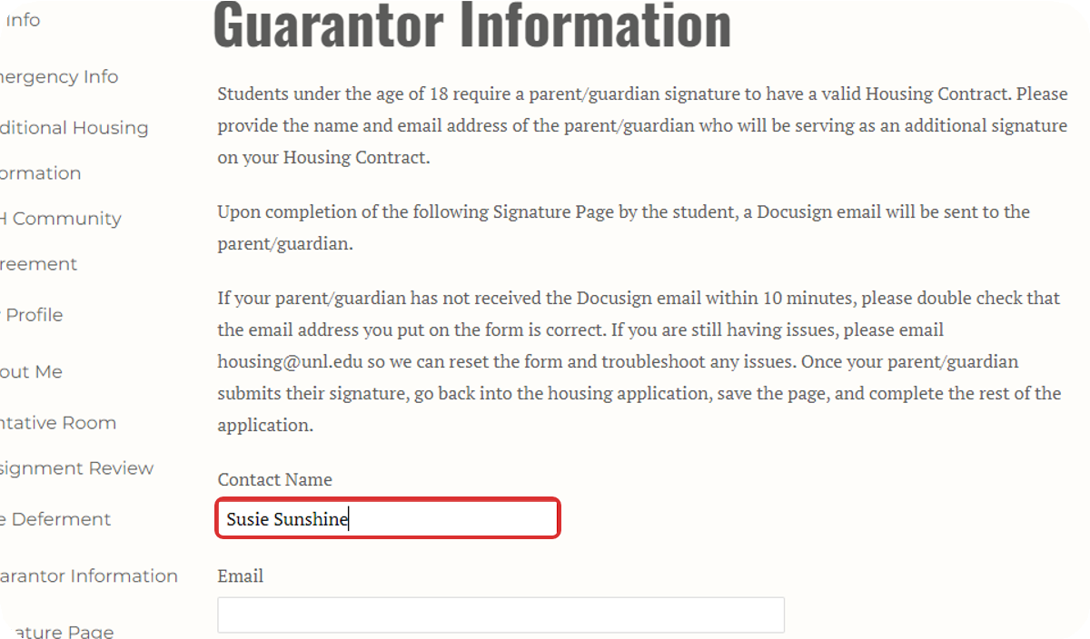
Provide Guarantor Information (Only for Students Under 18 Years Old).
Students under 18 years old must provide information for a parent or guardian who will sign the housing contract along with the student.
If you are 18 years or older, you will automatically move to the next page.

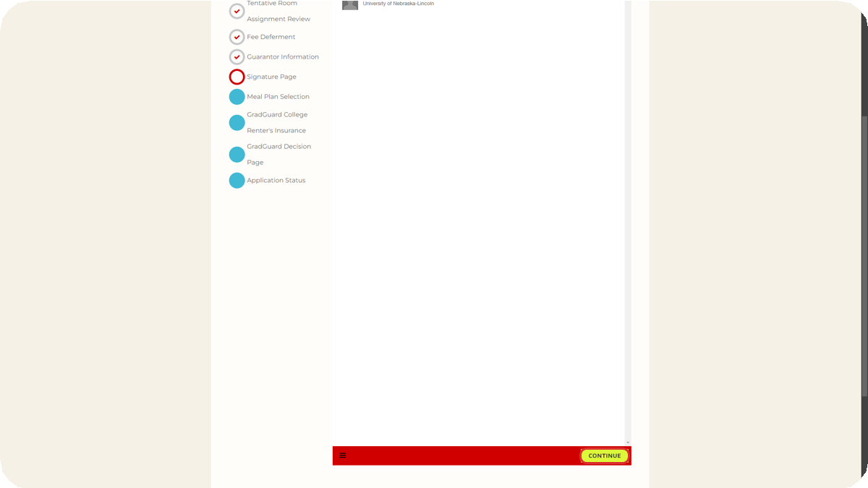
Sign the Housing & Dining Contract.
33
When you first navigate to the contract page, it may appear blank. If so, click the yellow Continue button at the bottom of the page.

34

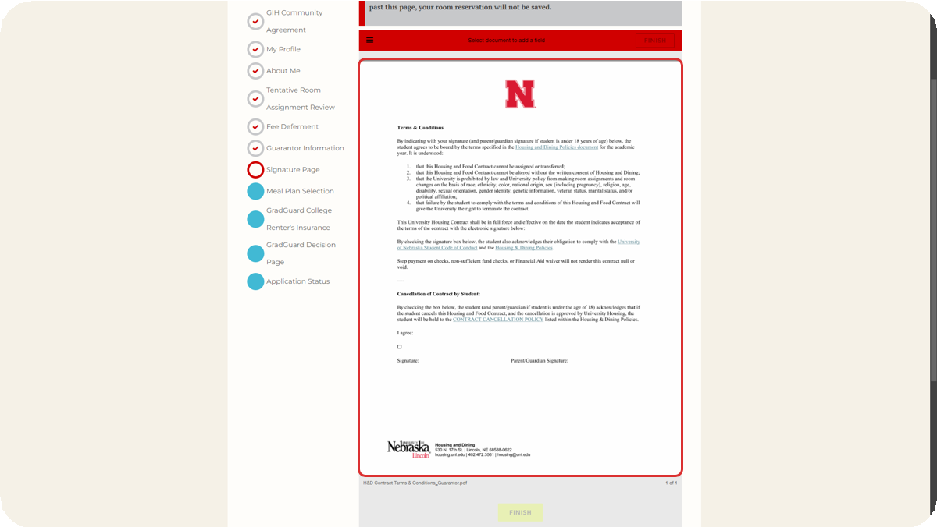
Review the Housing Contract.

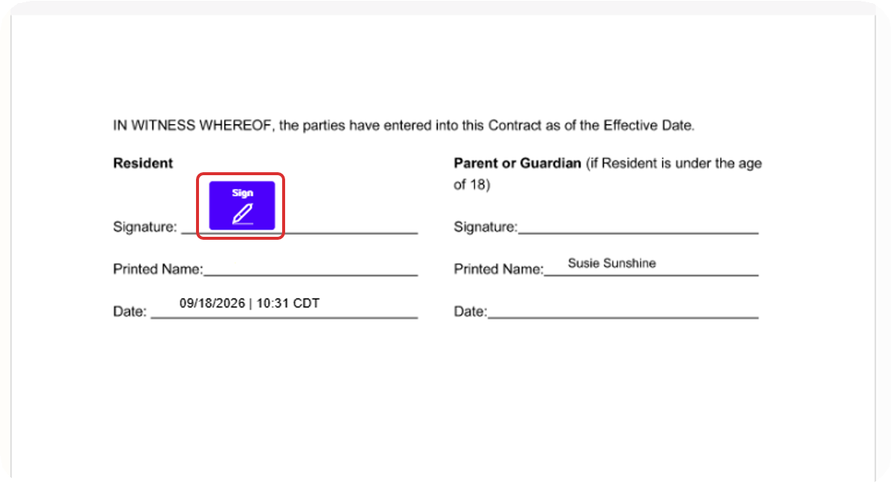
Add Your Signature.

35

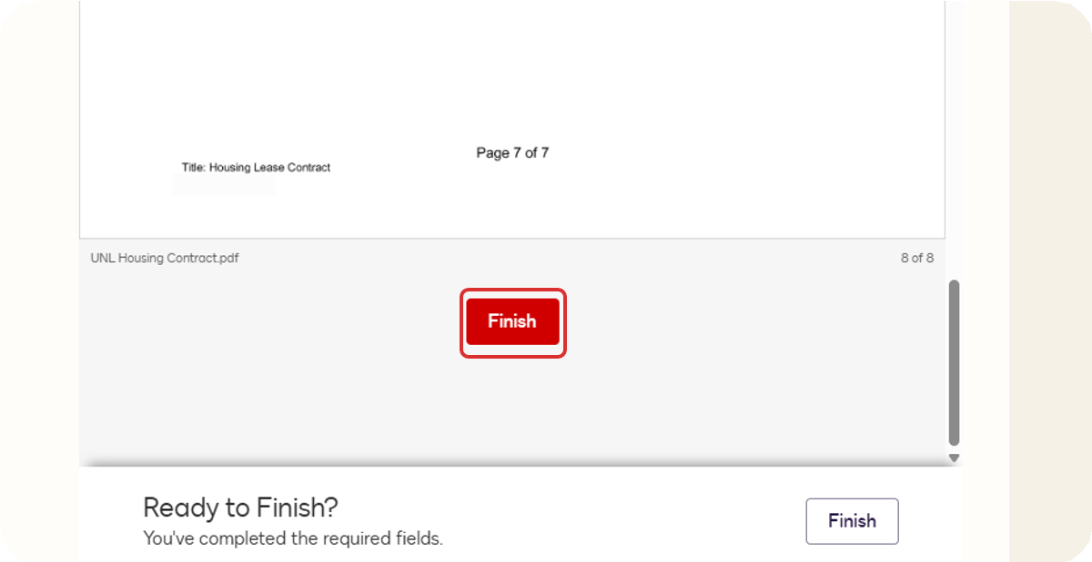
Click on FINISH.
36

Click on Save & Continue.

37
After you have signed the contract, the DocuSign window will go away, and you can click Save & Continue to move to the next page.
If you are under 18 years old, the parent or guardian you listed on the Guarantor Information page must sign the contract before you may continue. They will receive an email at the email address you provided with a link to sign the contract.
If you have any issues with the DocuSign, please reach out to Housing by emailing housing@unl.edu or calling 402-472-3561.

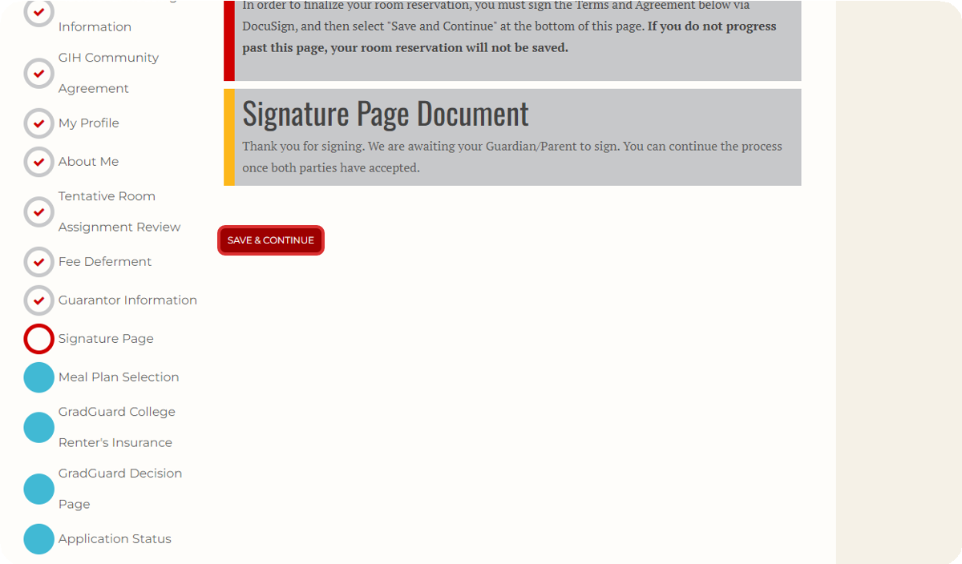

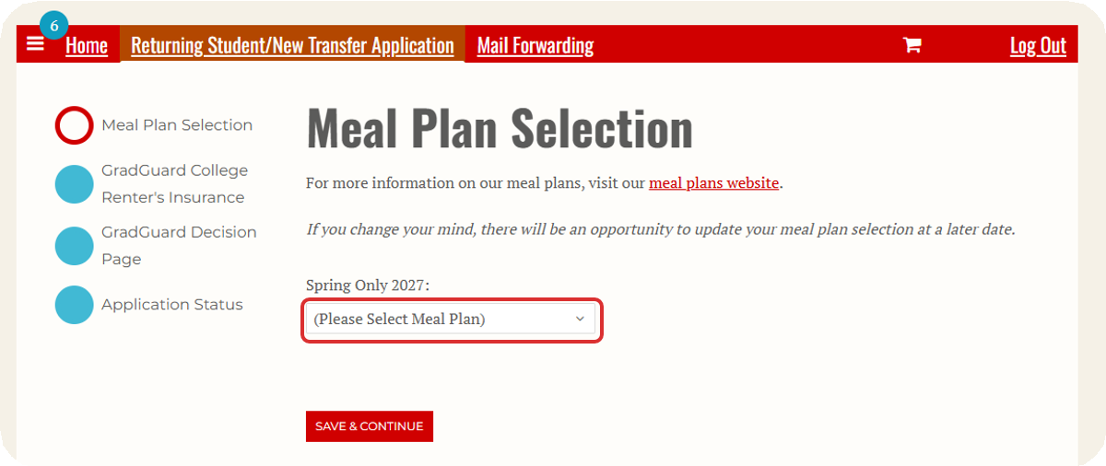
Review Meal Plan Options and Select a Meal Plan.
38
Students in Suite-Style and Traditional housing are required to have a meal plan.

39
If you have been placed in Apartment-Style housing, then you will also have the option to select "No Meal Plan".
Review the meal plan website, decide which meal plan you would like, and then select it from the drop down.

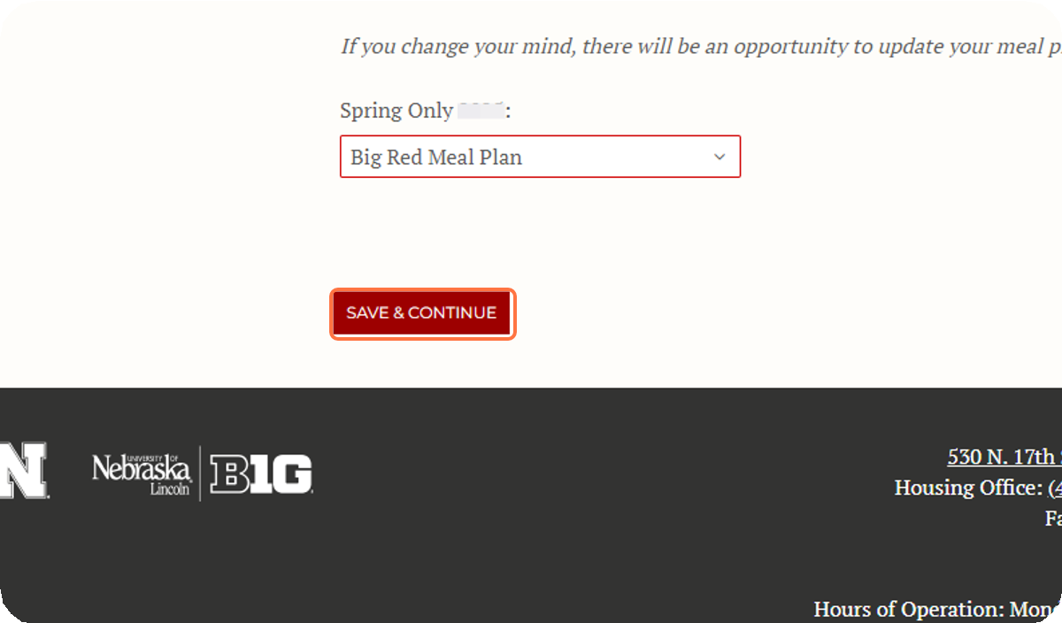
Click on Save & Continue.
After selecting your meal plan, click Save & Continue to move to the next page.

40

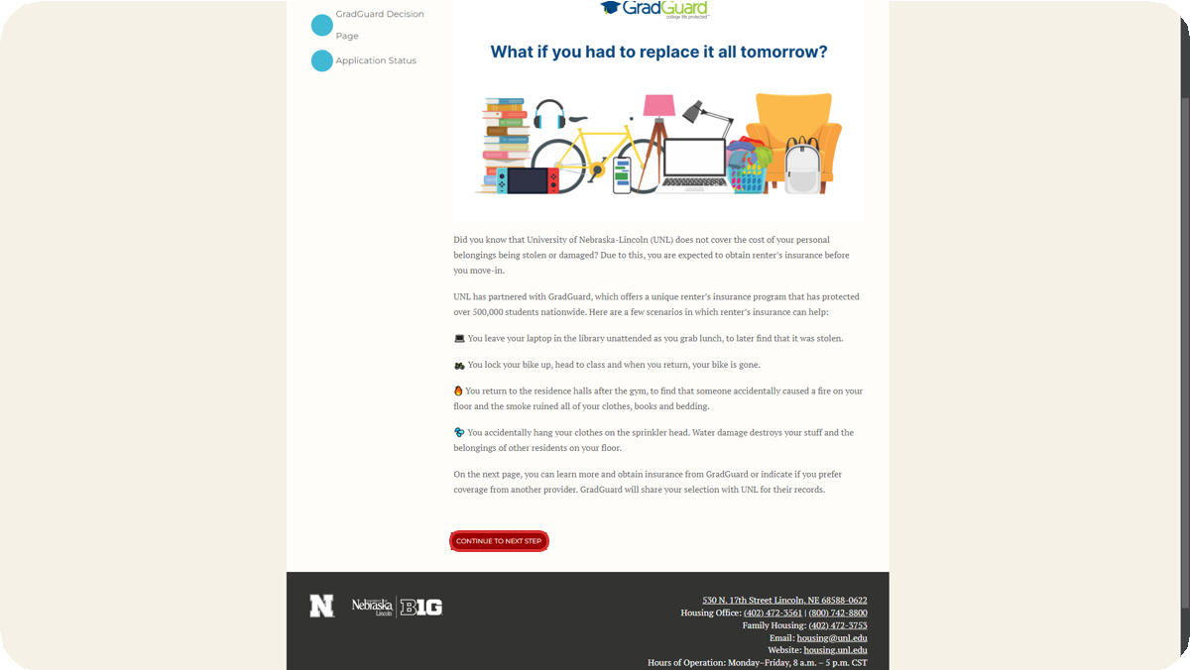
Review Renters Insurance Information.
University Housing & Dining encourages all students living on campus to have renters insurance. This page on the application provides information about GradGuard, one option for renters insurance.
After reviewing the information on this page, click Next Step to navigate to the GradGuard website.

 GradGuard - College Life Protected

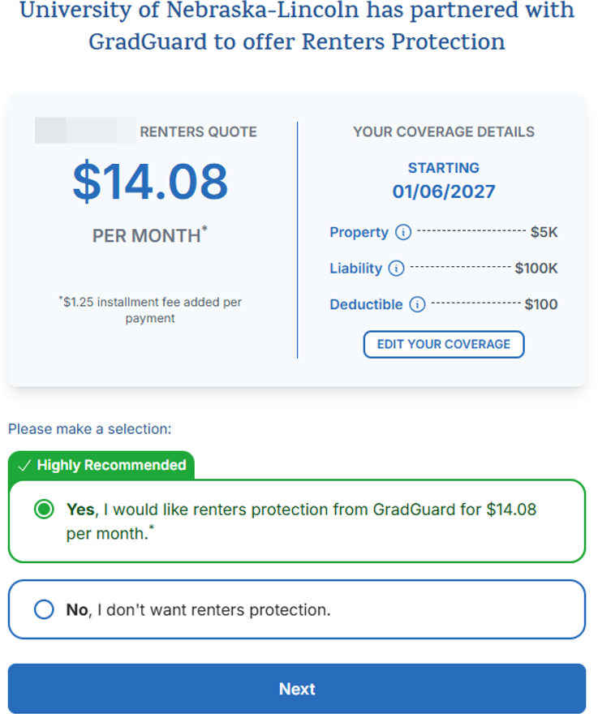
Select Whether to Purchase or Decline Renters Insurance.
41
GradGuard will provide you with a quote for renters insurance, and you will have the option to purchase or decline it.

42
After you have followed all of the steps on the GradGuard website, you will navigate back to your housing application in the housing portal.

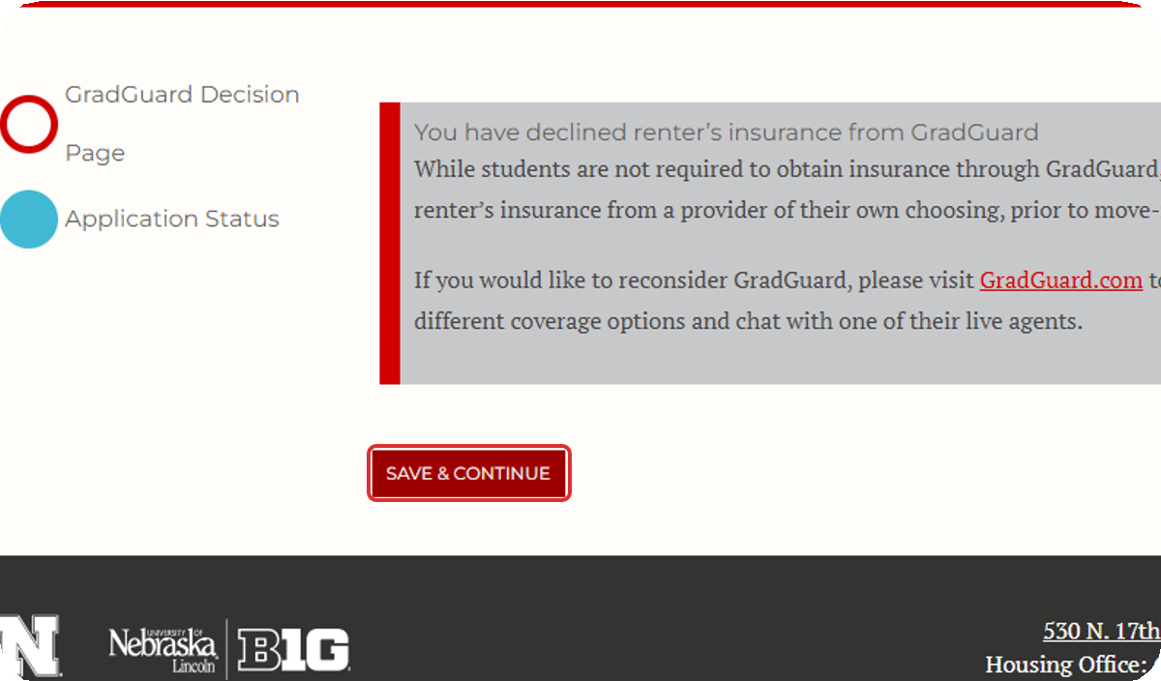
Confirm your Renters Insurance Decision.
When you return to the housing application, you will see a message confirming your decision on GradGuard. After confirming the message is correct, click Save & Continue to finish the application.

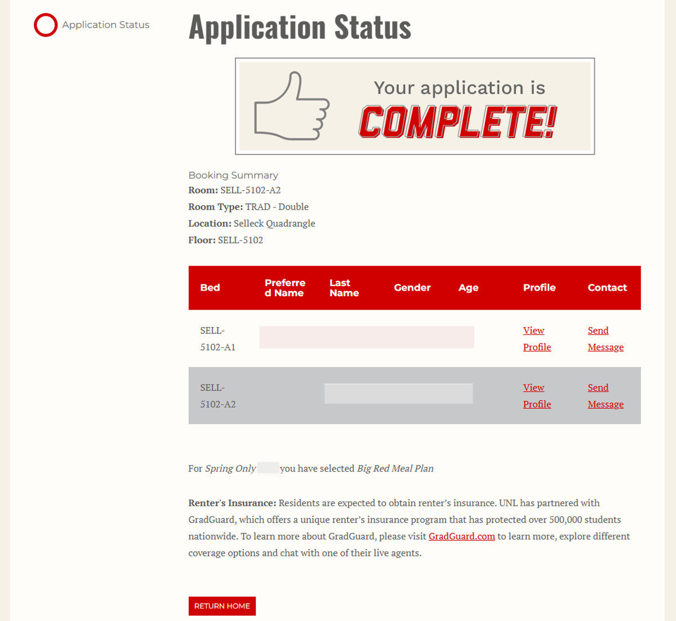
Your application is complete!
43
When you have reached the application status page with the "Your application is complete!" message, you have finished the housing application process, and your booking for Spring is confirmed.
You can return to this page any time by going back into the application. On this page you will be able to view your current room and roommates.

