

Step-by-Step Guide to Completing the New Student University Housing Application for Spring

 Navigate to the Housing Portal 33 Steps

You can get to the housing portal by pasting the following link into your web browser: go.unl.edu/housing-portal


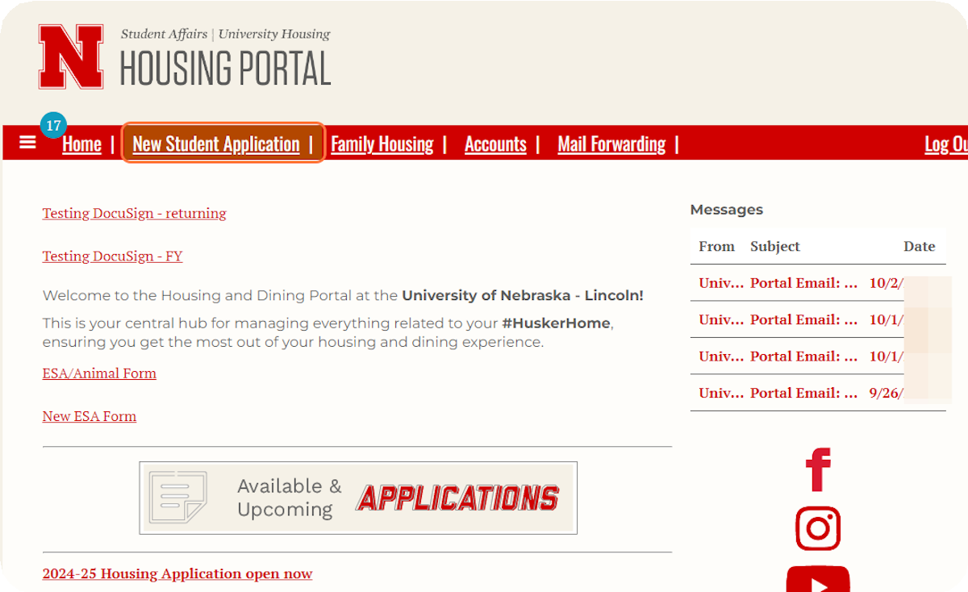
Click on New Student Application at the top of the page.
1


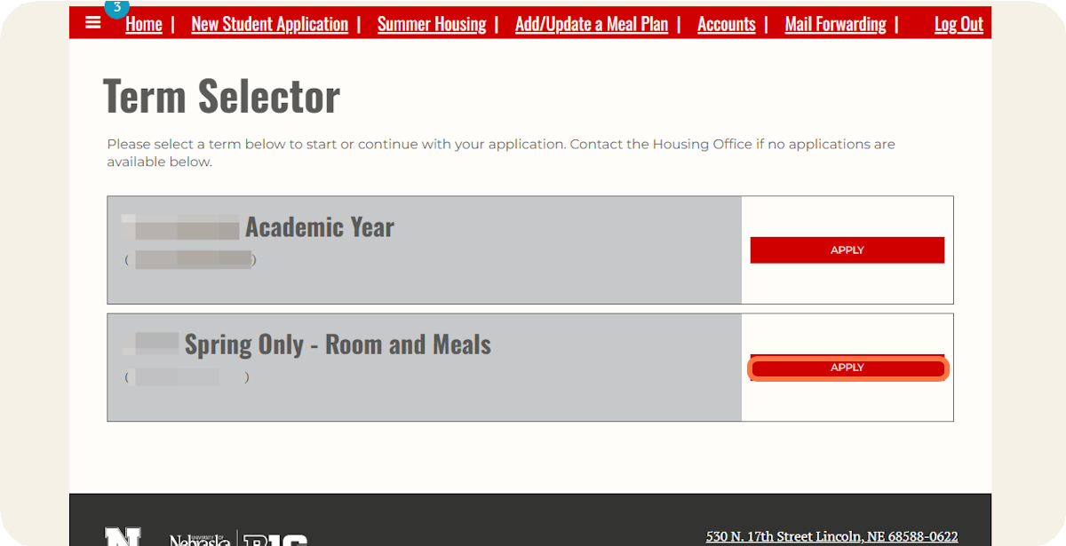
Click on Apply for Spring Only - Room and Meals.
2

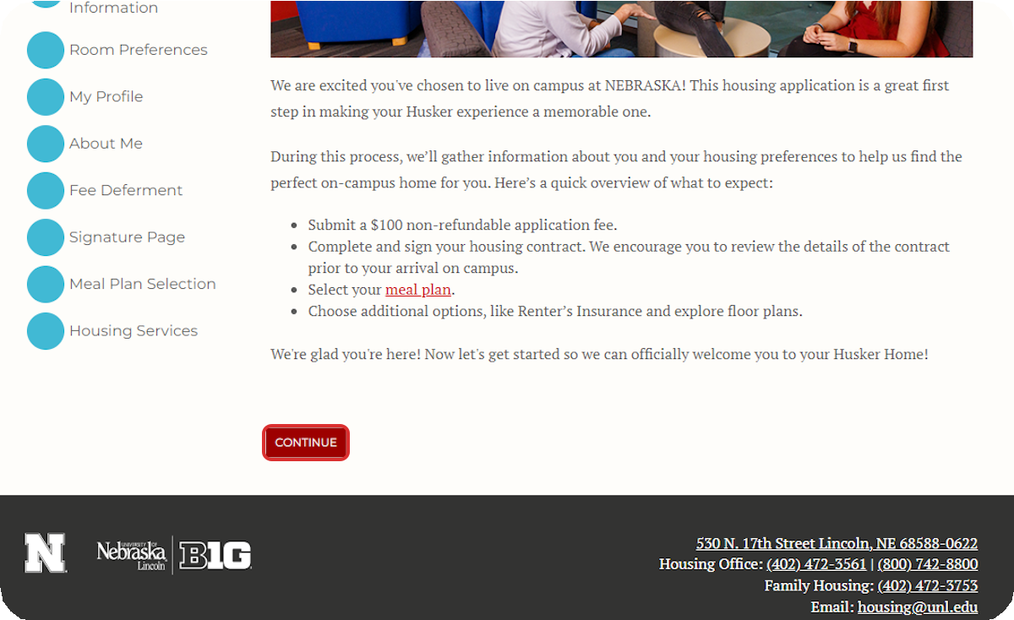
Read through the introduction and then click Continue.
3

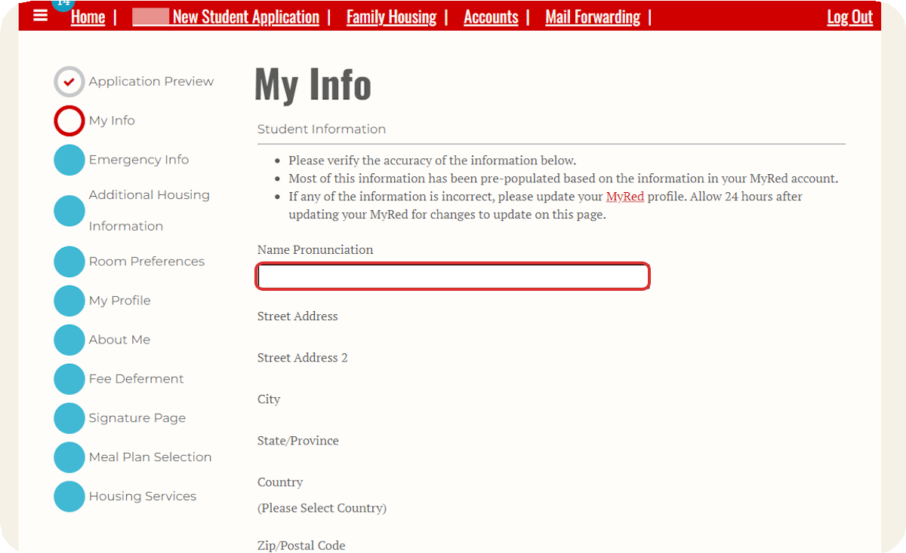
Review the personal information that was imported from MyRed into your Housing Application.
5

4
If any of the information is incorrect, you can update it in MyRed before returning to the housing application.
Optionally, you can answer the Name Pronunciation question if you would like to provide a phonetic spelling of your name.

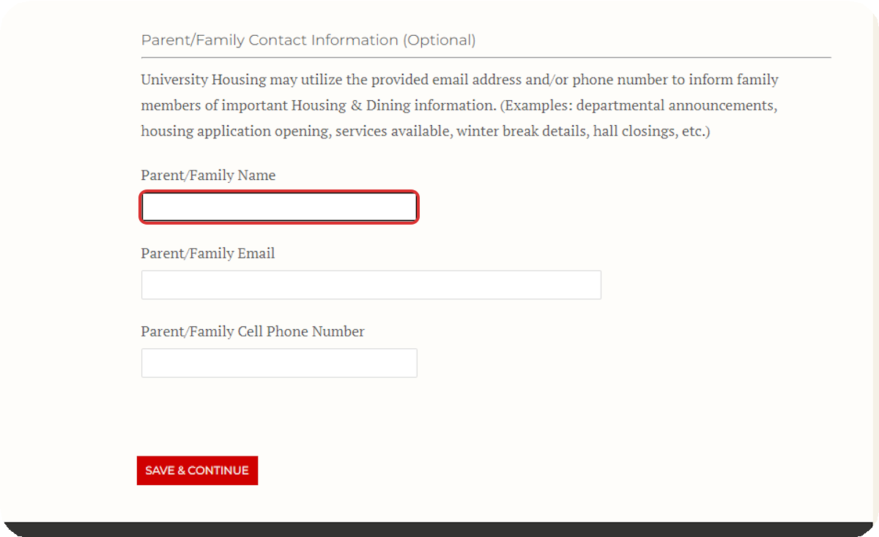
Provide Parent/Family Contact Information (Optional) and then click Save & Continue.
After confirming that all of the information on this page is correct, click Save & Continue to move to the next page.

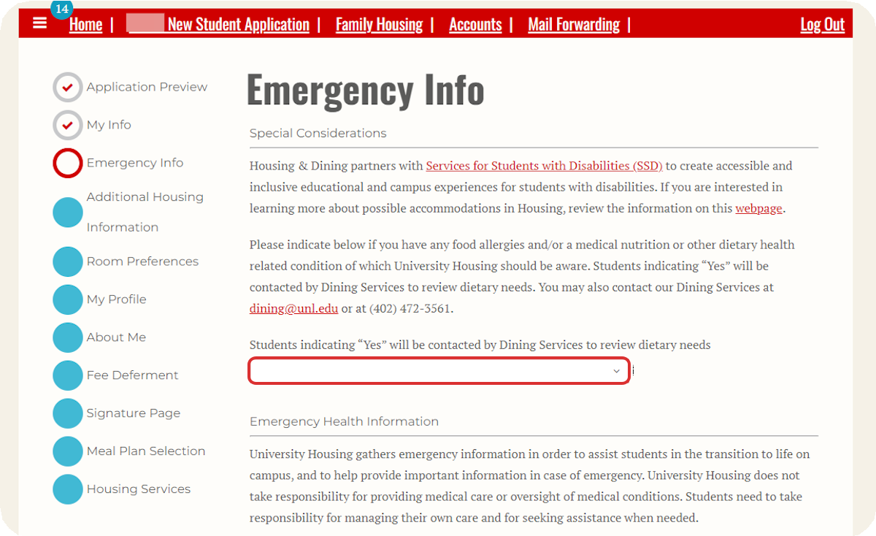
Indicate whether you would like to be contacted by Dining Services to review your dietary needs.
7
6
You can also review the available information about housing and dining accommodations for students with disabilities here. If there is any information that you would like us to be aware of in case of an emergency, you can indicate it on this page.

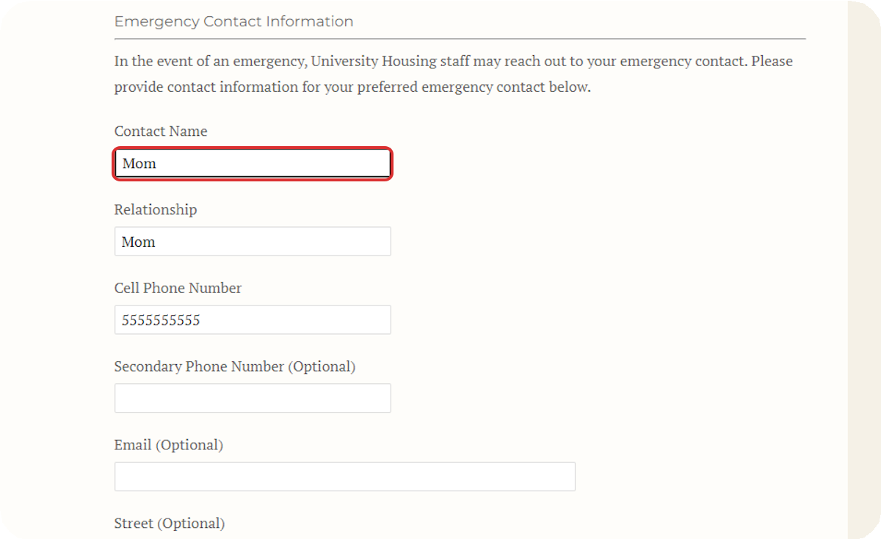
Fill out emergency contact information.
You must provide contact information for the person you would like us to contact in case of an emergency.

8
If you are under 18 years old, your emergency contact must be your parent or legal guardian.

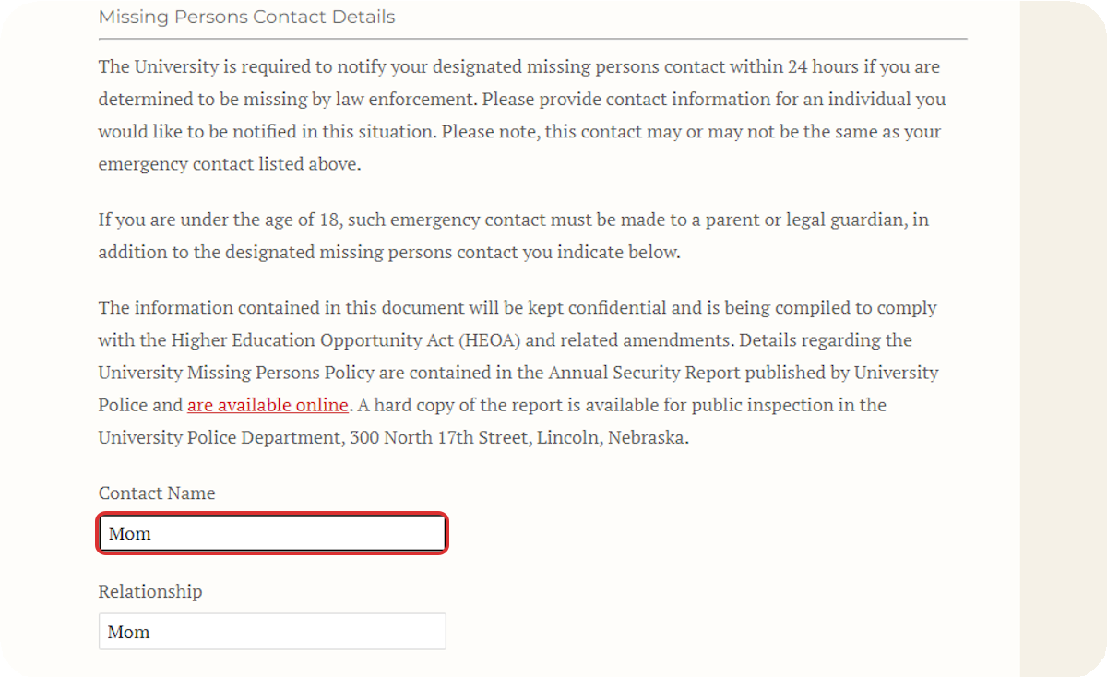
Fill out Missing Persons Contact Details.
You must provide contact information for the person you would like us to contact in the event that you go missing. This could be the same person or a different person from your emergency contact.
If you are under 18 years old, your missing persons contact must be your parent or legal guardian.

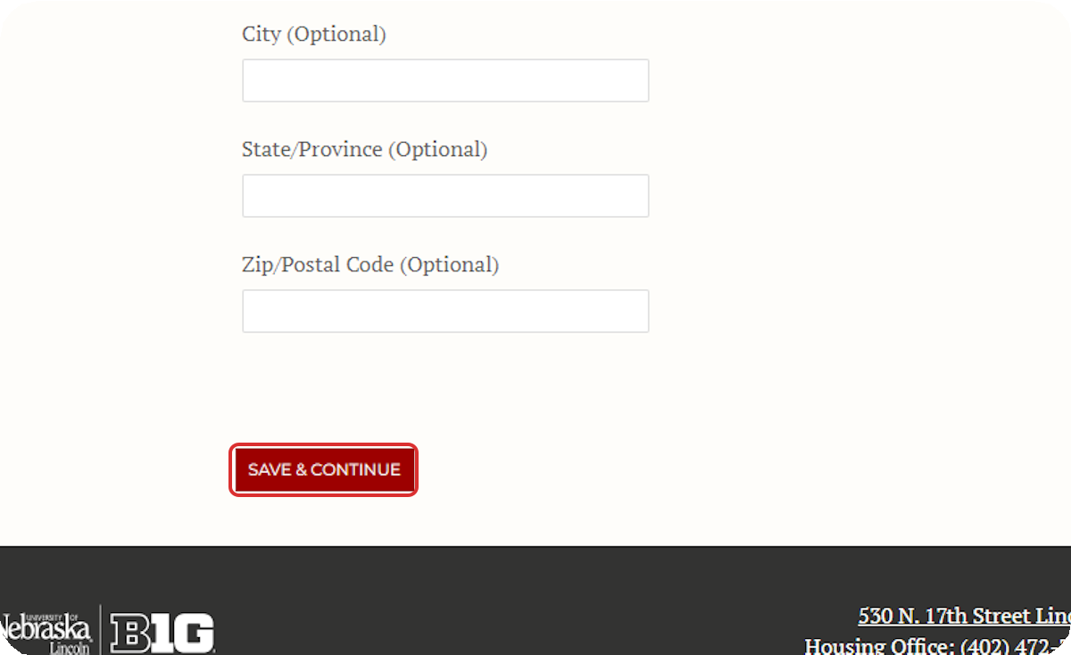
Click on Save & Continue.
9
After providing your emergency health information, emergency contact, and missing persons contact, click Save & Continue to move to the next page.

10

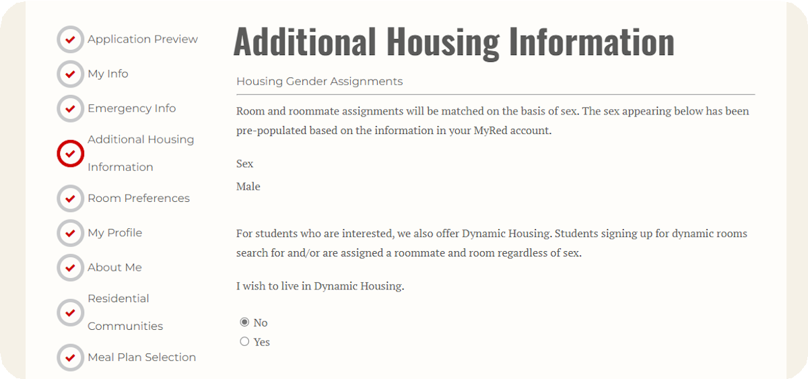
Indicate whether you would like to live in Dynamic Housing after reviewing the information.

11
If you opt in to Dynamic Housing, you will be assigned with other roommates in Dynamic Housing, regardless of sex.
If you do not opt into Dynamic Housing, you will be assigned with other roommates of your same sex.

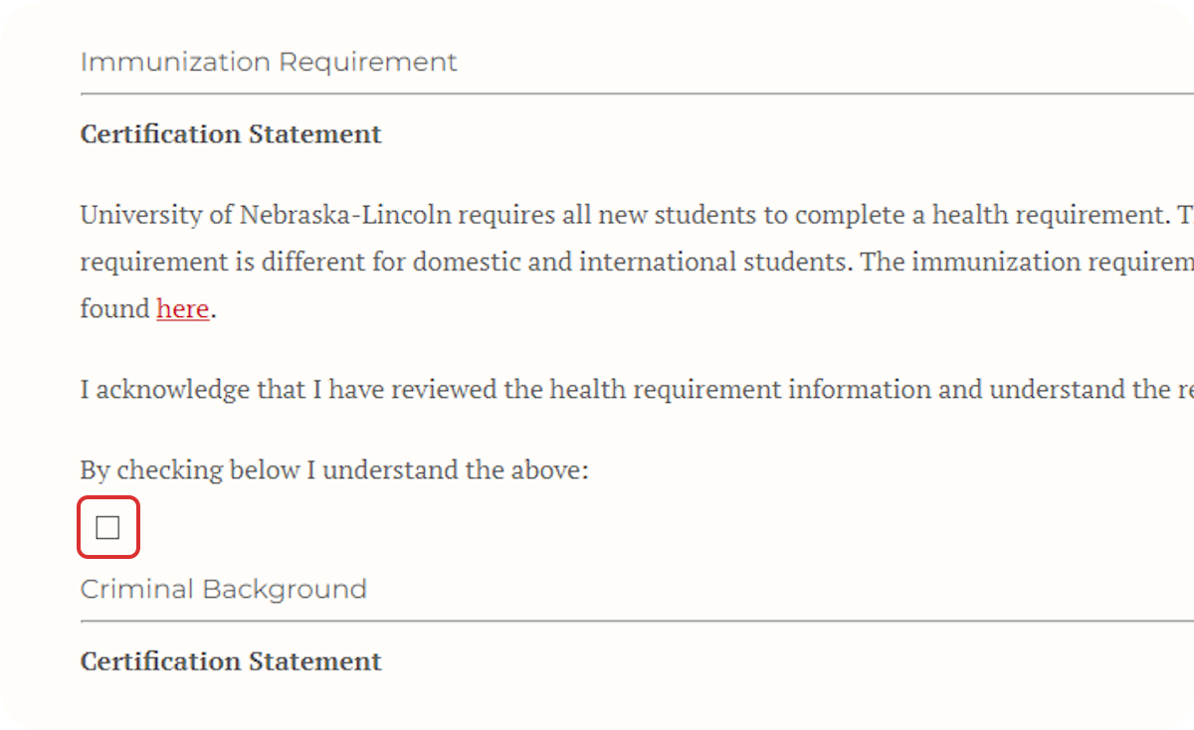
Read through and check the box indicating you understand the health and immunization requirement.

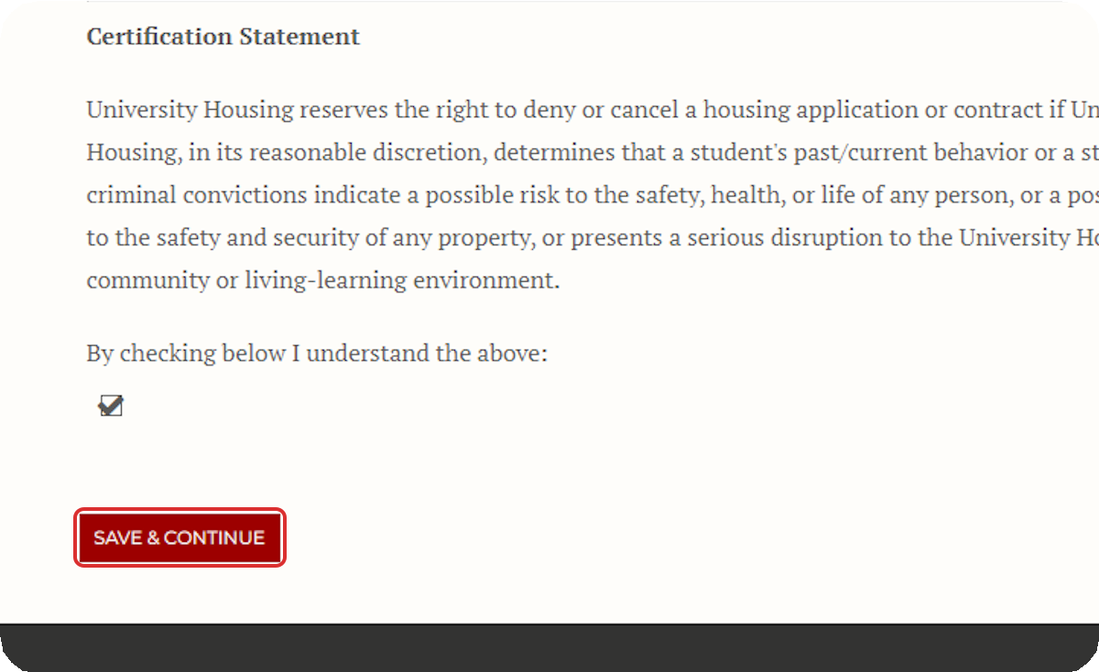
Read through and check the box indicating you understand the Criminal Background Certification Statement and then click Save & Continue.

13
12

Complete the Dynamic Housing Community Agreement (Dynamic Housing Only)
If you opted into Dynamic Housing, read through the Dynamic Housing Community Agreement and check the box to agree.
If you do not agree to the Community Agreement, then you can click "Additional
Housing Information" in the navigation bar on the left to return to the previous page and opt out of Dynamic Housing.
After checking the box, click Save & Continue to move to the next page.
If you have not opted into Dynamic Housing, you will skip this page automatically and move to Step 15.

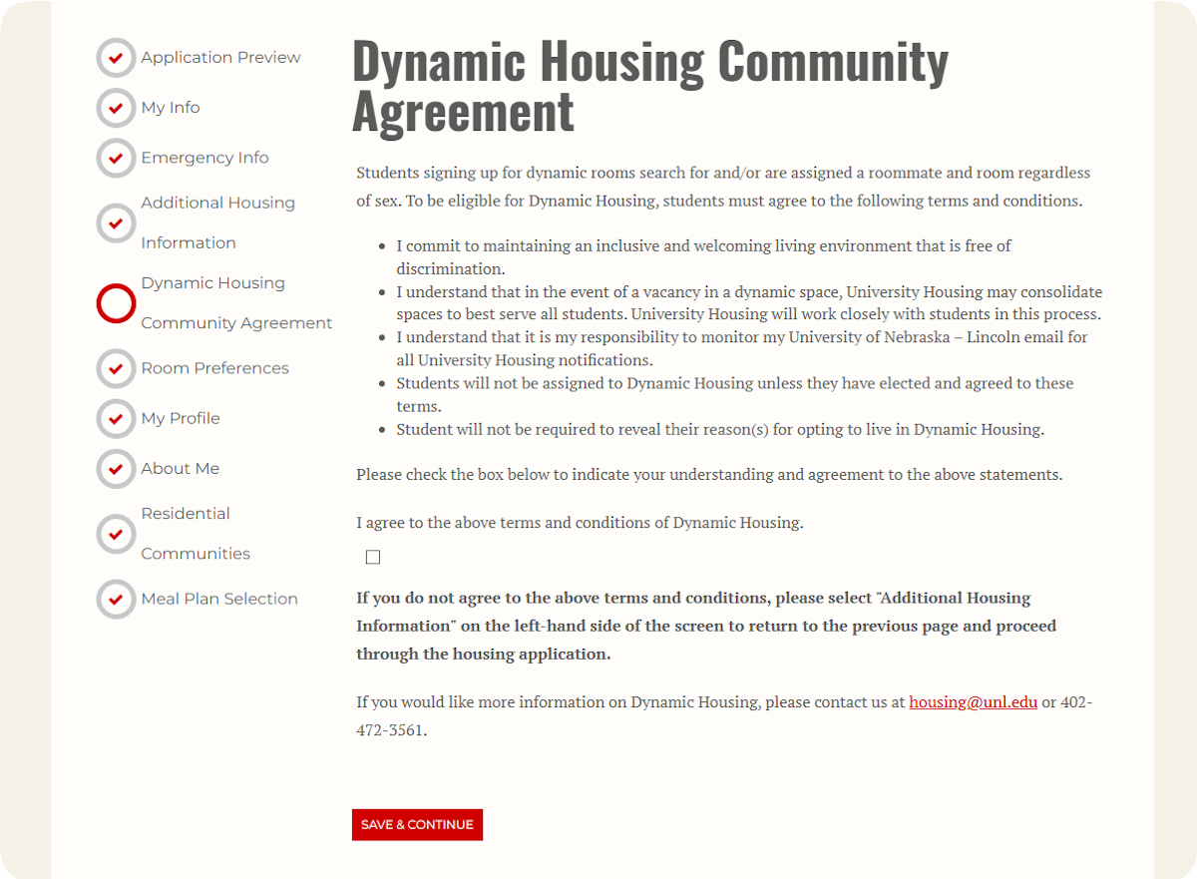

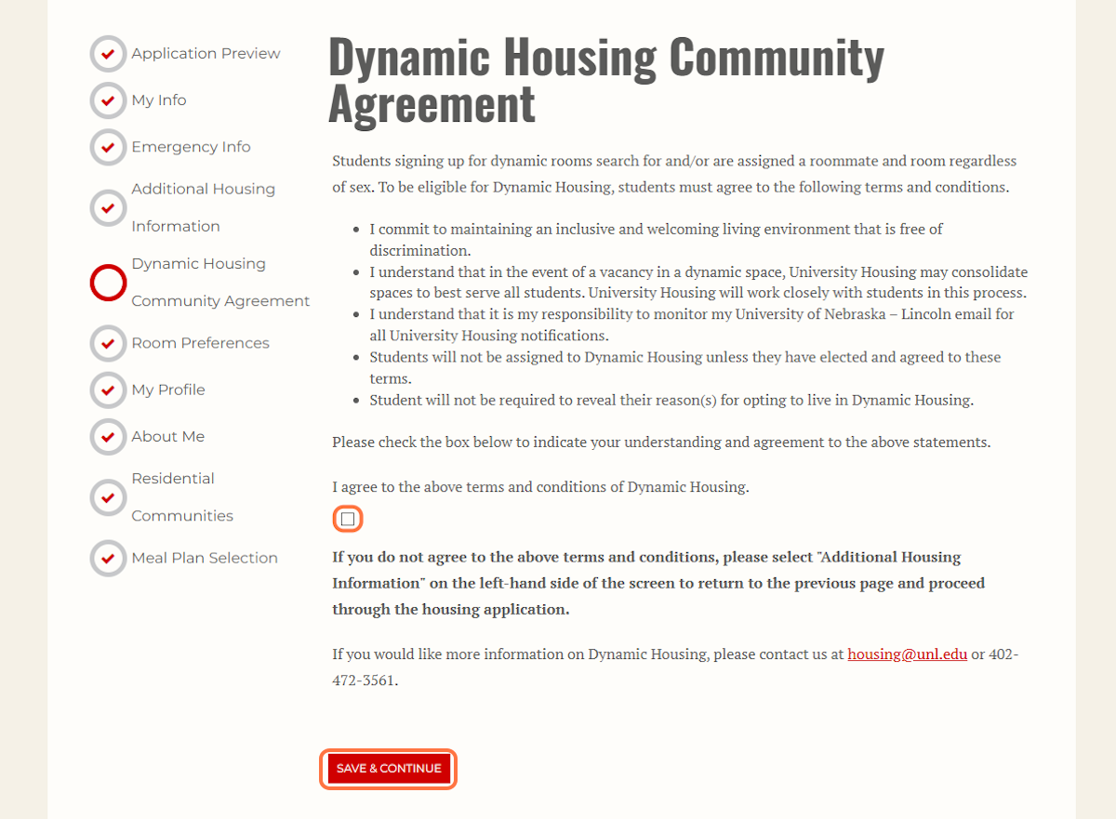
Once you have read the Dynamic Community Agreement and know you would like to be in Dynamic Housing, click the check box to agree and then click Save & Continue.

15
14

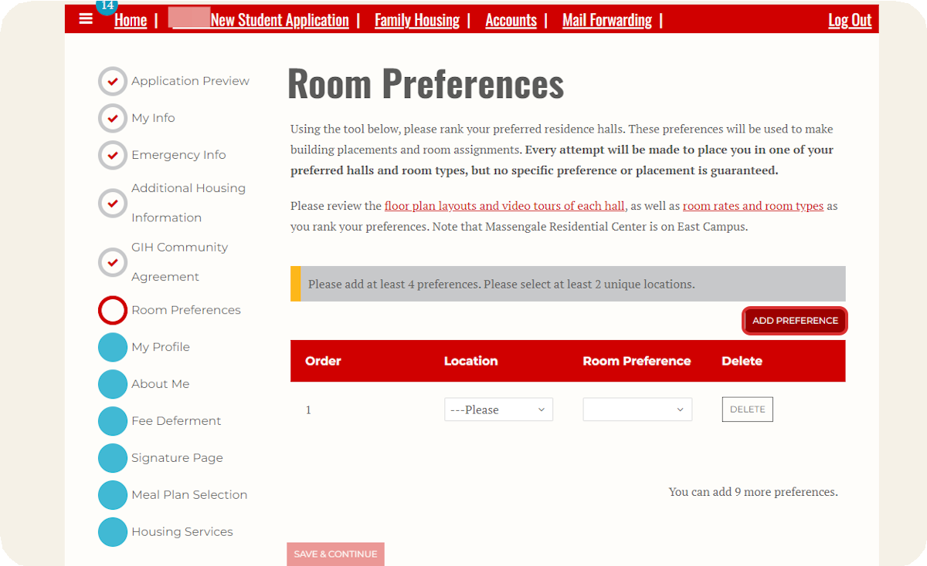
After reviewing the floor plan lay-outs, building video tours, and room rates and types, click Add Preference.

16

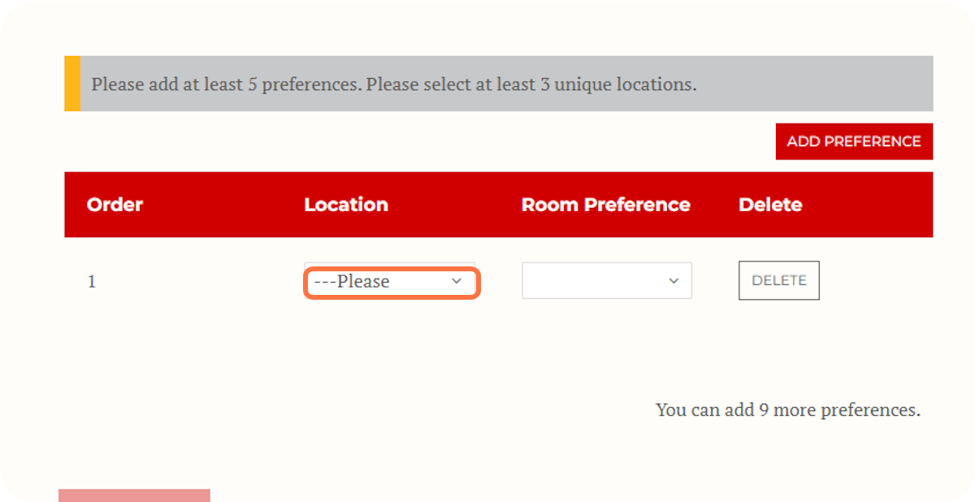
Select at least five different preferences in at least three unique locations. You can list 10 preferences at the most. Use the Delete button to delete any locations you would like to remove.

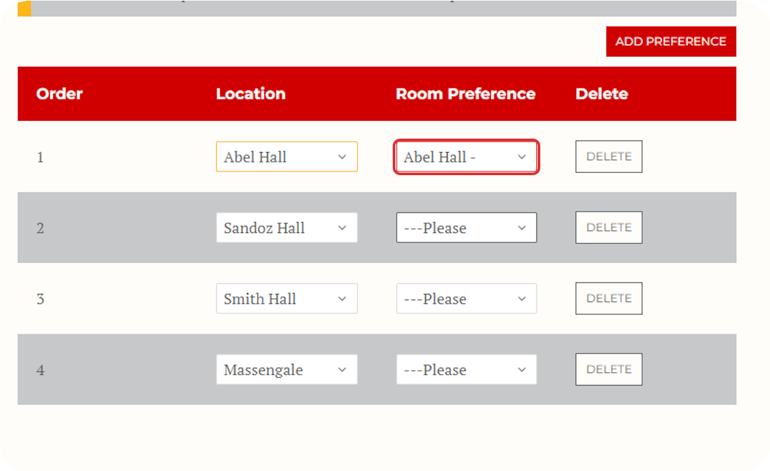
Select your room preference for each location you selected.
17

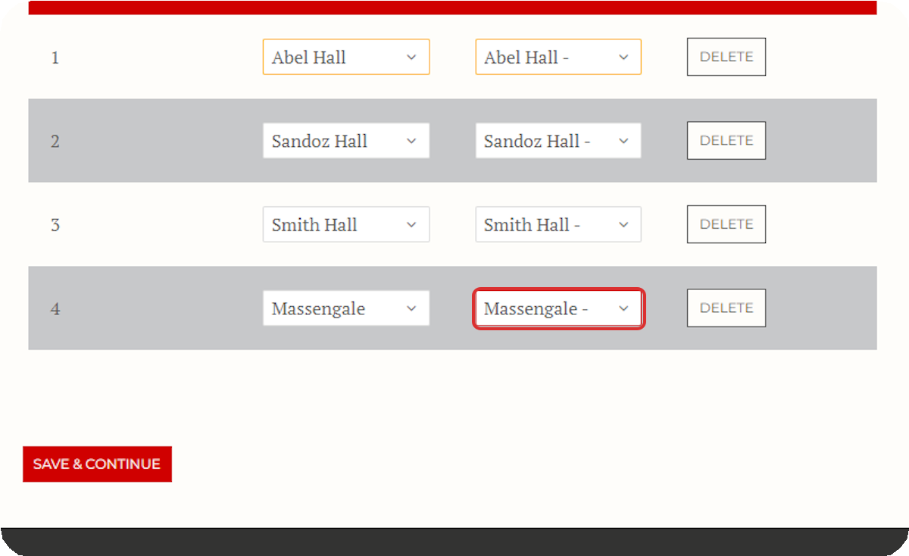
Once you have filled out your preferences with at least five locations, you will be able to click Save & Continue.

18

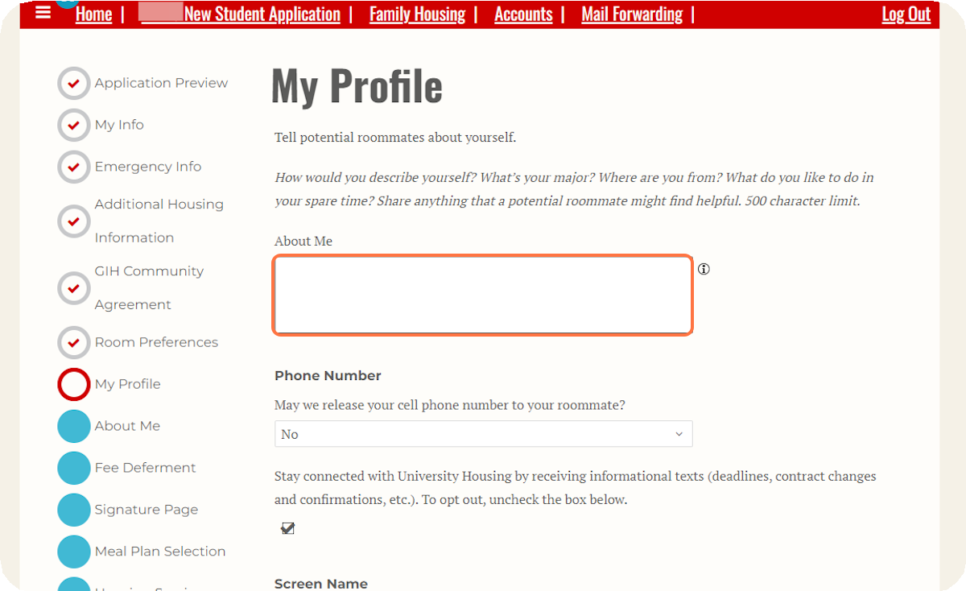
Fill out your Roommate Profile.
19
This gives you an opportunity to share a little bit about yourself to help you be matched with the best possible roommate.

20
Please Note: The roommate finder will not be open for the Spring semester. University Housing will attempt to make the best possible roommate matches with the space that is available.
Indicate whether you would like us to share your cell phone number on file with your roommate. Sharing your phone number can help you connect with your new roommate once you are assigned to live together, but it is not required.

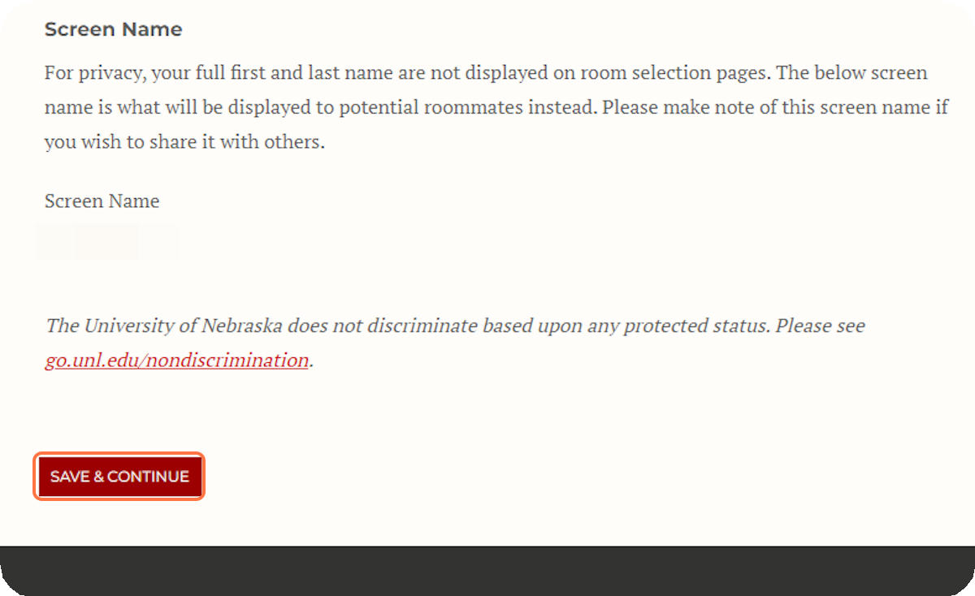
Click Save & Continue.
After completing your roommate profile, click Save & Continue to move to the next page.

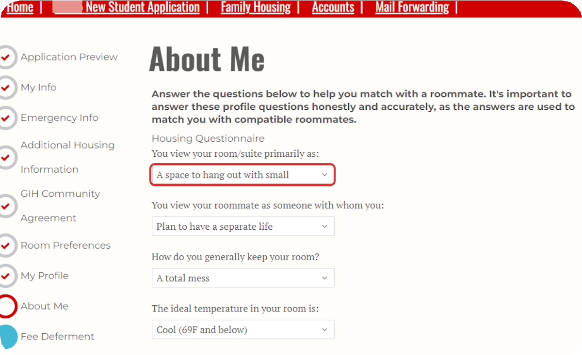
Fill Out the Roommate Matching Questionnaire.
21
These questions about your lifestyle and preferences for your room and roommates will help us match you with the roommates that will be a good fit for you.

22
You must answer all of the questions.

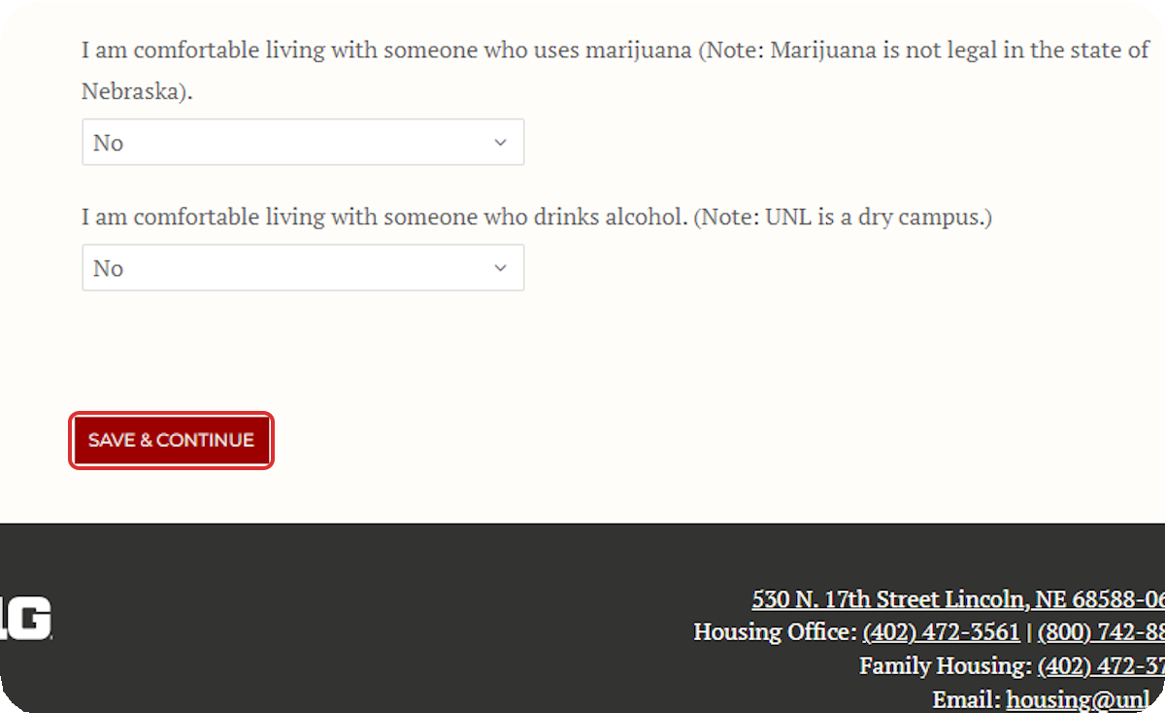
Click on Save & Continue.
After completing all of the roommate matching questionnaire, click Save & Continue to move to the next page.

23

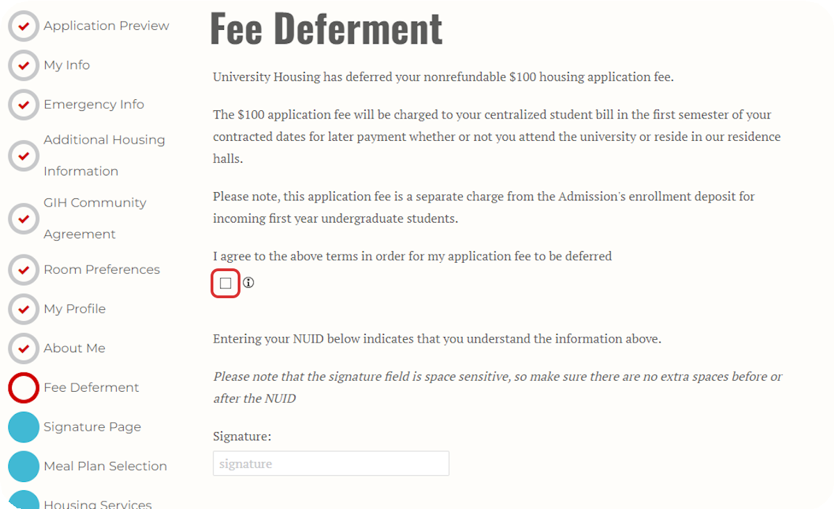
Pay the Housing Application Fee or Complete the Fee Deferment Agreement.
If you have deferred your enrollment fee when you were admitted to the university, your Housing Application Fee will also be deferred. The $100 charge will be added to your spring bill in January.
All other students will skip this page and move to the step below.

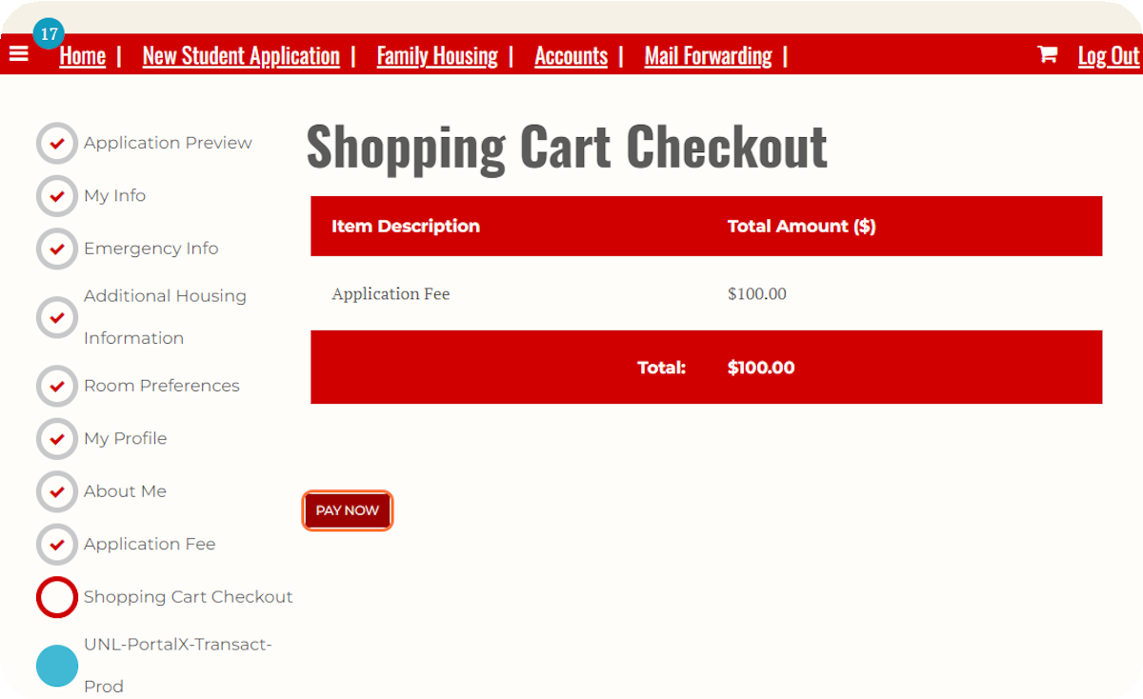
Pay the Housing Application Fee.
24
If your application fee is not deferred, you will reach the "Shopping Cart Checkout" page where you will see the $100.00 application fee.

25
Click Pay Now to navigate to the CashNet website and pay the fee.

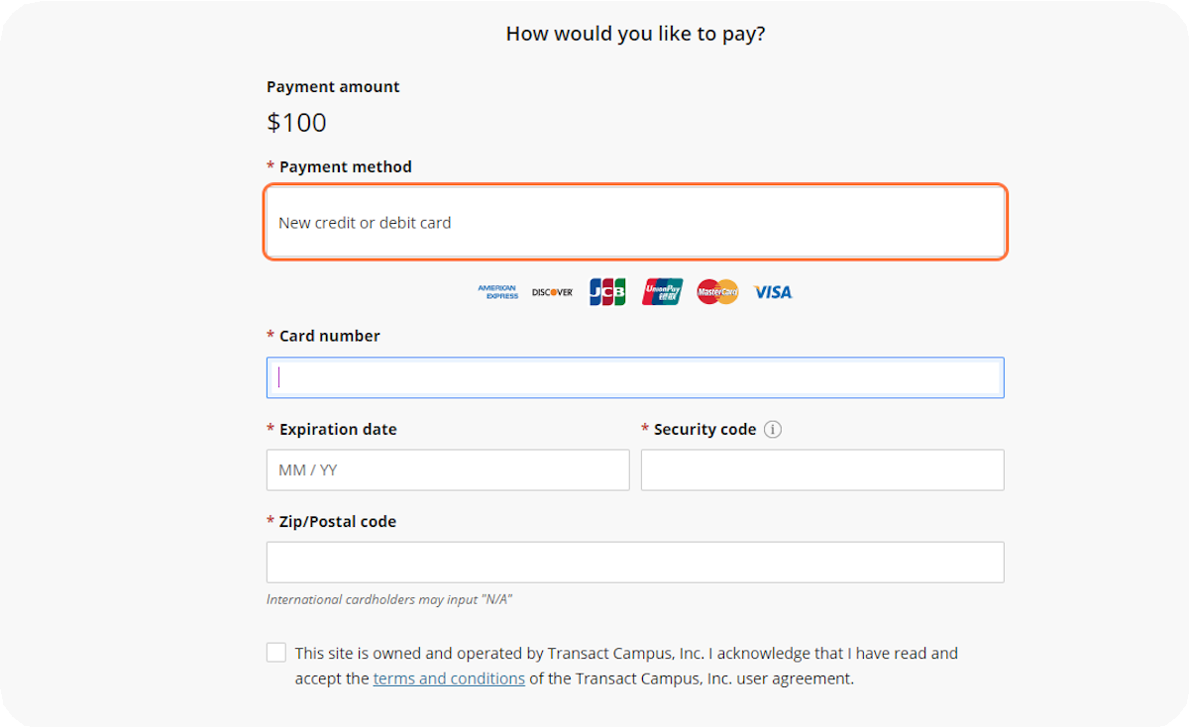
Pay the Housing Application Fee.
On the CashNet website, you will enter your credit or debit card information to pay the $100.00 housing application fee.

26
After paying the fee, you will automatically return to the housing portal to complete your housing application.

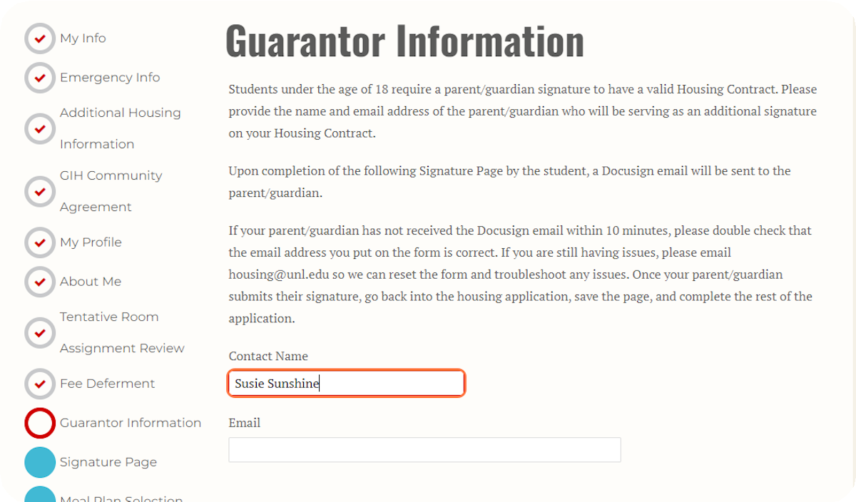
Provide Guarantor Information (Only for Students Under 18 Years Old)
Students under 18 years old must provide information for a parent or guardian who will sign the housing contract along with the student.
If you are 18 years or older, you will automatically move to the next page.

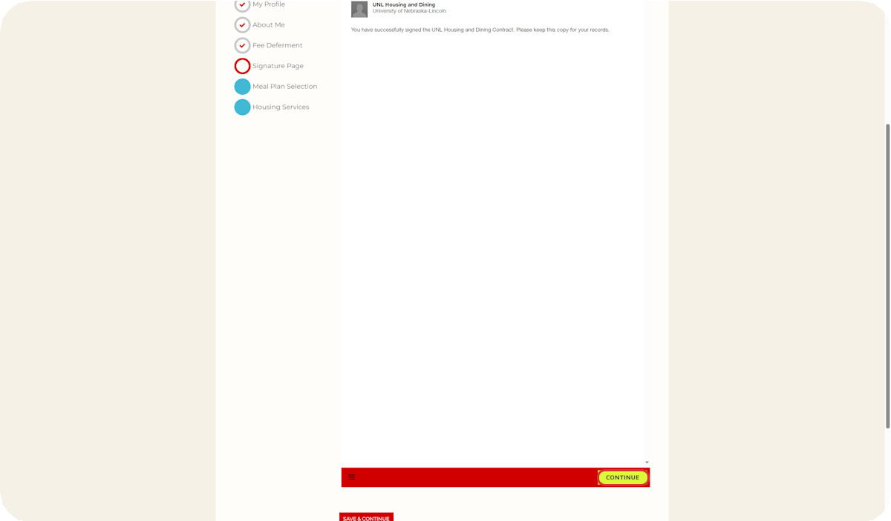
Sign the Housing & Dining Contract.
27
When you first navigate to the contract page, it may appear blank. If so, click the yellow Continue button at the bottom of the page.

28

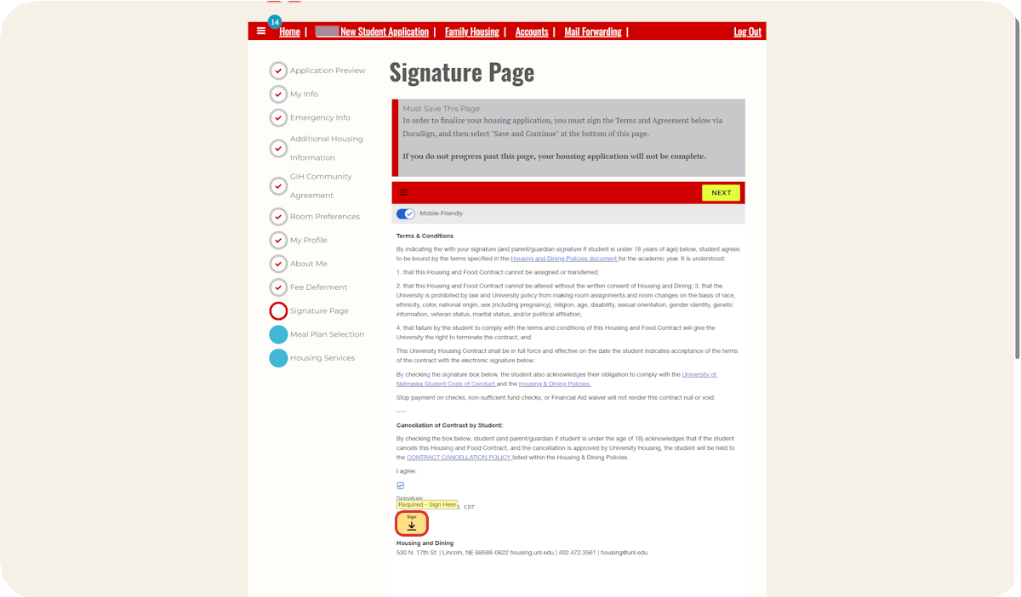
Review the Housing Contract.

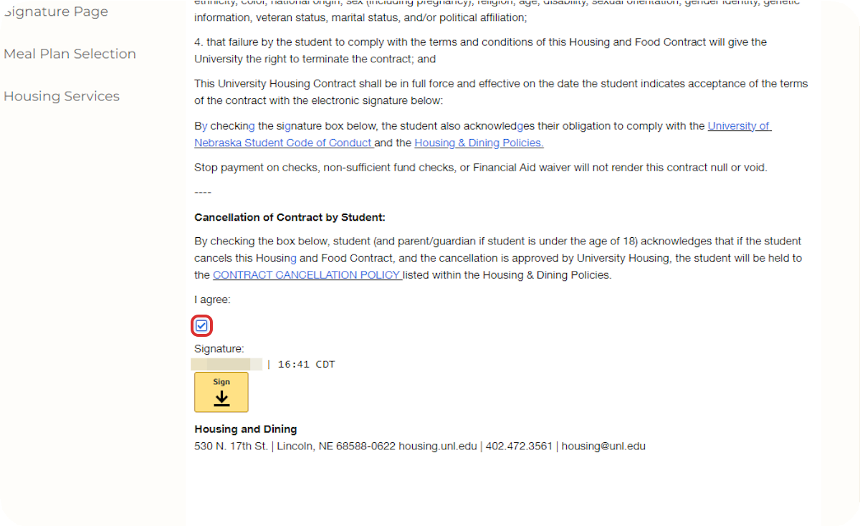
Click "I agree" and click "Sign" after reading the document.

29

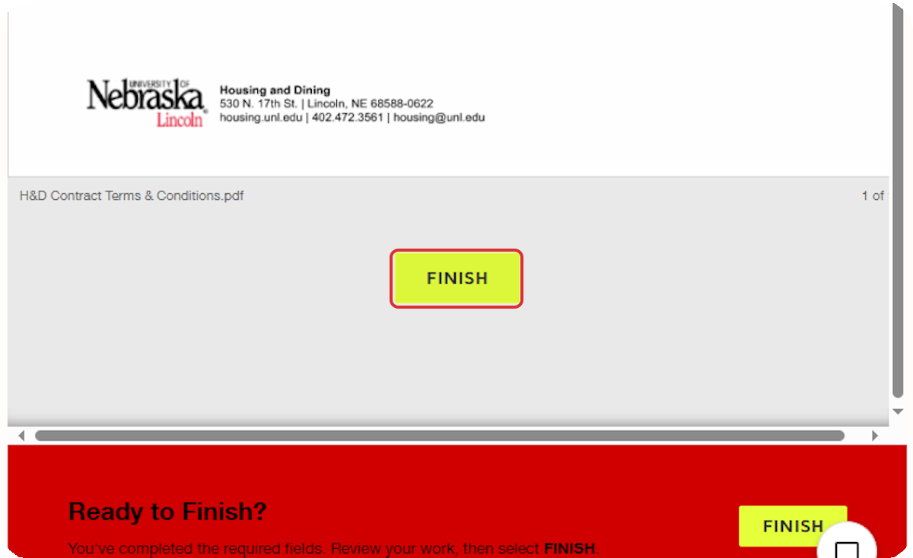
Click on FINISH once you have completed reading and signing the DocuSign.
30

31

Click on Save & Continue.
After you have signed the contract, the DocuSign window will go away, and you can click Save & Continue to move to the next page.
If you are under 18 years old, the parent or guardian you listed on the Guarantor Information page must sign the contract before you may continue. They will receive an email at the email address you provided with a link to sign the contract.
If you have any issues with the DocuSign, please reach out to Housing by emailing housing@unl.edu or calling 402-472-3561.

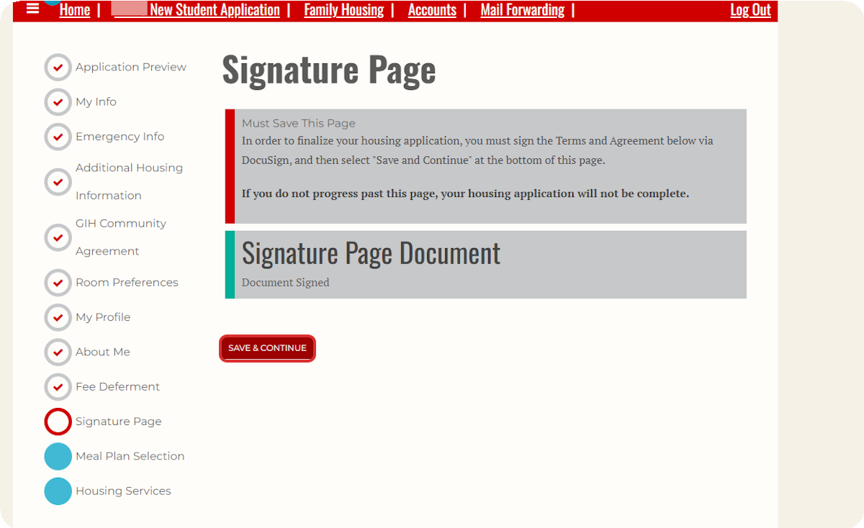

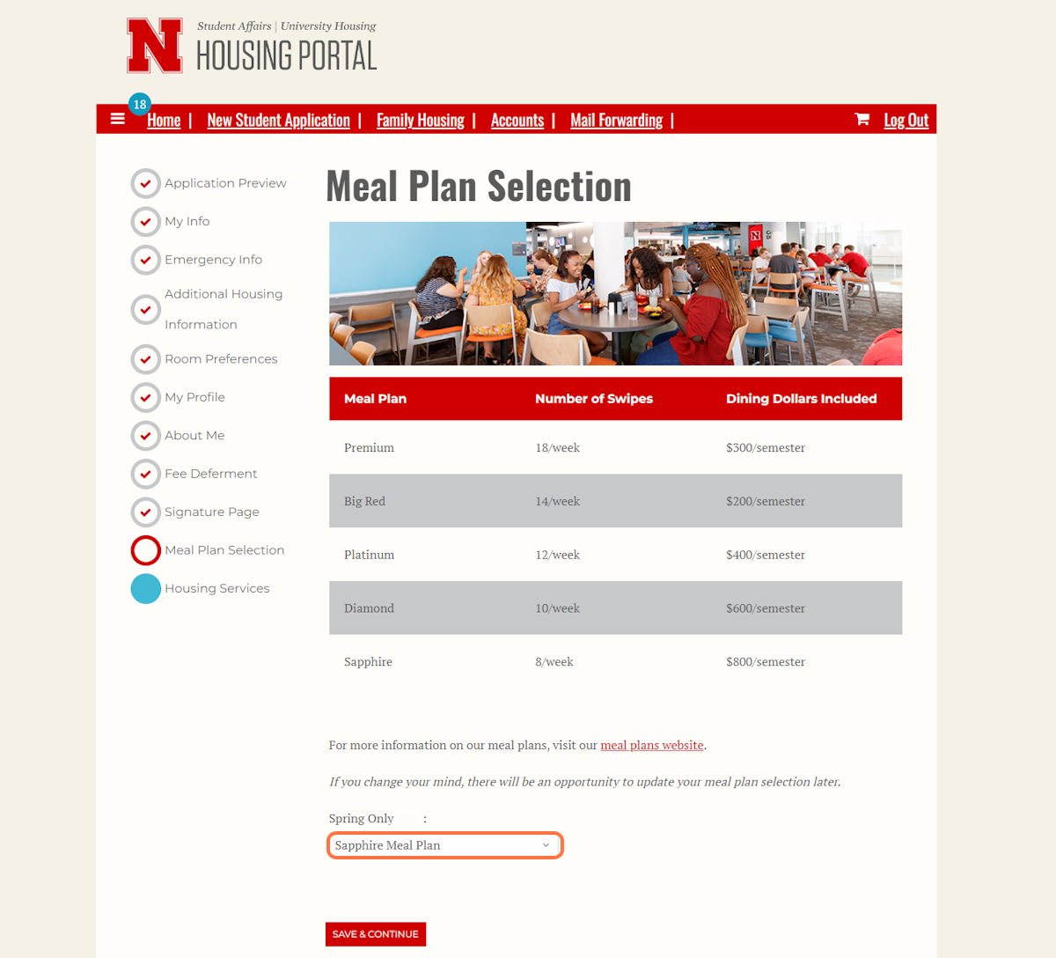
Review Meal Plan Options and Select a Meal Plan.
32
All freshmen students living on campus are required to have a meal plan. Review the meal plan website, decide which meal plan you would like, and then select it from the drop-down menu. Once you are satisfied with your meal plan selection, click Save & Continue. You will receive an email that your application is complete.

33

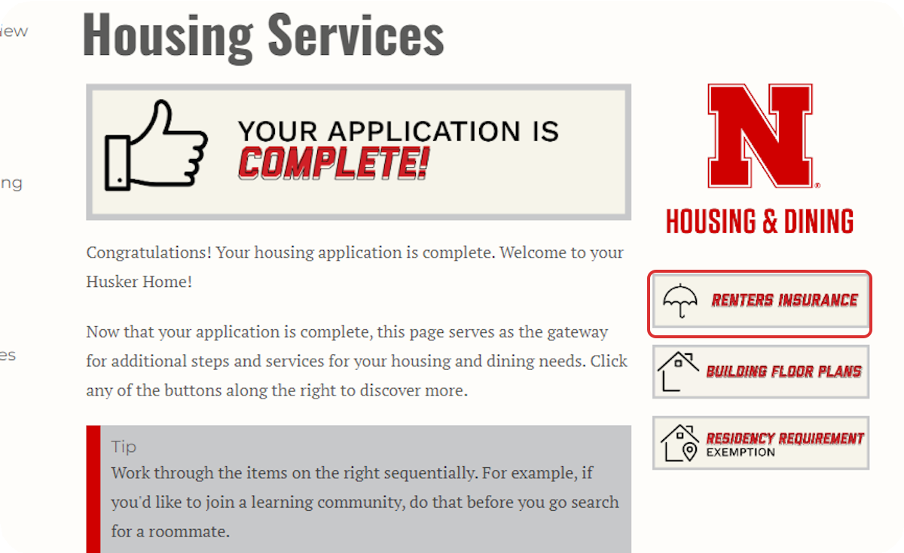
There will be different options to explore on the righthand side of the page depending on which application you are filling out and the time of year. Review and complete each option thoroughly as applicable to make sure you are ready to arrive on campus!

