

Step-by-Step Guide to Applying for Summer Housing and Meal Plans

 University Housing Portal 41 Steps

You can get to the Housing Portal by pasting the following link into your web browser: go.unl.edu/housing-portal


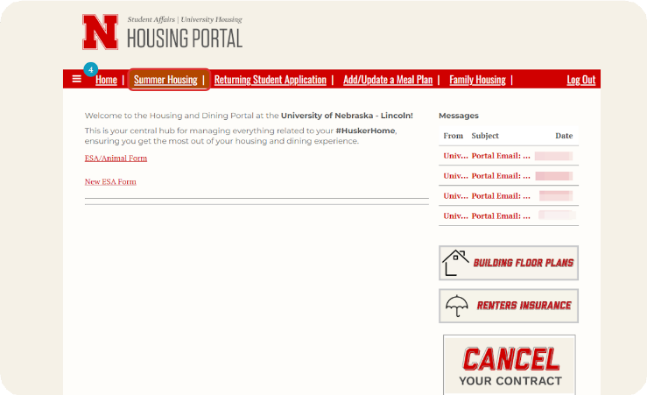
Click on Summer Housing at the top of the page.
1

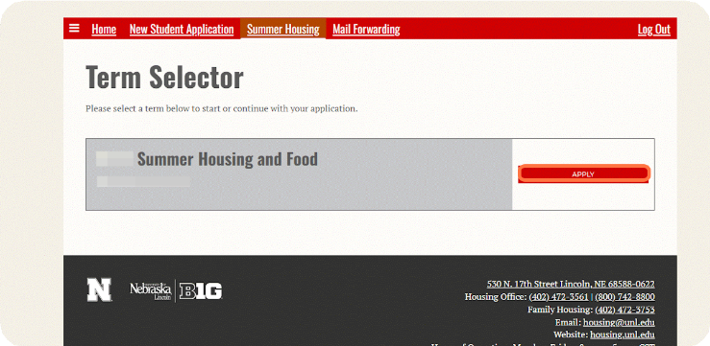
Click on Apply for 2026 Summer Housing and Food.

2


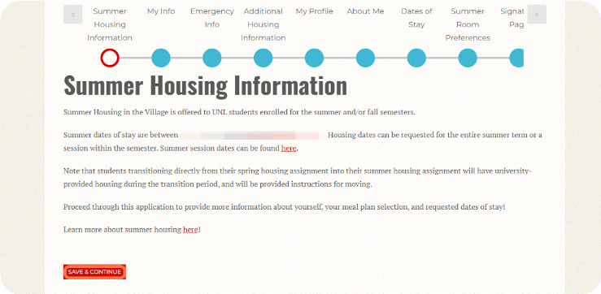
Review the Summer Housing Information section and then click on Save & Continue.

3

Review the personal information that was imported from MyRed into your Housing application. Provide Parent/Family Contact Information (Optional).
4
If any of the information is incorrect, you can update it in MyRed before returning to the housing application.
Optionally, you can answer the Name Pronunciation question if you would like to provide a more phonetic spelling of your name.
Provide Parent/Family Contact Information (Optional)
After confirming that all of the information on this page is correct, click Save & Continue to move to the next page.

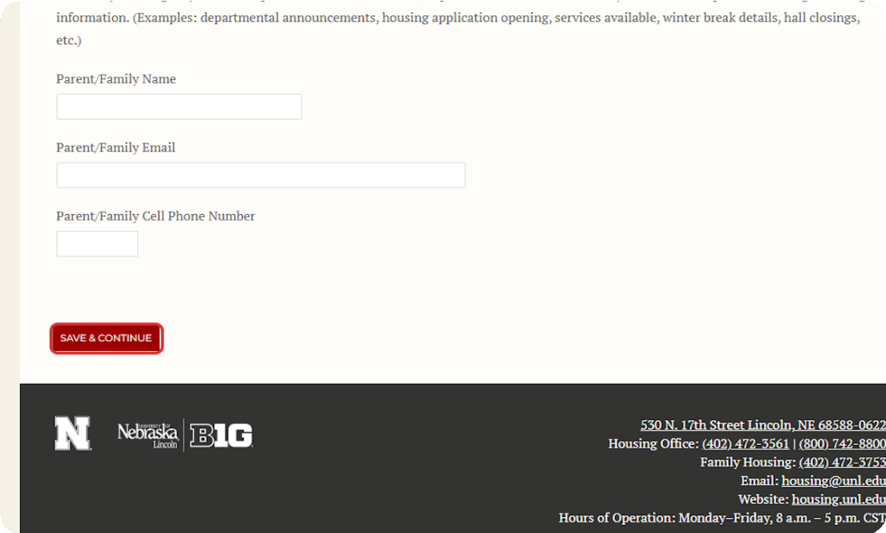

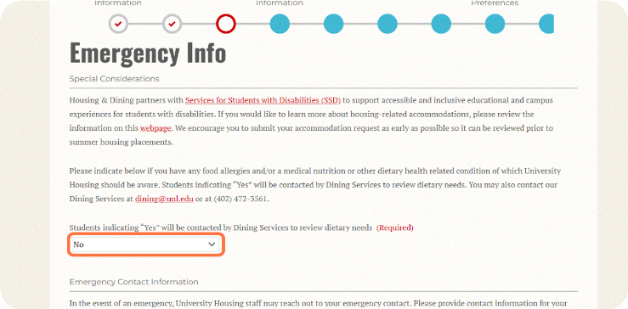
Add dietary considerations information.
5
If you have dietary considerations that the University should be aware of, please indicate this under the Special Considerations section.

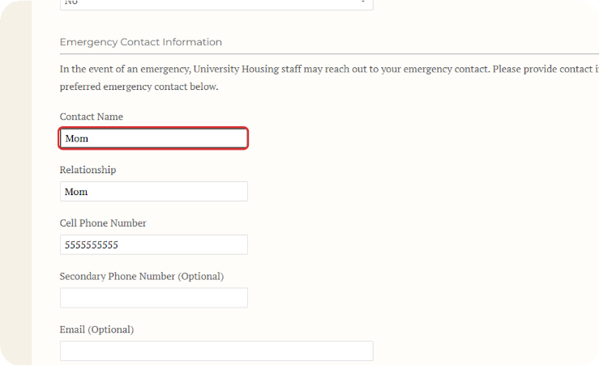
Add emergency contact information.
6
You must provide contact information for the person you would like us to contact in case of an emergency.
7
If you are under 18 years old, your emergency contact must be your parent or legal guardian.

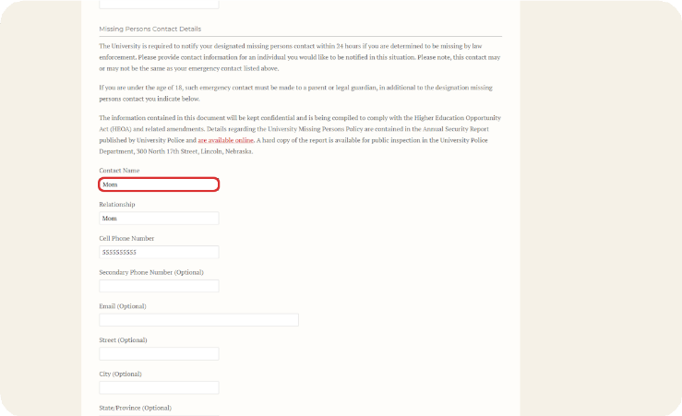
Provide Missing Persons Contact Information.

8
You must provide contact information for the person you would like us to contact in the event that you go missing. This could be the same person or a different person from your emergency contact.
If you are under 18 years old, your missing persons contact must be your parent or legal guardian.

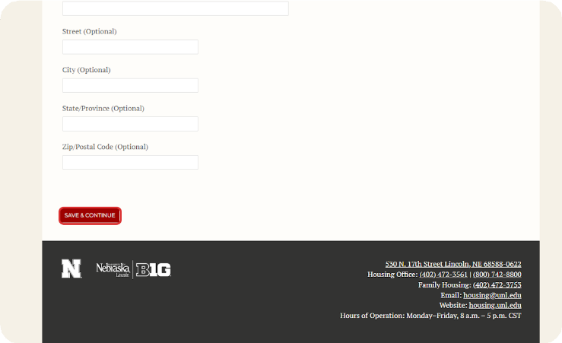
After providing your dietary considerations, emergency contact and missing persons contact, click Save & Continue to move to the next page.

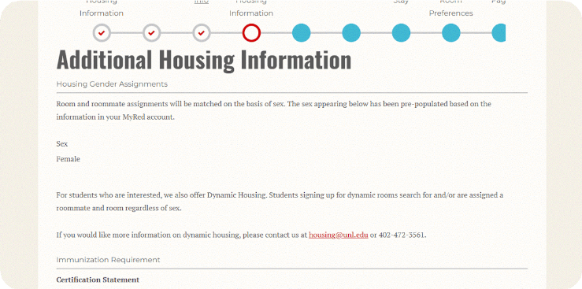
Read through the Housing Gender Assignments section.
9

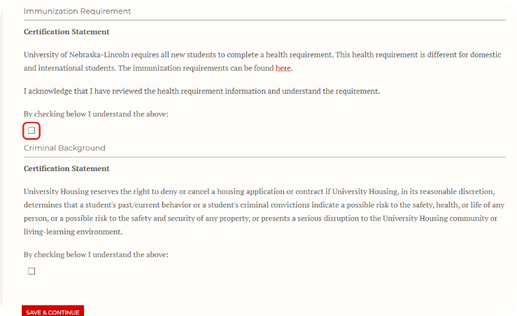
Read the Immunization Requirement Statement and check the box to agree.

10

11

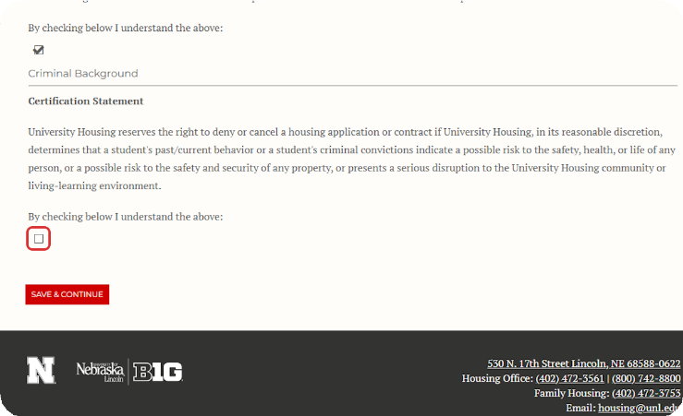
Read the Criminal Background Certification Statement and check the box to agree.

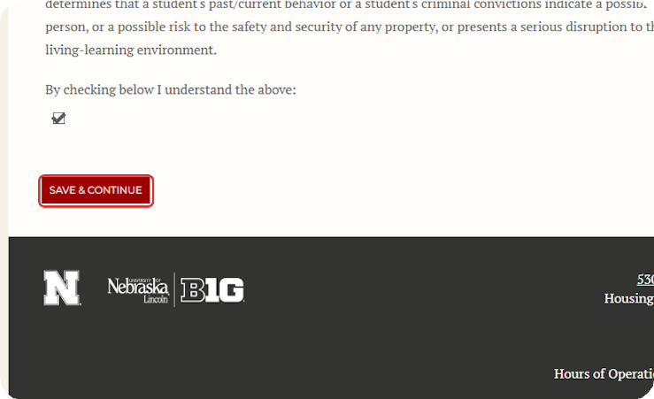
After reviewing the Housing Gender Assignments section and agreeing to the Immunization Requirement Statement and Criminal Background Certification Statement, click Save & Continue to move to the next page.

13
12

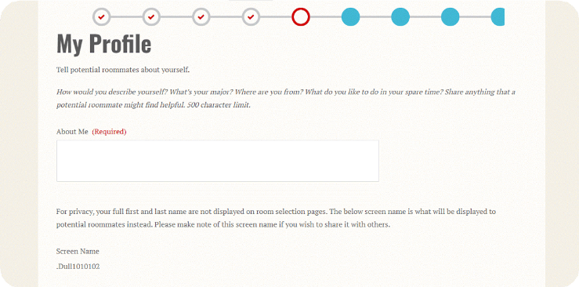
Fill Out Your Roommate Profile.
This gives you an opportunity to share a little bit about yourself to help you be matched with the best possible roommate.

14

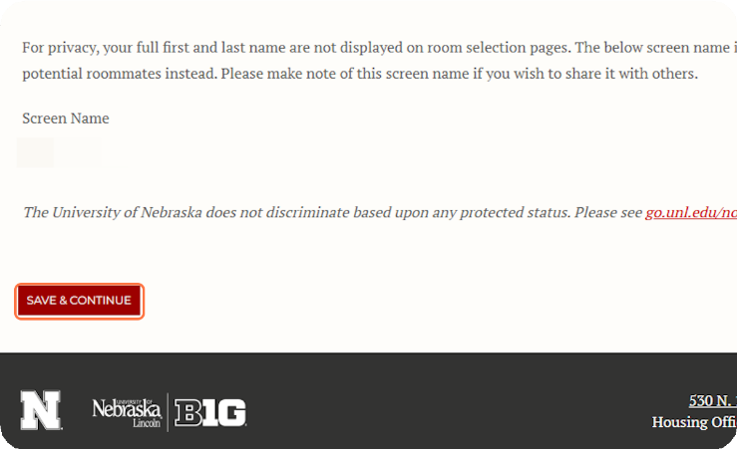
After completing your roommate profile, click Save & Continue to move to the next page.

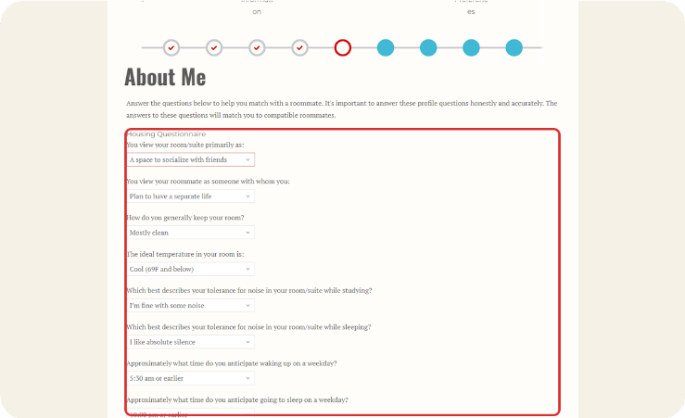
Fill Out the Roommate Matching Questionnaire.
15
These questions about your lifestyle and preferences for your room and roommates will help us to match you with the roommates that will be a good fit for you.

16
You must answer all of the questions.

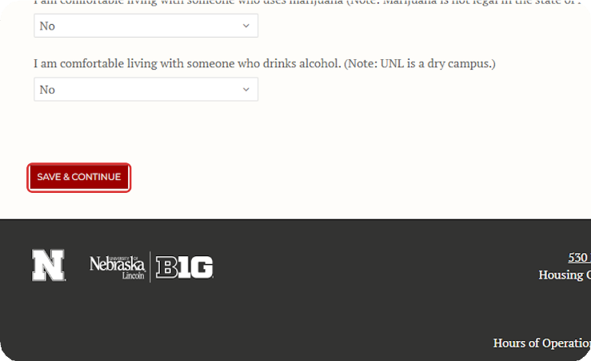
Click on Save & Continue.
After completing all of the roommate matching questionnaire, click Save & Continue to move to the next page.

17

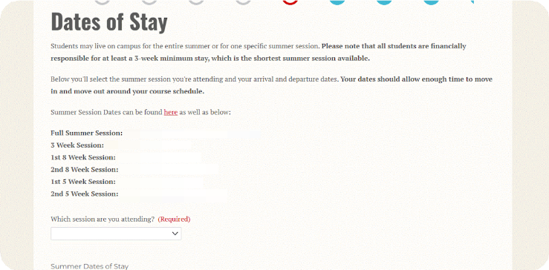
Select which session you are planning to attend for Summer Housing.
Students staying in Summer Housing are responsible for the payment of the duration of their stay no less than the 3-week minimum (the shortest summer session available).

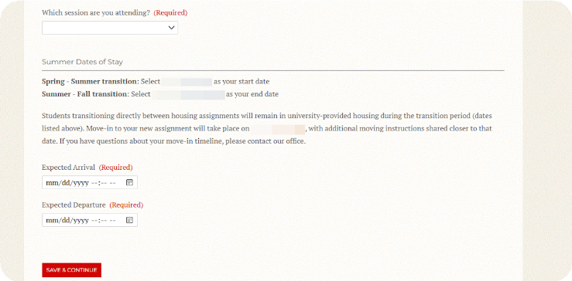
Select your Summer Dates of Stay. Be sure to include the correct day you plan to come and the correct day you plan to move out. Helpful dates are above on the same page.

19
18

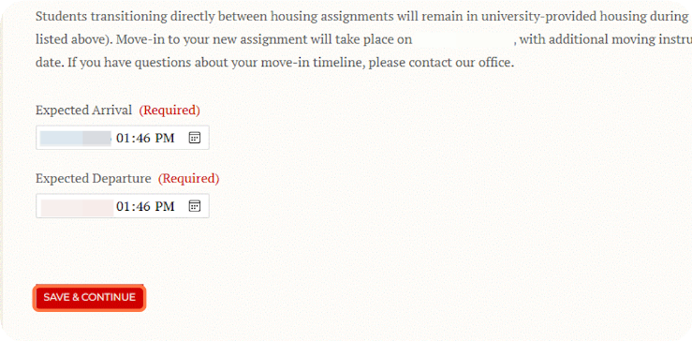
Once you have selected your Dates of Stay, click on Save & Continue.

20

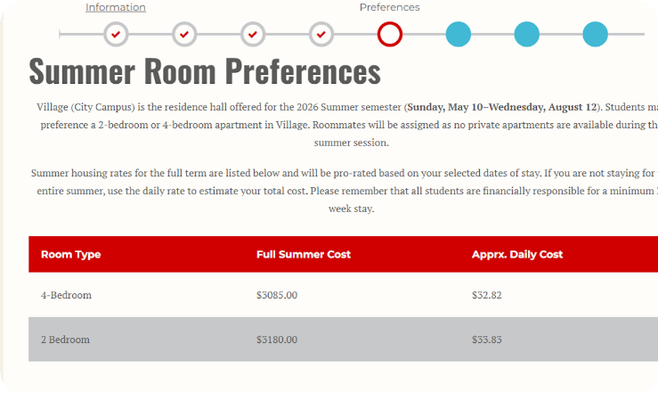
Select your Summer Room Preferences.
After reading through the information on the page, decide if you'd rather stay in
a 2-bedroom apartment or a 4-bedroom apartment.

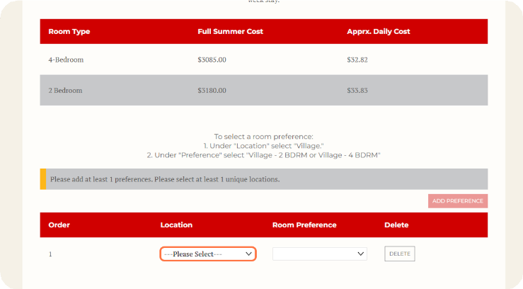
Select Your Building.
21
Under "Location" click on the Please Select drop down menu and select The Village.

22

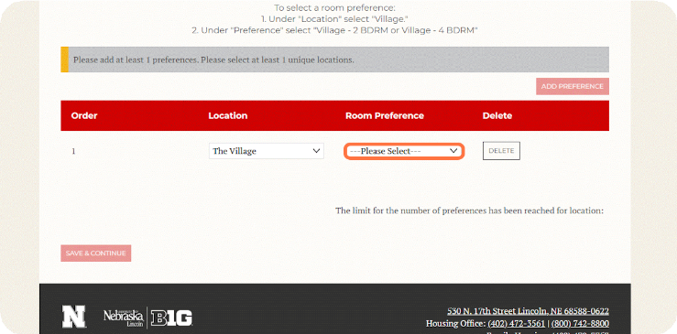
Select Your Apartment Type.
Under "Room Preference" click on the Please Select drop down menu and select either "The Village Apt. Style - 2 BDRM" or "The Village Apt. Style - 4 BDRM".

23

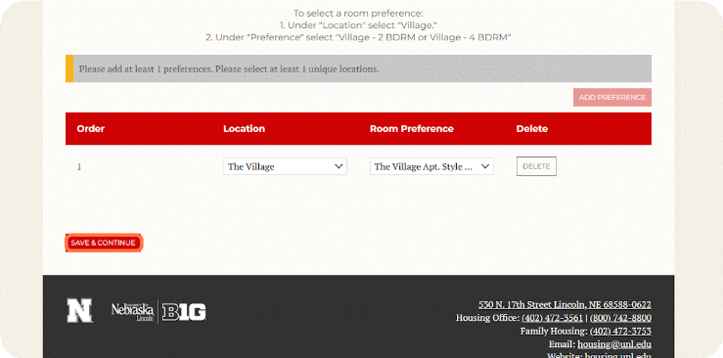
Once you have selected your apartment type under "Room Preference", click on Save & Continue
.

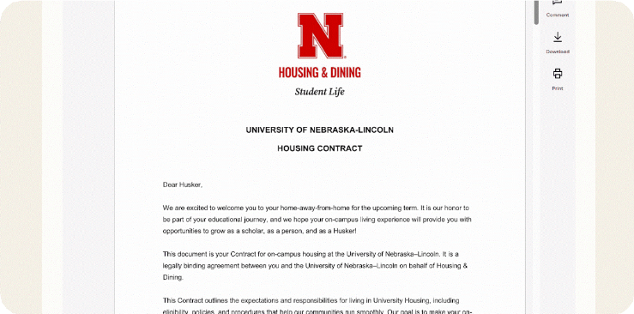
Review the Housing Contract in full.
24

25
Be sure to read through the entire contract so you understand what's included in the contract.

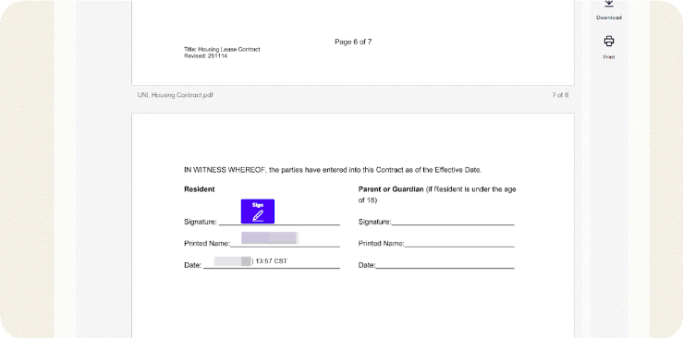
Sign the Housing Contract.
Click "Sign" and complete your signature. Your printed name should auto-fill along with the date and time. If you are under the age of 18, your parent or guardian will also need to sign the contract.

26

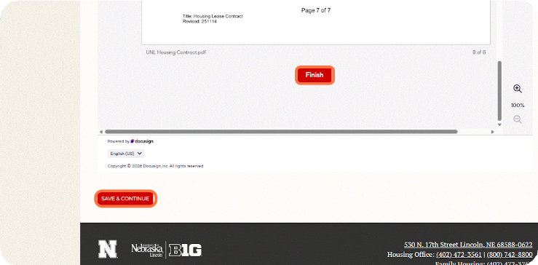
Click "Finish" and then "Save & Continue". You will receive an email that your document has been signed and completed once you click "Finish". If you are under 18, you will receive an email that your document has been signed and completed once your parent or guardian signs.

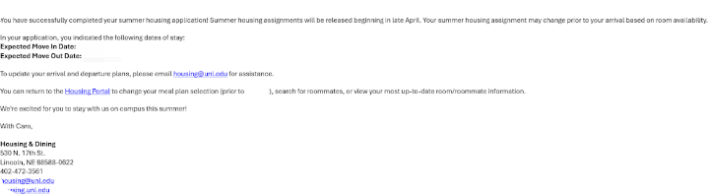
Application Completion Email.
27
Once you click "Save & Continue" after signing the Housing Contract, you will receive a confirmation email. Please review it carefully to ensure all information is correct.

28

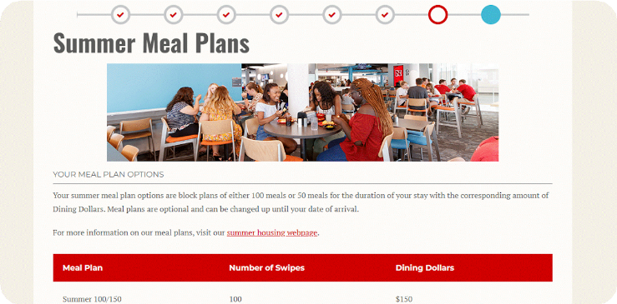
Next is selecting your summer meal plan.

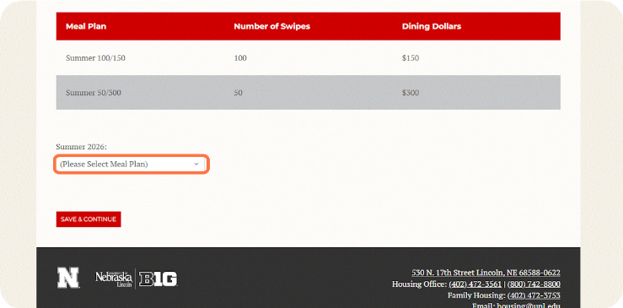
Pick Your Meal Plan.

29
Decide if you want the Summer 100/150, the Summer 50/300, or No Meal Plan. Under the Summer 2026: section, click on "Please Select Meal Plan" for the drop-down menu to select your chosen meal plan.

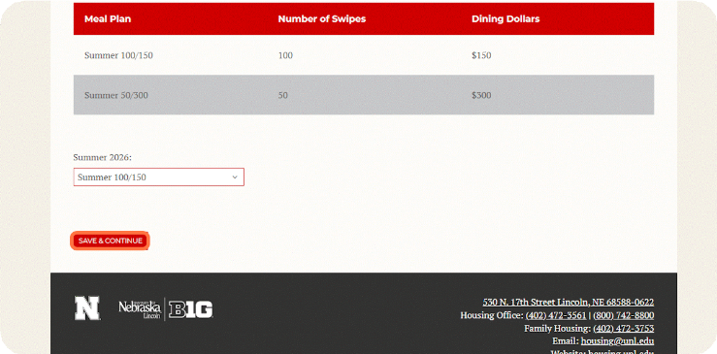
Click "Save & Continue".
30
Once you pick the meal plan that's right for you, click "Save & Continue".

31

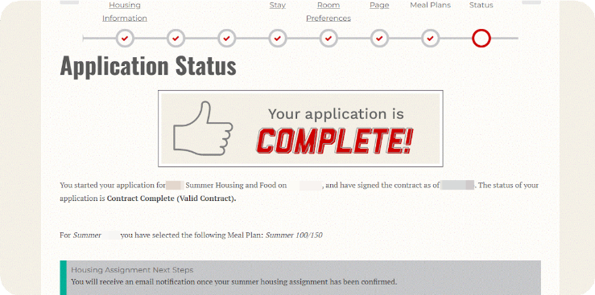
Application Complete.
Congratulations! You've completed the summer housing application by signing the contract and selecting a meal plan. If you don't have a roommate preference, you can stop here. If you do have a roommate preference, please complete the next steps so we can assign you with your friend.



