

Step-by-Step Guide to Applying for Summer Housing Roommates

 University Housing Portal

You can get to the Housing Portal by pasting the following link into your web browser: go.unl.edu/housing-portal

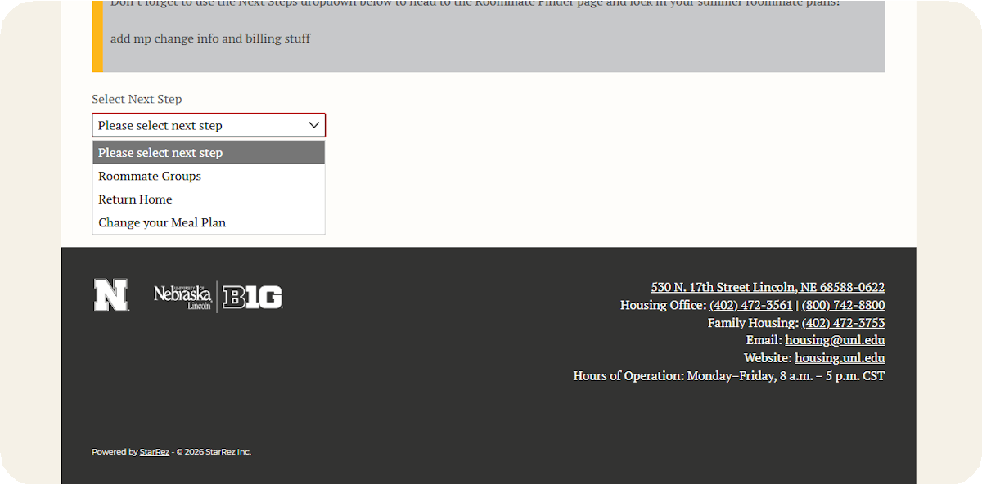

Select Your Next Step.
1

After completing the room and meal plan portion of the Summer Application, you will see a drop-down menu. From this drop-down menu, you can either form a roommate group, return to the Home page, or change your Meal Plan.

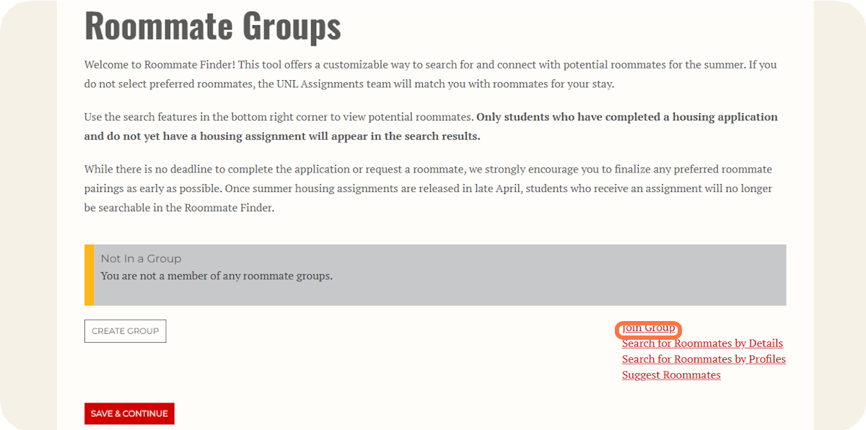
It’s time to find a roommate!

2

If you know who you want to live with and they have already created a roommate group, click Join Group. You should be able to get all necessary information from the roommate Group Leader to find and join the group.

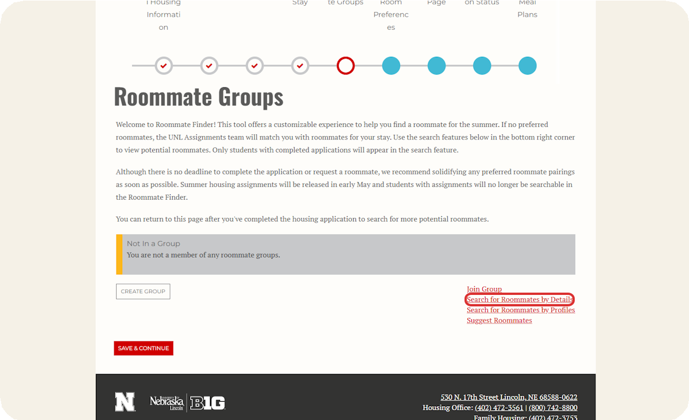

To find a roommate that you already know, click on Search for Roommates by Details.

3

Search for specific roommates by information, such as their name or NUID number.
4
Screen name is not the student's actual name. It is the username that was automatically generated for the student by the Housing Portal to be used for the roommate finder.
The most accurate way to search for other students you know is to search them by NUID number. When you have added the information you would like to search by, click Search. Your search results will appear at the bottom of the page.
The roommate finder will not display the student's name, only the screen name as
signed to them for the roommate finder. You may need to ask your friend to log into the housing portal and verify that the screen name is correct.
Clicking View Profile in the search results will allow you to view the student's answers to the roommate matching questionnaire.
The percentage match can be a helpful tool to see compatibility at a glance, but we recommend you view the other student's profile to look at their specific answers to the roommate matching questions and how they line up with your own.

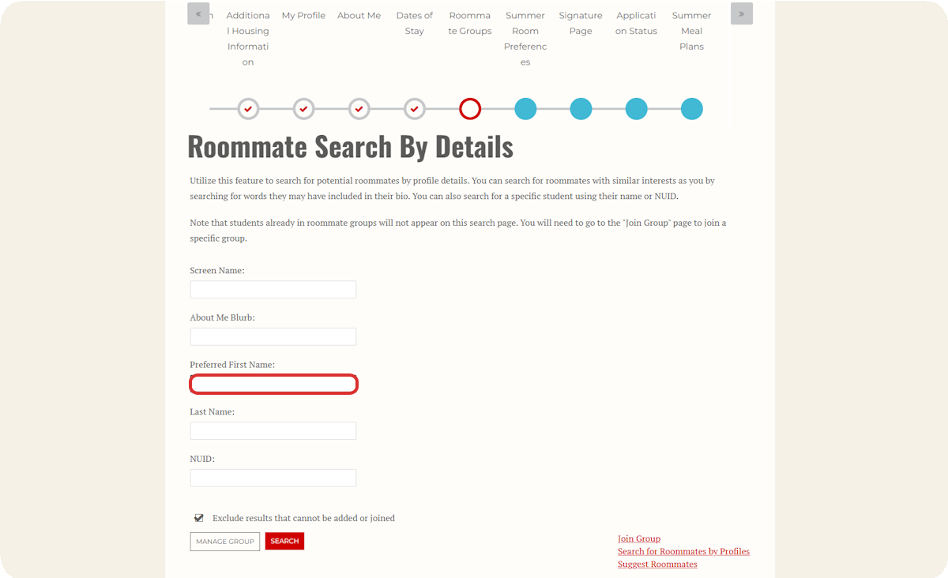

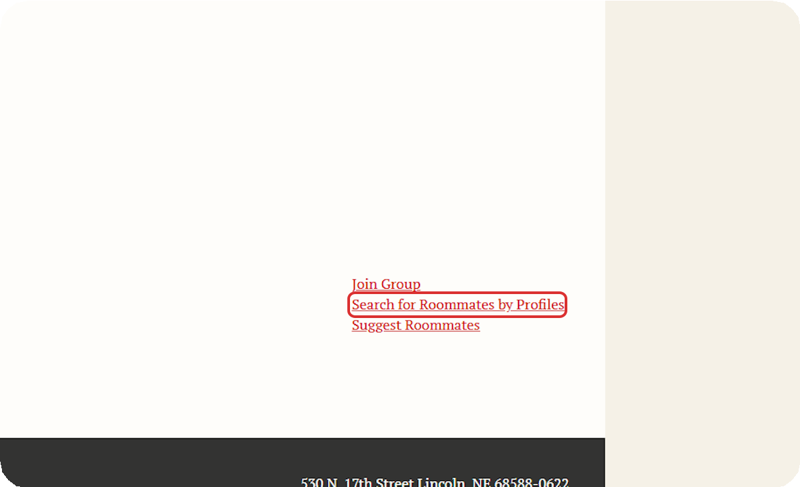
You Can Also Search for Roommates by Profiles.
5
The Search for Roommates by Profiles function will allow you to search for roommates based on specific answers to the roommate matching questions. For example, if you know that it is very important to you that your room be a private space without many guests, you can search based on the question "You view your room/suite primarily as:" and filter down to students who answered, "A private space to study and relax.
6

Use the dropdown menus to specify your search criteria.

By default when you arrive on this page, the search will be set to show students with any response to all of the questions. You can use the dropdown menus to specify answers to as many or as few of the questions as you would like. We recommend selecting only one or two options that are very important to you as this can really limit the roommate options you see.

After adding your criteria, Click on Search. If you are not seeing any matches, that's okay! Just decrease the amount of filters you are using or try searching for a roommate another way. Remember that people may be compatible with you but have slightly different answers that would make them not show up if you are filtering for very specific answers to multiple questions.

Any potential roommates matching your search criteria will be at the bottom of the page. The roommate finder will not display the student's name, only the screen name assigned to them for the roommate finder.

Clicking View Profile in the search results will allow you to view the student's answers to the roommate matching questionnaire.

The percentage match can be a helpful tool to see compatibility at a glance, but we recommend you view the other student's profile to look at their specific answers to the roommate matching questions and how they line up with your own.

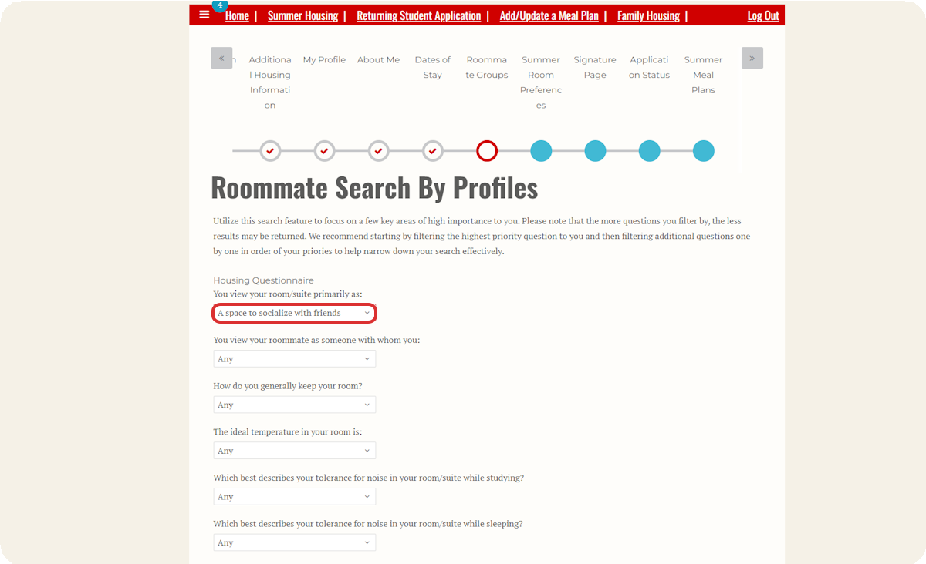

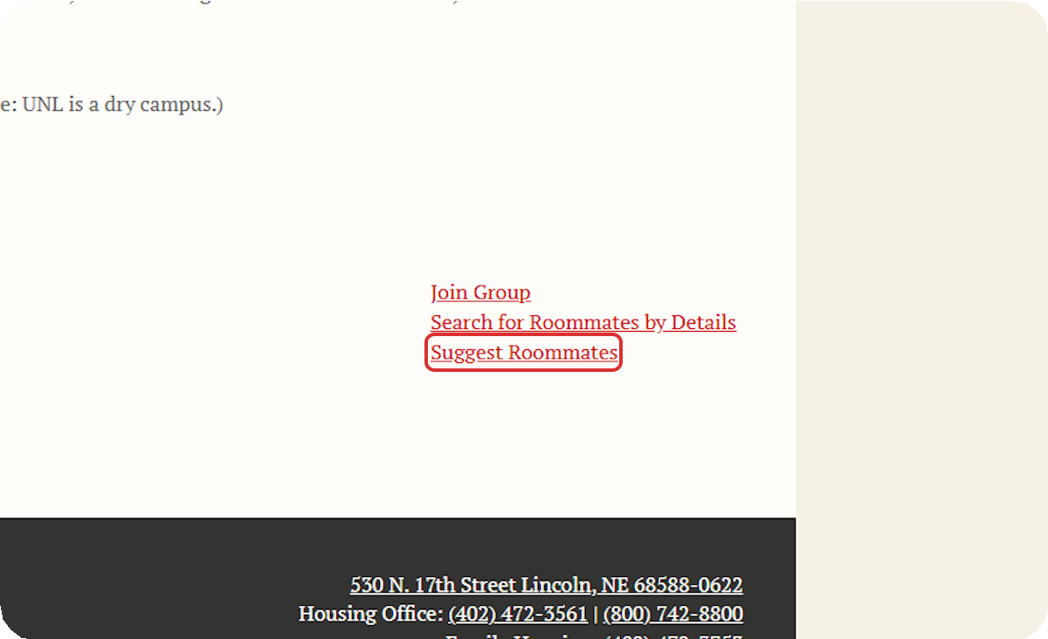
Another option for finding potential roommates is the Suggest Roommates function. Clicking on this will show you some roommates who could be a good match for you based on the percentage match of your answers from the roommate matching questionnaire in the application.

7

Review Potential Matches.
8
When looking at potential roommates in the roommate finder, there are a few things to keep in mind.
The roommate finder will not display the student's name, only the screen name assigned to them for the roommate finder.
Clicking View Profile in the search results will allow you to view the student's answers to the roommate matching questionnaire.
The percentage match can be a helpful tool to see compatibility at a glance, but we recommend you view the other student's profile to look at their specific answers to the roommate matching questions and how they line up with your own.

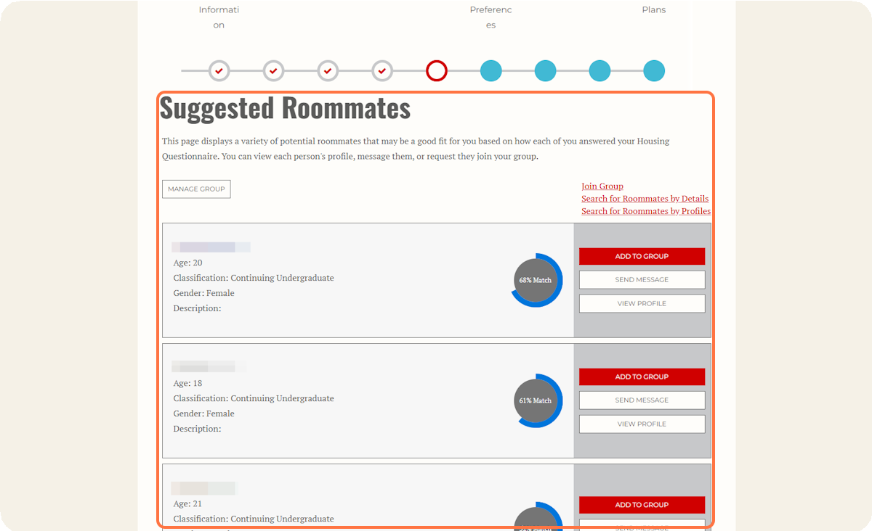

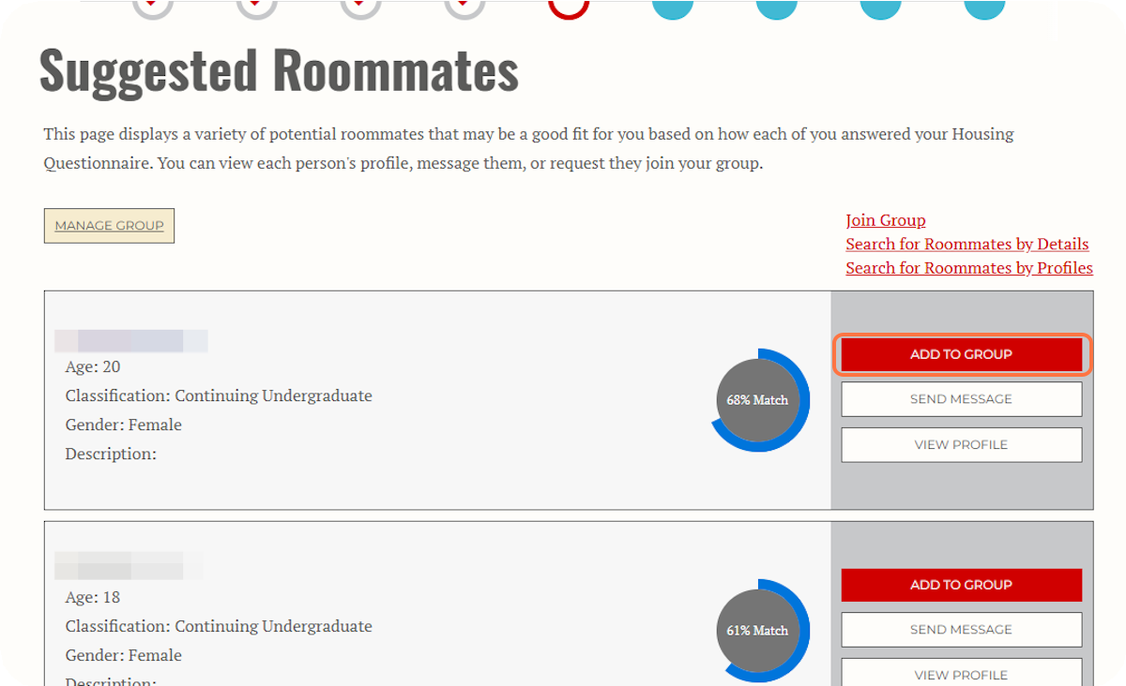
After verifying that you have found the roommate you want, click on Add to Group.
9
Clicking Add to Group will send the other student a notification that they can join your roommate group.

10
The other student must log into the Housing Portal to accept the request in order for you to successfully create a roommate group.

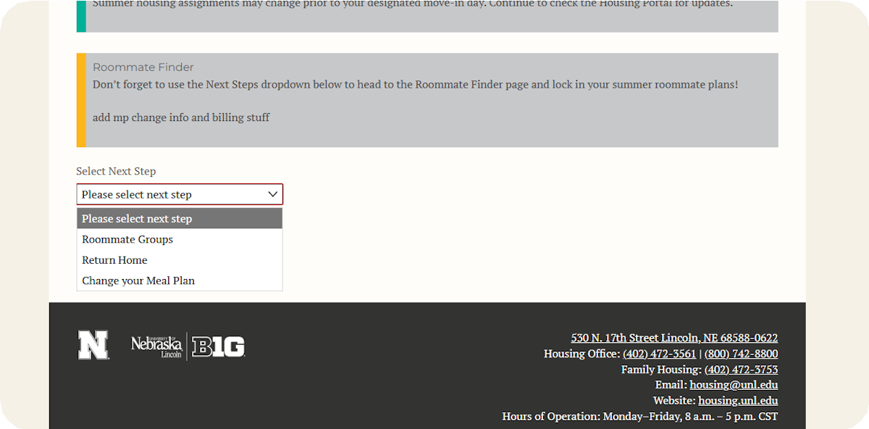

If you do not want to select a roommate for the summer, you do not have to. The Housing Assignments team will place you with a roommate based on available space and good roommate match.

To skip this section, simply close out of the application or choose a different option on the Application Status page. You can always access the Application Status page by going back into your Summer Housing application.

