

First Year Housing Application

 University Housing Portal 34 Steps


Log into the Housing Portal and Click on New Student Application at the Top of the Page.
1

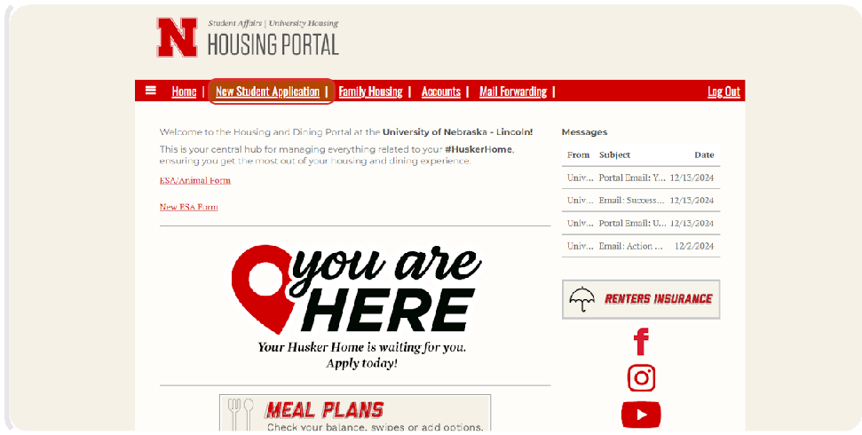


Click on Apply for the Academic Year.
2

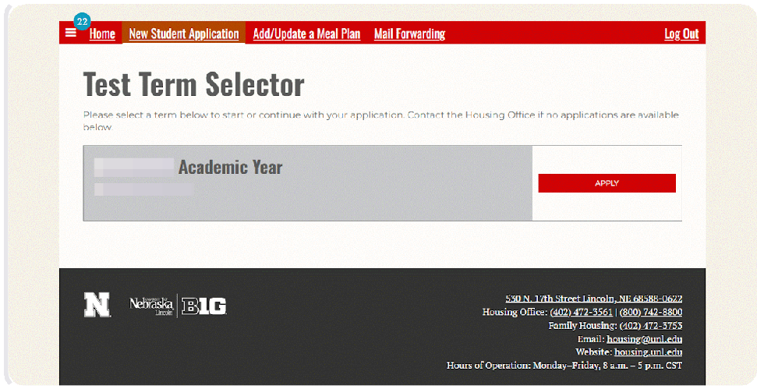

Read the Application Overview and Then Click "Continue".
3
This page will give you an overview of what to expect in the application.

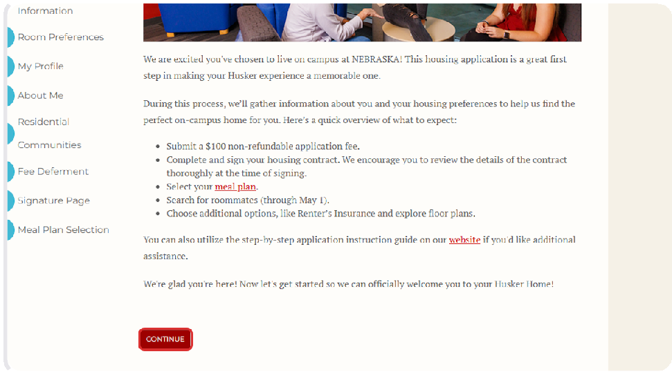

Review Your Personal Information.
4
This page will display the personal information and home address that you provided in your application to UNL. If any information has changed or is incorrect, you can update this information in your MyRed profile using the link on this page. You can optionally use the name pronunciation box to provide a phonetic spelling of your name if you would like.

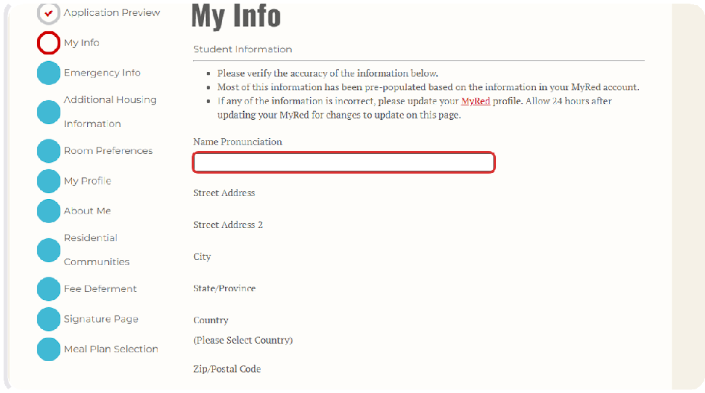

Add Parent/Family Contact Information (Optional).
5
If you would like your parent or family member to receive updates about housing processes, you can provide their contact information here.

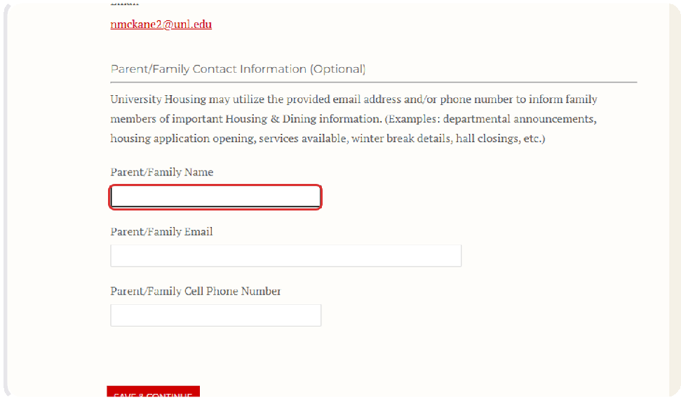

After reviewing your information and adding your parent's information, Click on Save & Continue.
6

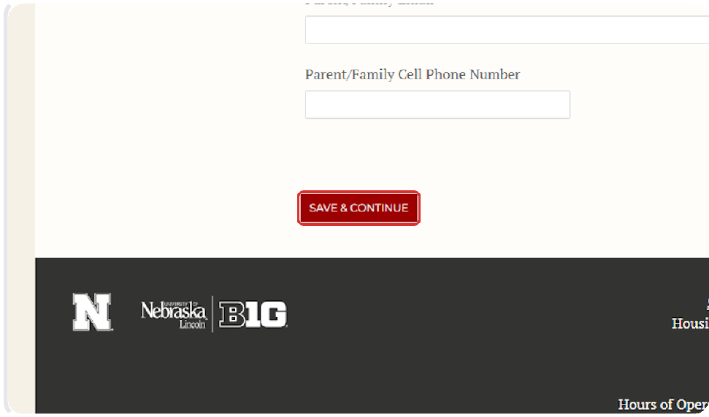

Review Accommodations Information.
7
Students with a disability or health condition that may require specific housing accommodations can submit a request to the Services for Students with Disabilities (SSD) office. We recommend that students submit this request by April 1st.
Students with dietary restrictions who need additional information about on-campus dining options can contact Dining Services. Use the dropdown menu to indicate whether you would like a staff member from dining services to reach out to you or not.

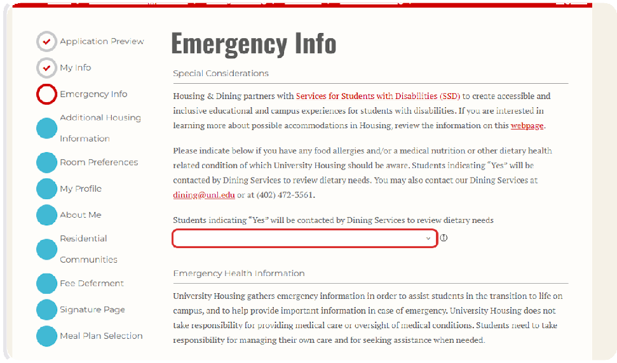

If you would require any particular assistance in the case of an emergency, use the boxes on this page to provide that information (Optional).
8

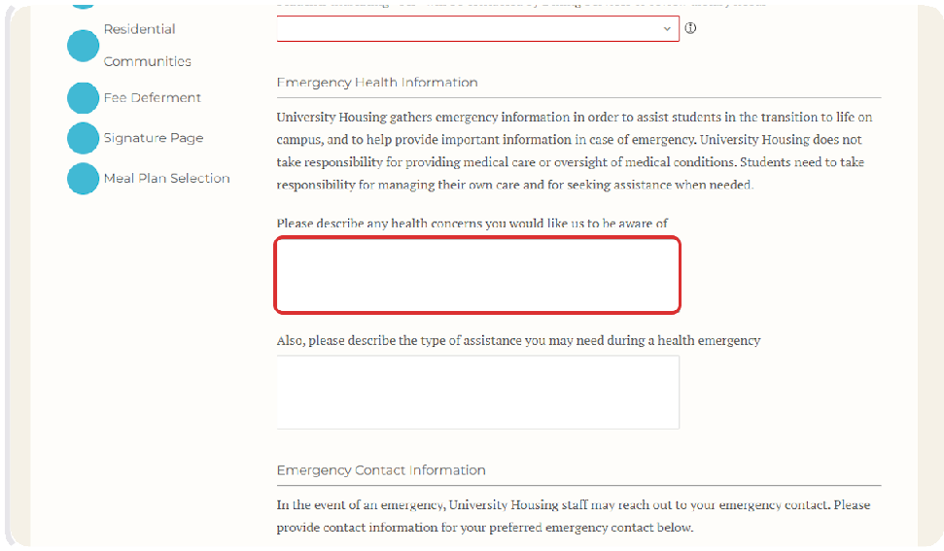

Add Emergency Contact Information.
9
Provide the name and contact information of the person who you would like to be your emergency contact.

Students under 18 years old must submit a parent or guardian as their emergency contact.

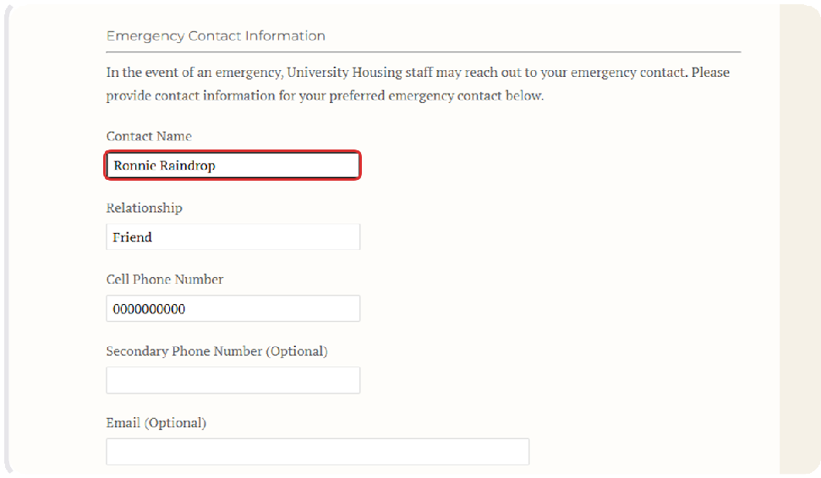

Add Missing Person Contact Information.
10
Provide the name and contact information for the person you would like us to contact if you were determined to be missing by law enforcement.

This can be the same person or a different person from your emergency contact. Students under 18 years old must submit a parent or guardian as their missing person contact.

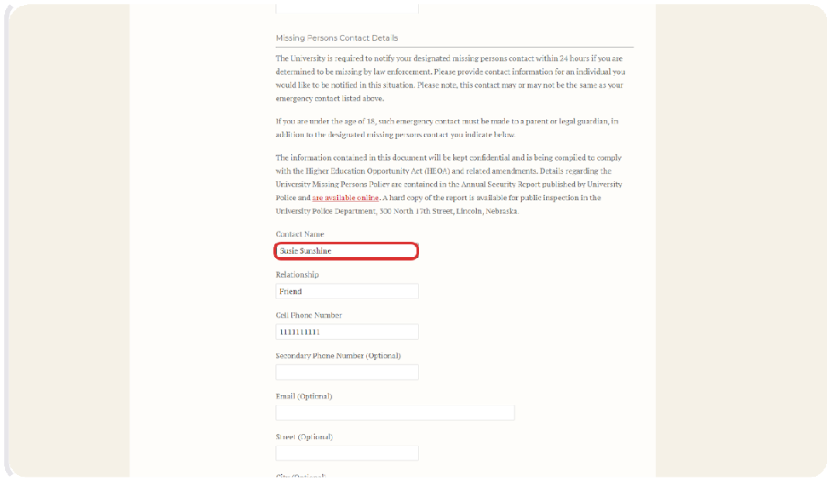

After providing emergency and missing person contact info, Click on Save & Continue.
11

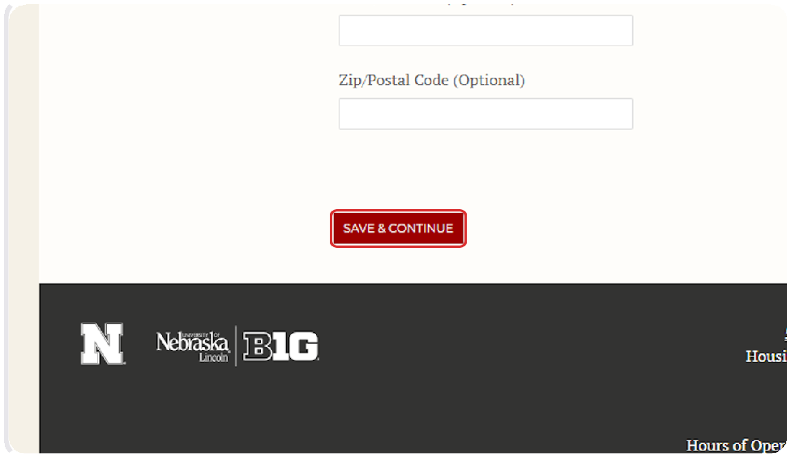

Indicate whether you would like to live in Dynamic Housing.
12
This page will display the sex that is listed on your application to the university.
If you select "No", then you will not be in Dynamic housing. This means that your roommate(s) will be the same sex as you.
If you select "Yes", then you will be placed in Dynamic housing, meaning that your roommate(s) could be someone of any sex.

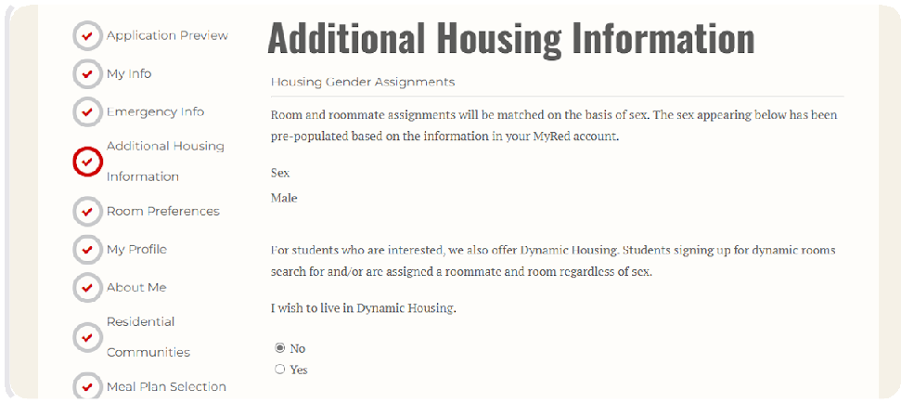

Review and Acknowledge the Immunization Requirement.
13
By checking the box, you are acknowledging that you understand the university's immunization requirement.

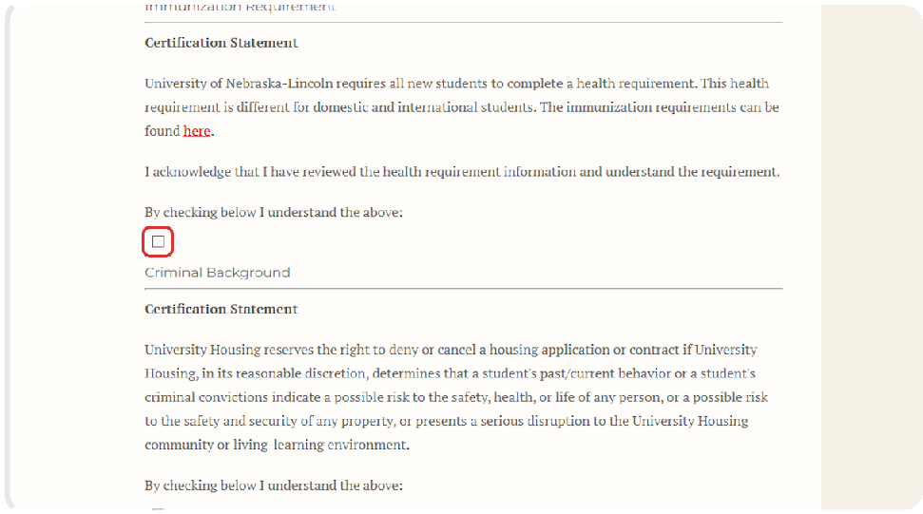

Review and Acknowledge the Criminal Background Certification Statement.
14
By checking the box, you are acknowledging that you understand the certification statement.

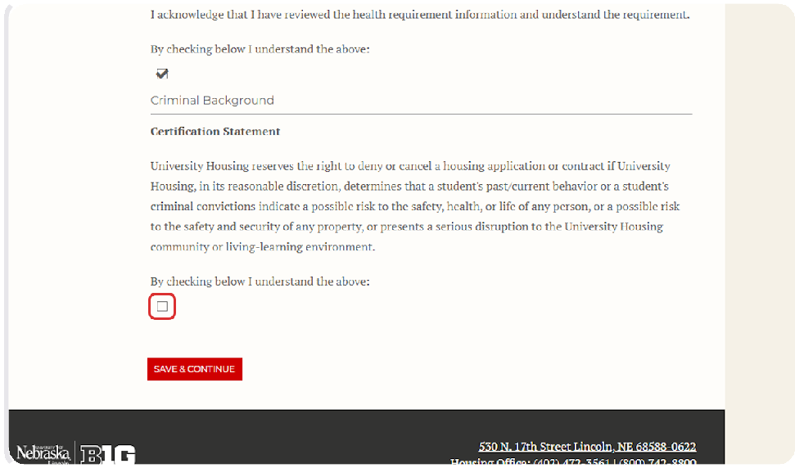

Click on Save & Continue.
15

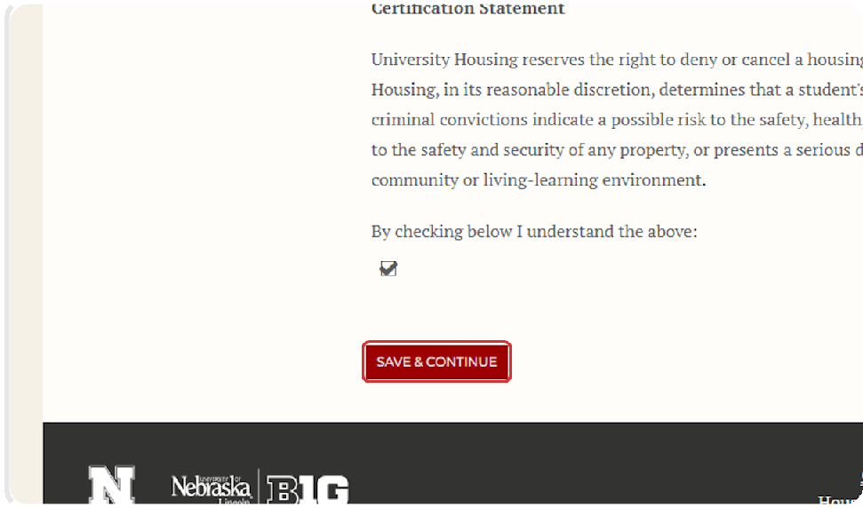

Review and Accept the Dynamic Housing Community Agreement (Dynamic Housing Students Only)
16
If you opted-in to Dynamic Housing on the previous page, you will be directed here to review the expectations of students living in Dynamic Housing. After reading the agreement, you can check the box to agree, then click Save & Continue to move to the next page.
If you read the Dynamic Housing community agreement and do not agree, then you can use the navigation menu on the left side of the screen and click "Additional Housing Information" to return to the previous page and opt out of Dynamic Housing.

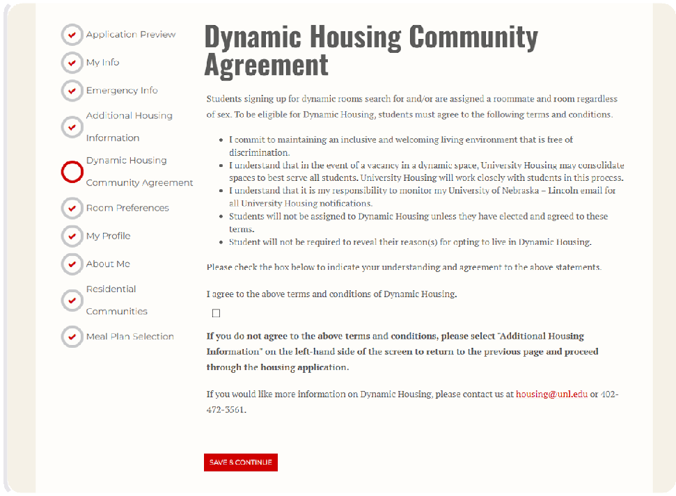

Add Room Preferences.
17
Utilize the drop-down menu under Location to select your most preferred building. Utilize the drop-down menu under Room Preference to select your most preferred room type in that building.
You can find some information about the building and room type options at the top of this page of the application. You can find additional information about housing options at the following website: Residence Halls
Students cannot list suite-style buildings in their room preferences, because space in suite-style buildings is reserved for students who are a part of the honors program, a learning community, or athletics. Students who are eligible for space in a suite-style building will be placed there regardless of the preferences listed here.

You can indicate interest in honors housing or apply for a learning community after you have submitted your housing application.

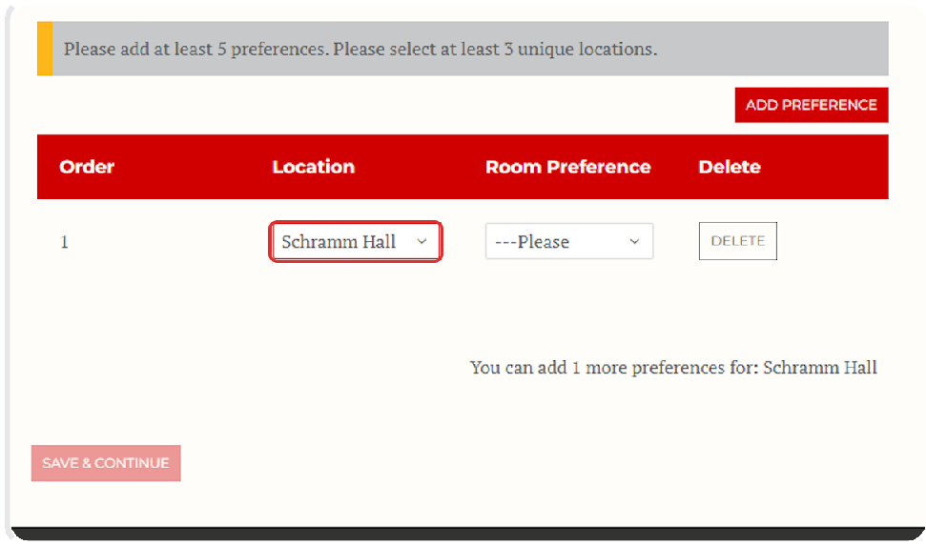

Click on Add Preference to Continue Adding Room Preferences.
18
You must rank at least your top five preferences for buildings and room types. You can continue to list additional preferences if you like.

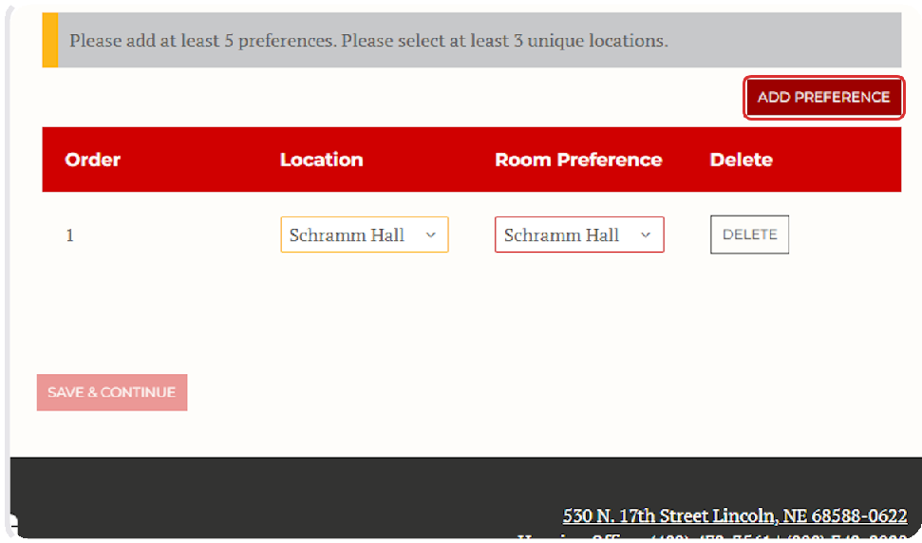

After Adding Room Preferences, Click on Save & Continue.
19

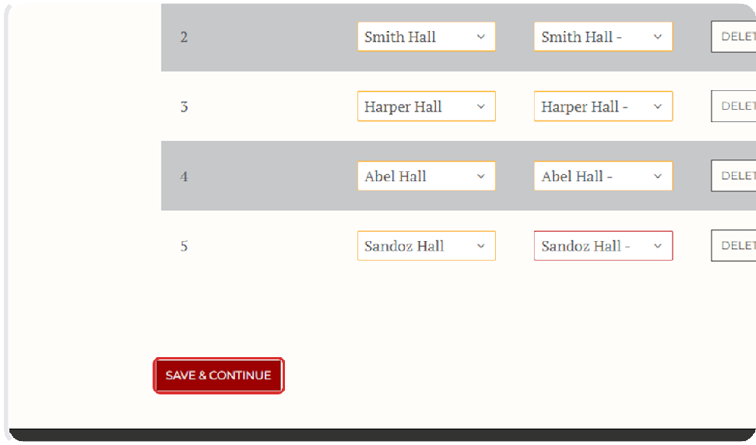

Fill Out Your Roommate Matching Profile.
20
Provide a brief description of yourself and your interests. This will be displayed in the roommate finder to help you search for potential roommates who could be a good match for you.

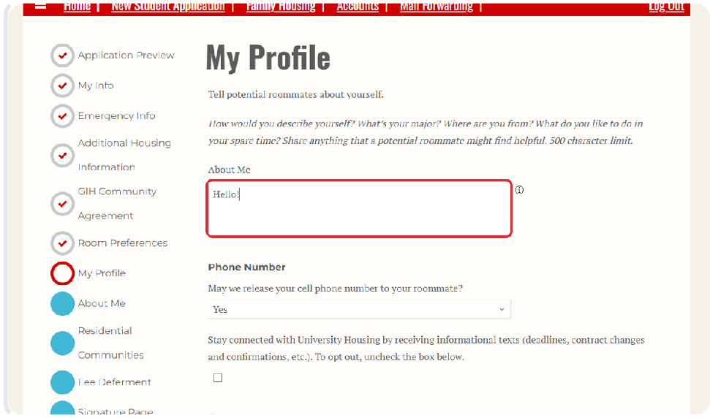

Click on Save & Continue.
21

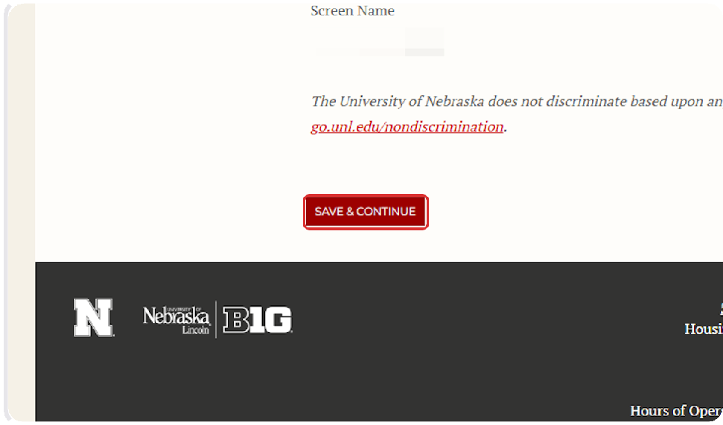

Respond to the Roommate Matching Questionnaire.
22
This page includes a variety of questions about how you like to live and what you are looking for in a roommate. We encourage students to answer honestly, not idealistically, in order to help us match you with the best possible roommate.

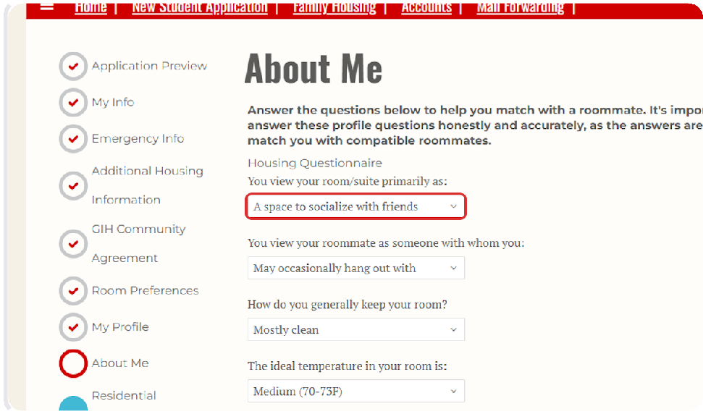

After answering all of the questions, Click on Save & Continue.
23

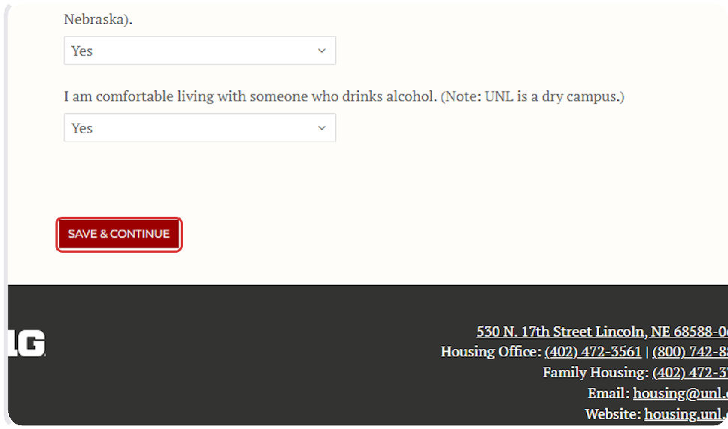

Review and Agree to the Statement about Residential Communities.
24

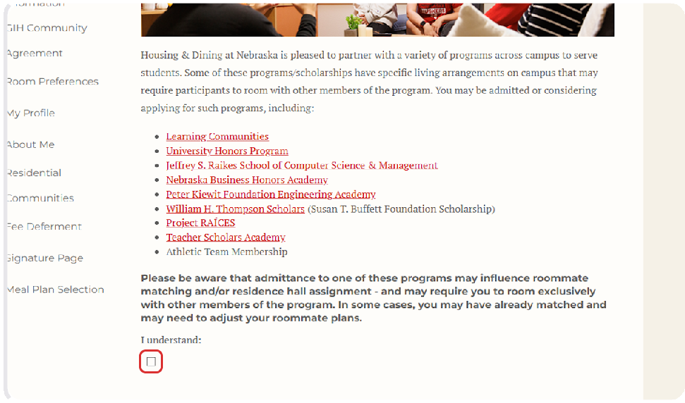

Click on Save & Continue.
25

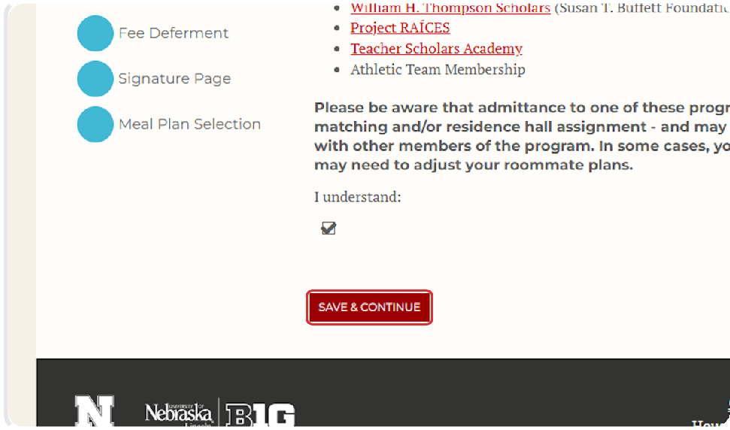

Pay Your Housing Application Fee (Option 1)
26
For most students, you will reach the "Shopping Cart Checkout" page where you will see the $100.00 application fee.

Click Pay Now to navigate to the CashNet website and pay the fee.
If your Enrollment Deposit was deferred by the office of Admissions when you were accepted to UNL, your housing application fee will also be deferred, and you can skip to step 28 of this guide.

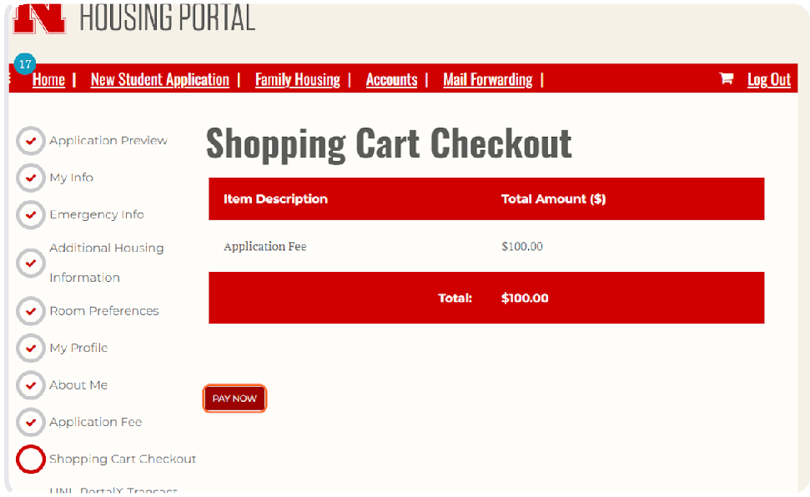

Pay the Housing Application Fee (Option 1)
27
On the CashNet website, you will enter your credit or debit card information to pay the
$100.00 housing application fee.

After paying the fee, you will automatically return to the housing portal to complete your housing application by proceeding from step 30 of this guide.

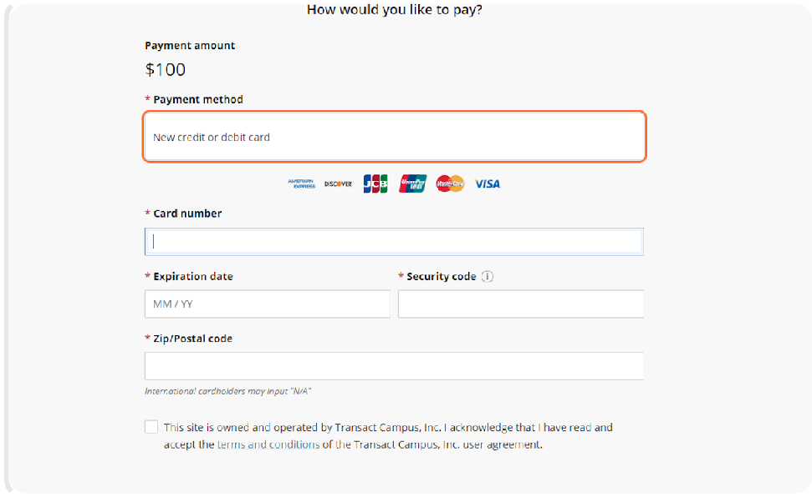

Defer Your Housing Application Fee (Option 2)
28
If your Enrollment Deposit was deferred by the office of Admissions, then your housing application fee will also be deferred. That means that, instead of paying the fee when you complete the application, the fee will be added to your Fall bill for you to pay at the start of the semester.

The fee will be charged to you even if you end up not living on campus or not attending UNL.
Review the Deferment Agreement and Use the Checkbox to Agree.

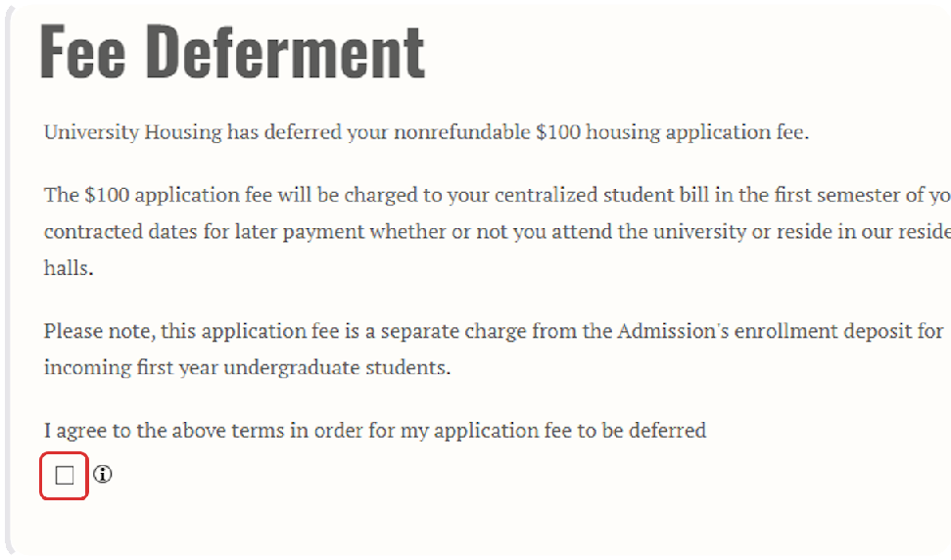

Defer Your Housing Application Fee (Option 2)
29
Enter Your NUID as a Signature in the box below the deferment agreement. Then click Save & Continue to Proceed.

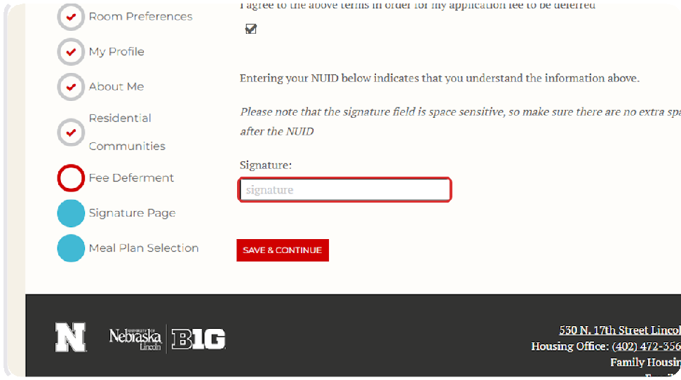

Provide Guarantor Information (Under 18 Years Old Only)
30
Students under 18 years old must provide information for a parent or guardian who will sign the housing contract along with the student.
If you are 18 years or older, you will automatically move to the next page.

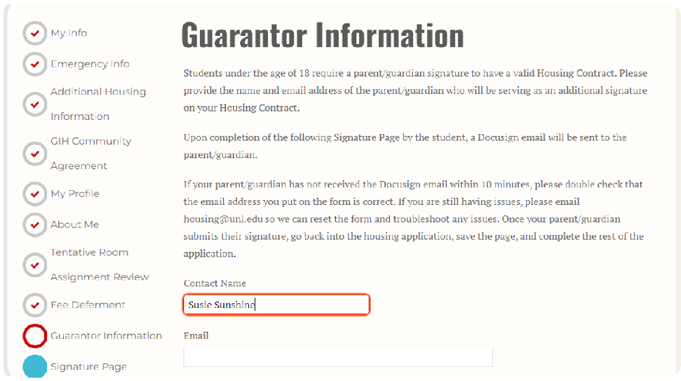

Review and Sign the Housing & Dining Agreement.
31
You may have to click a yellow button toward the top of the page to get the agreement to appear. Please read through the agreement as well as the linked information on our website, and feel free to reach out with any questions before signing!

After reading the agreement, click the "I Agree" checkbox at the bottom of the page, and click the signature line to add your electronic signature.

Click the yellow "Finish" button and the red "Save & Continue" to move forward with the application.
For students under the age of 18, the agreement will be sent to your guarantor at the email you provided before you will be able to proceed with the application.

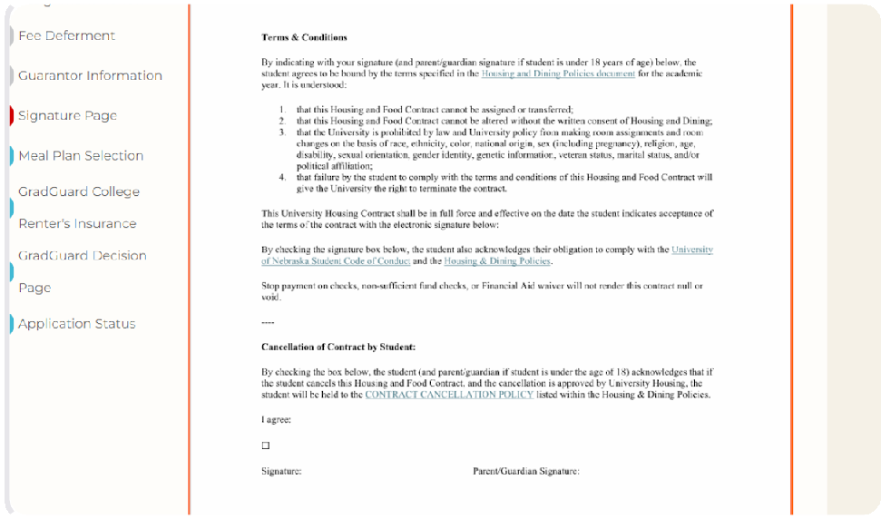

Select a Meal Plan from the Drop-Down Menu.
32

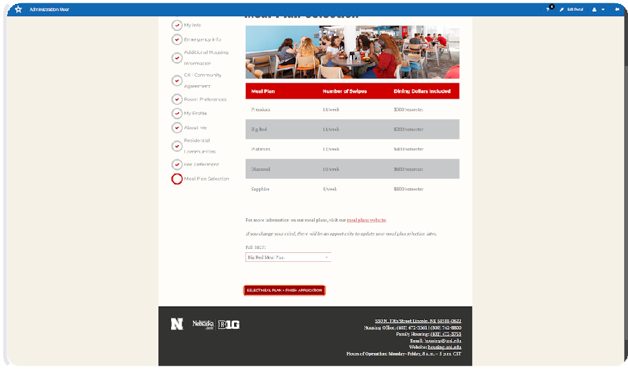

Click on Select Meal Plan + Finish Application.
33

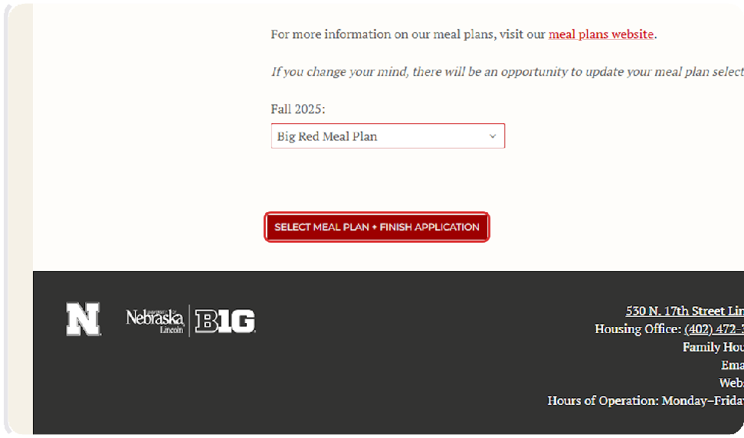

Your Application Is Complete!
34
After selecting your meal plan, your application is complete, and you will be returned to the home page of the housing portal.

You will also receive a confirmation email stating that you have completed your application.
You can use the buttons on the right side of the screen to explore additional options such as applying for a learning community, exploring the roommate finder, or purchasing renter's insurance.

