

First Year Application - Forming a Roommate Group

 What Is the Roommate Finder?

The Roommate Finder allows you to browse other students who have completed their housing application and look at your compatibility based on the questions you answered in your application. You can use the Roommate Finder to search for a specific person who you know you would like to live with, or you can browse other students who seem to be most compatible with you to find someone new.
Forming a roommate group is optional. If you do not form a roommate group, then you will be randomly assigned to a roommate who seems to be compatible with you based on your answers to the roommate matching questions in the application.

Who Can I See in the Roommate Finder?

If you have opted to live in Honors Suites, you will only be able to see other roommates within Honors Suites. Those who have opted into a Theme Community will also only
be able to see roommates within their Theme Community. Please note that roommate groups may need to be separated if one person is accepted into a Learning Community, Themed Community, or Honors Program later as those students are required to live with others in their same program.
Other students will only appear to you in the Roommate Finder after they have completed their housing application. If you are looking for someone specific, they will need to complete their application before you can search for them in the Roommate Finder.
The Roommate Finder will only show you students of the same gender as you. Students who have opted into Dynamic Housing will only be able to see other students who have opted into Dynamic Housing.
A roommate group is typically only 2 students. However, for students living in Honors, they can form a group of 2, 3, or 4 students. Additionally, anyone who has preferenced living in a triple room will be able to form a roommate group of 3. Once a student has joined a roommate group, they will no longer be visible in the Roommate Finder.


Navigate to the Housing Portal


You'll start on the Home page. To select your roommate for the academic year, you'll use the Roommate Finder feature. Click on the Roommate Finder button to begin.
1

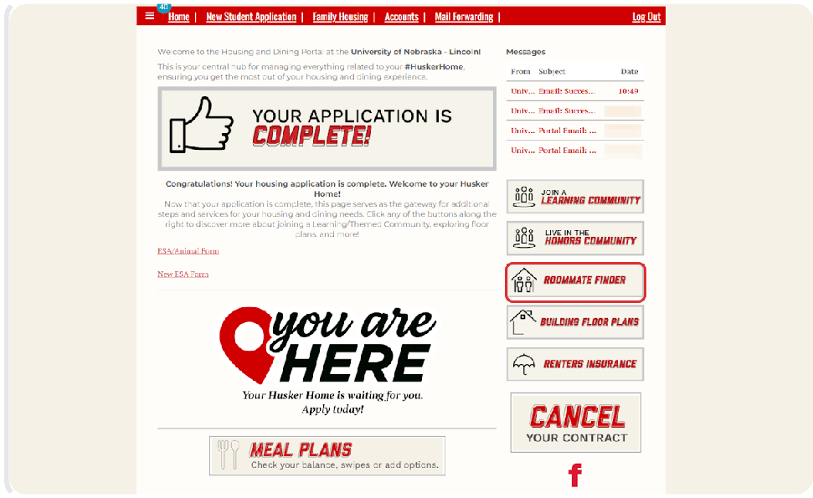

Click on Continue for the Academic Year application.
2

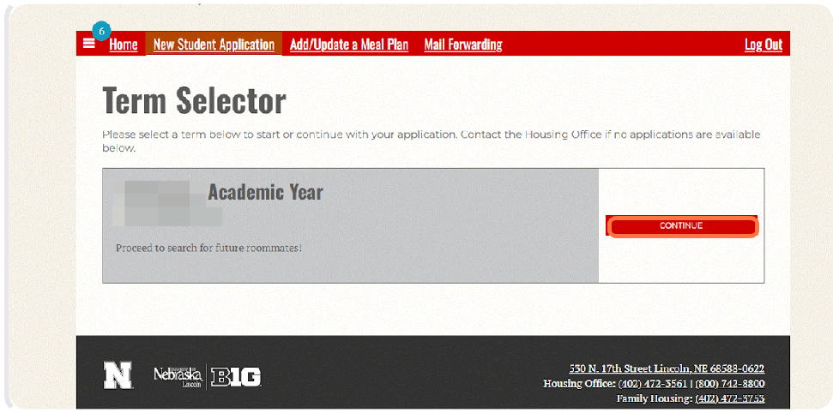

Search By Details to Find a Roommate- There are several ways to search for a roommate. We will review all three below.

The first option is to click on Search By Details. Using this feature will allow you to search for specific roommates.
3

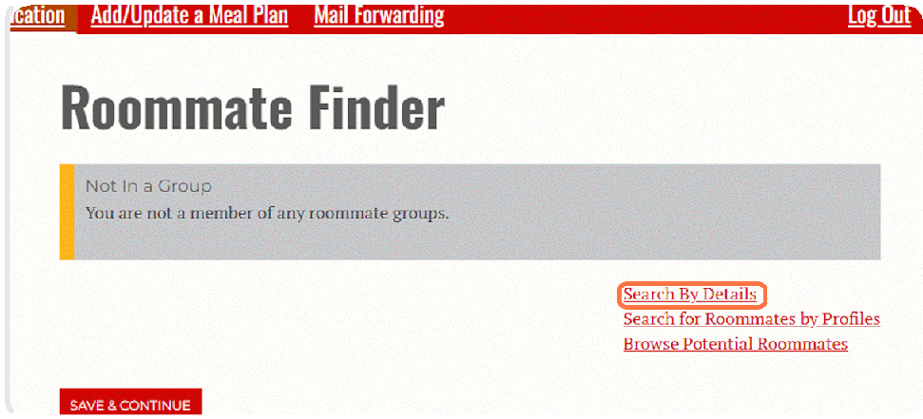

If you know someone's first or last name or you want to see who is in the same Learning Community (LC) as you, this is the easiest way to find them. Type in the information and then click Search.
4

Screen name is not the student's actual name. It is the username that was automatically generated for the student by the Housing Portal to be used for the Roommate Finder.
Your search results will appear at the bottom of the page.
The Roommate Finder will not display the student's name, only the screen name assigned to them for the Roommate Finder. You may need to ask your friend to log into the housing portal and verify that the screen name is correct.

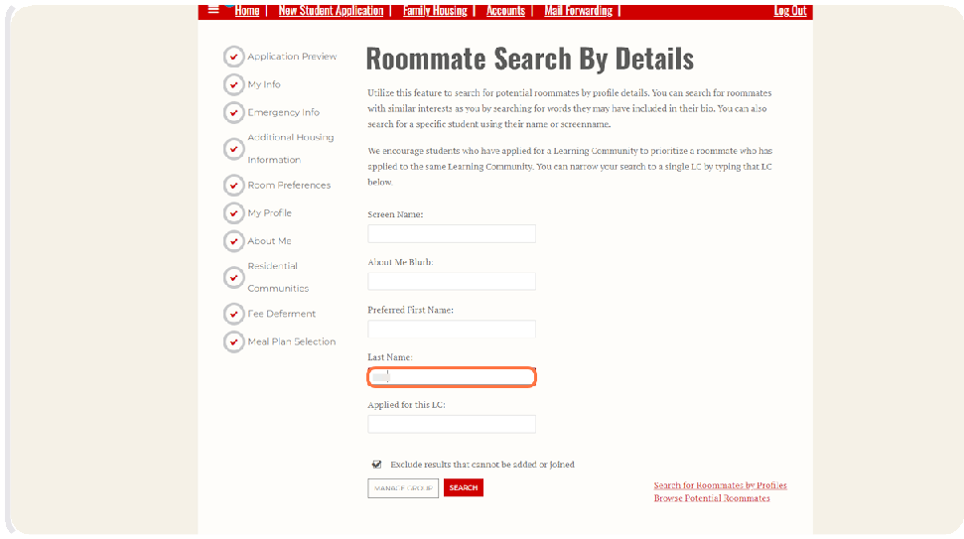

Search for Roommates by Profiles

A second way to search for potential roommates is to click on Search for Roommates by Profiles.
5

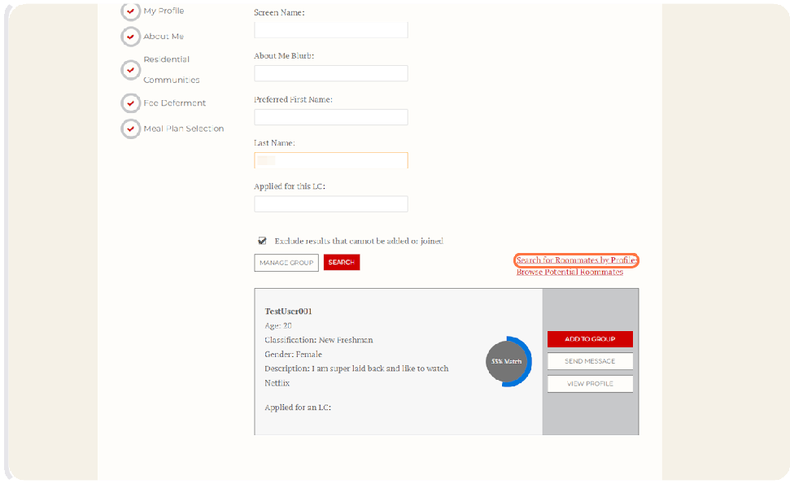

Here, you will be able to select specific answers to questions from the Housing App. We recommend selecting only one or two options that are very important to you as this can really limit the roommate options you see.
6
If you do not see any matches, that's okay! Just decrease the amount of filters you are using or try searching for a roommate another way. Remember that people may be compatible with you but have slightly different answers that would make them not show up if you are filtering for very specific answers to multiple questions.

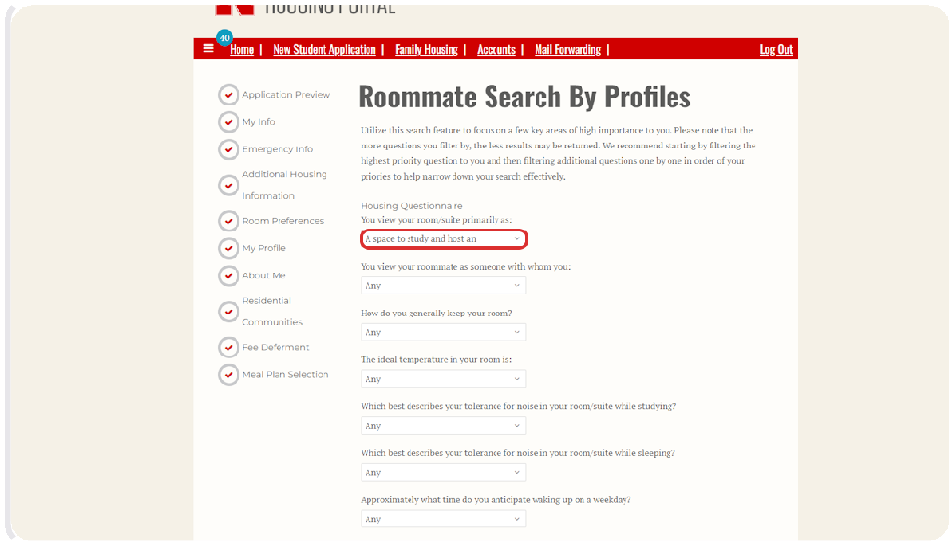


Once you have selected one or two answers, click on Search.
7

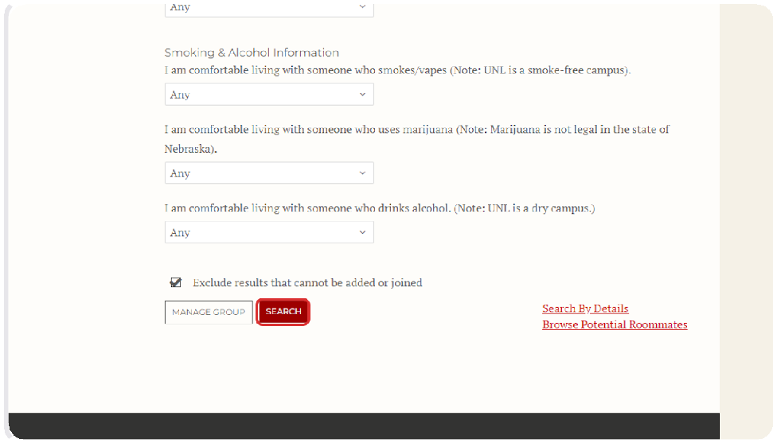

This will take you to a page where anyone who has the same answer will be displayed.
8

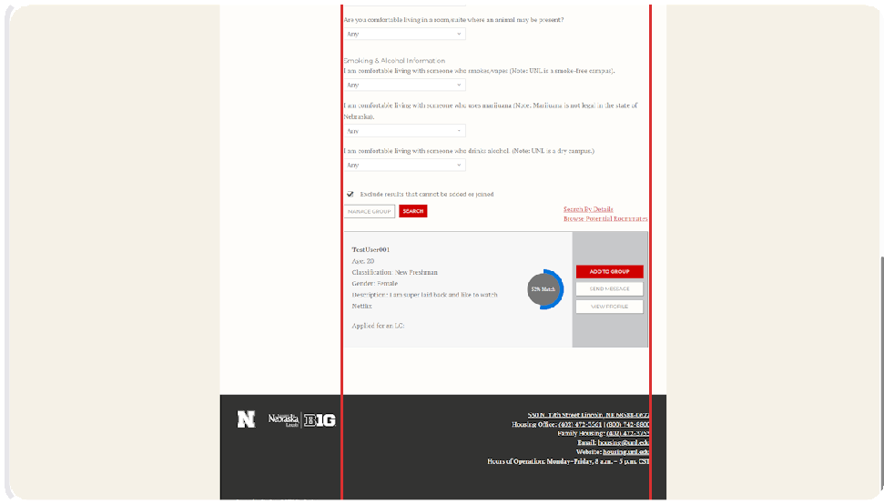

Browse Potential Roommates

The third option is to view available roommate options by clicking on Browse Potential Roommates.
9

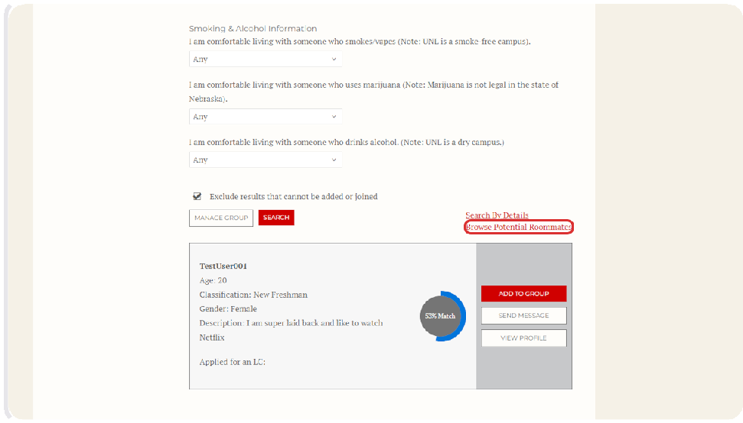

This will take you to a page that displays people who would be good roommate matches for you based on the answers in your Housing Application. It will display your highest matches first.
10

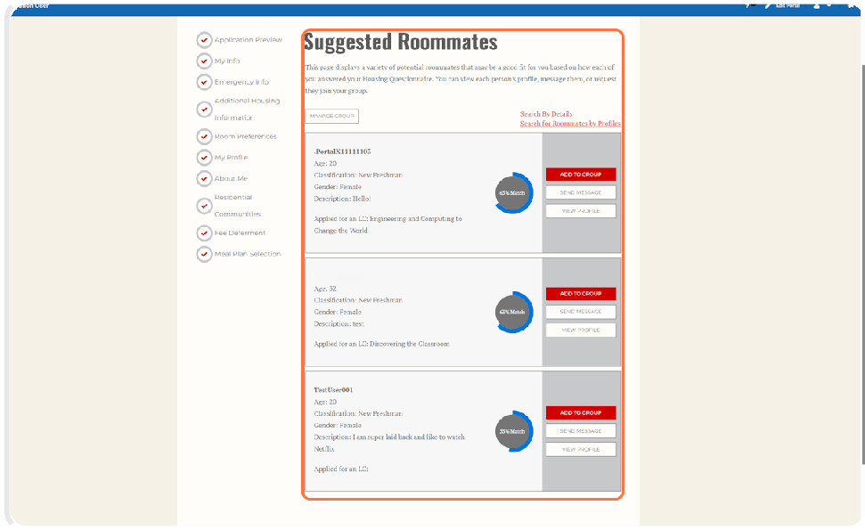

How to See More Information About Potential Roommates

Once you have found someone who you might want to live with, you can connect with them through the Housing Portal by clicking Send Message.
11
Please note that messaging and agreeing to live together does not mean that you have formed a roommate group. You still need to go through the formal process of creating a roommate group to be assigned to live together.

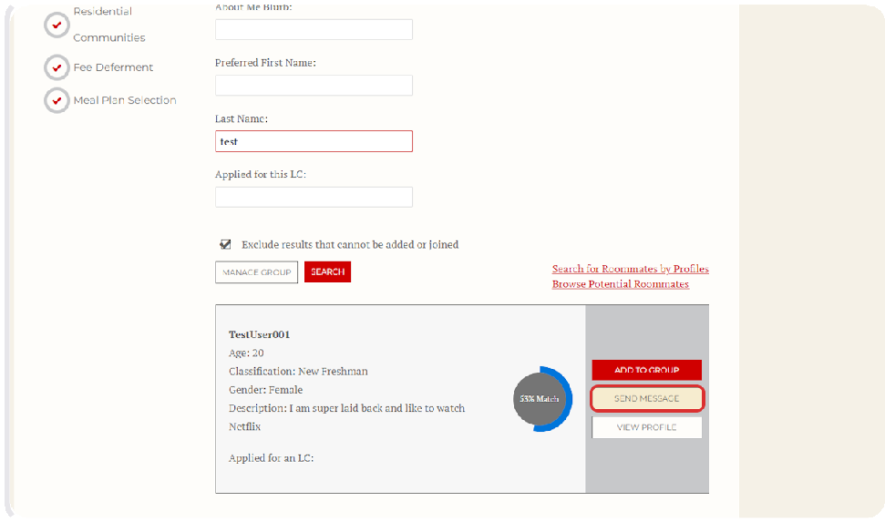

Compose your message and click Send Message to connect with your potential roommate.
12

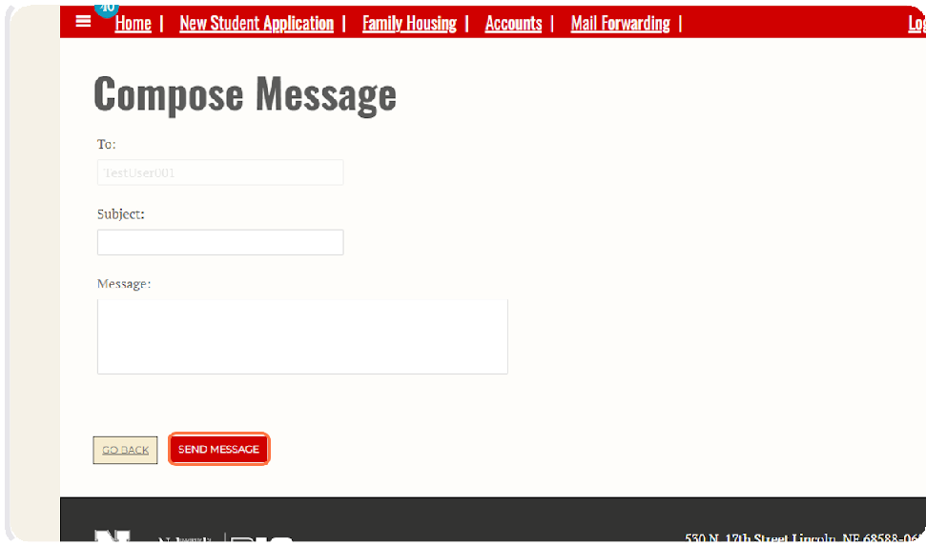

You can also see how compatible you are with someone based on the percentage match displayed. The system calculates this percentage based on your answers and the other person's answers in their housing application.
13
Clicking View Profile in the search results will allow you to view the student's answers to the roommate matching questionnaire.
The percentage match can be a helpful tool to see compatibility at a glance, but we recommend you view the other student's profile to look at their specific answers to the roommate matching questions and how they line up with your own.

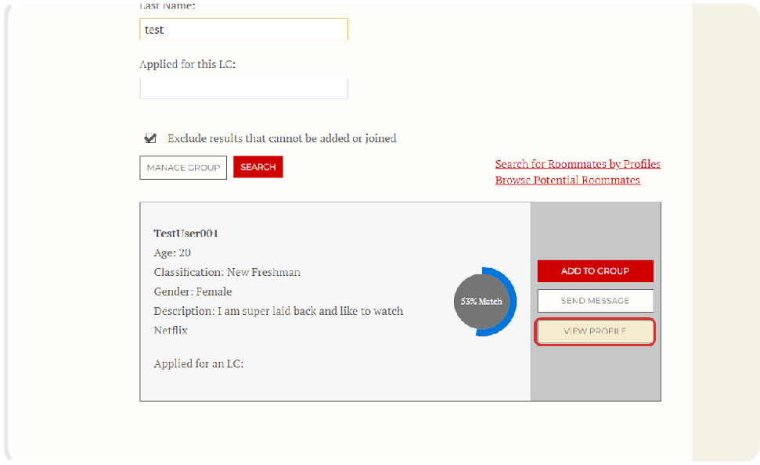

If you want to see how someone answered each question on their Housing Application, which can tell you more about how compatible you may be, click on View Profile.
14

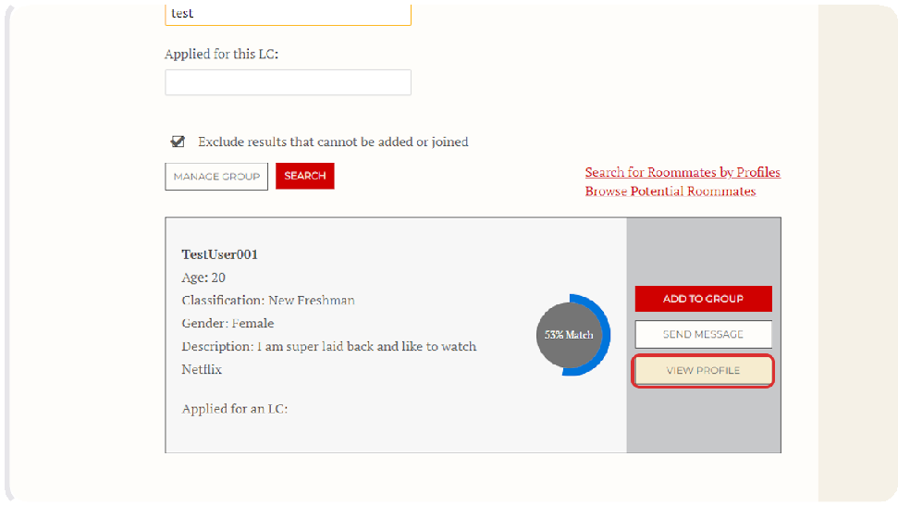

Once you are done viewing the person's profile, click on GO BACK to continue searching for roommates or to add the person to your roommate group.
15

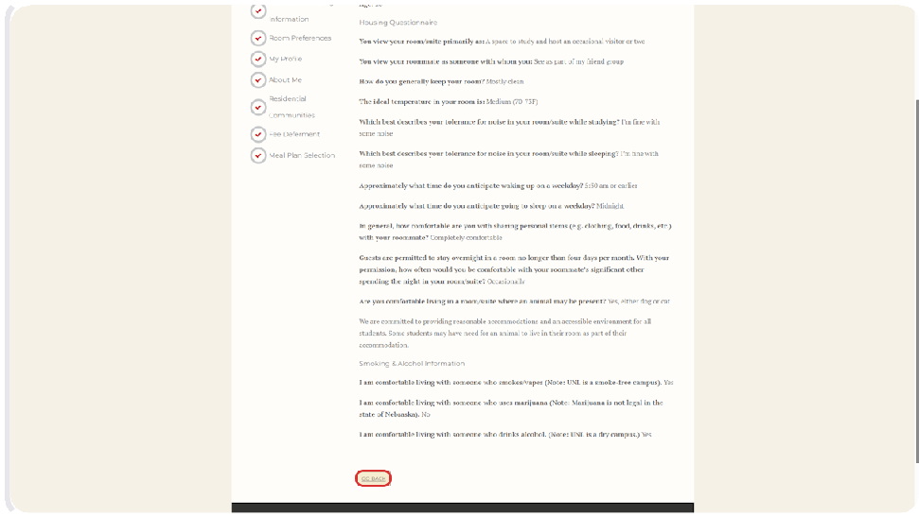

Creating a Roommate Group

Once you are ready to create a roommate group, you will click on Add to Group on the student you want to be in a roommate group with.
16
Clicking Add to Group will send the other student a notification that they can join your roommate group.
The other student must log into the Housing Portal to accept the request within 7 days in order for you to successfully create a roommate group.

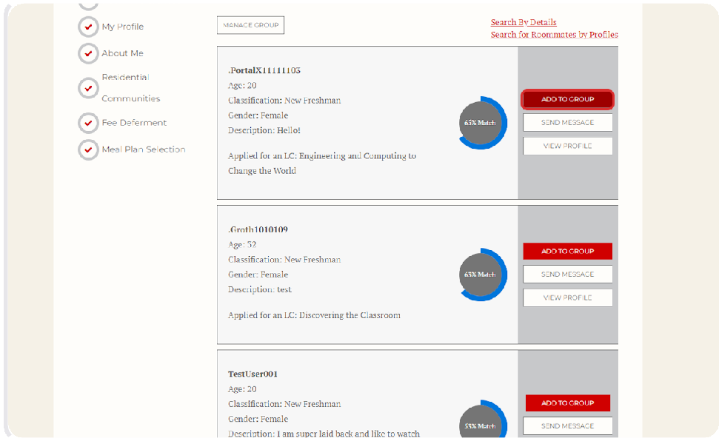

Student 2 Logs Into the Housing Portal to Accept the Request.
17
Once your friend has received the email notifying them they've been invited to join your roommate group, they can log into the Housing Portal and click on the Roommate Finder.

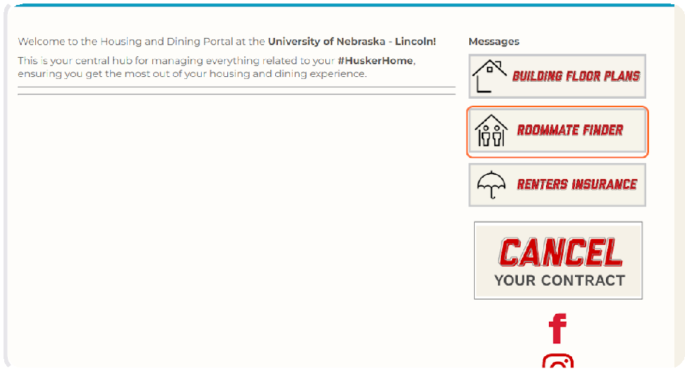

Click on Accept.
18
The student will see an incoming request to join your roommate group. The request includes your screen name so that they know it is the correct group.
When they click Accept, both students will receive an email letting them know that they
are now in a group together.

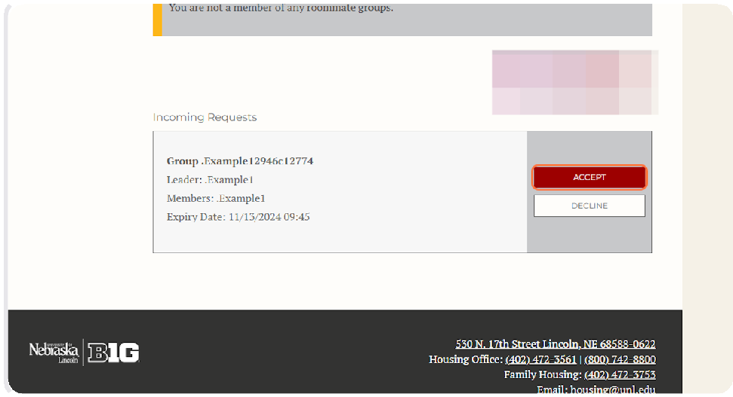

Once your roommate has accepted the request to be in the roommate group, you should be able to see on the Housing Portal that your roommate was added to your group.
19
From this page, you can remove a roommate, send them a message, view their profile, continue browsing potential roommates, and delete the roommate group.

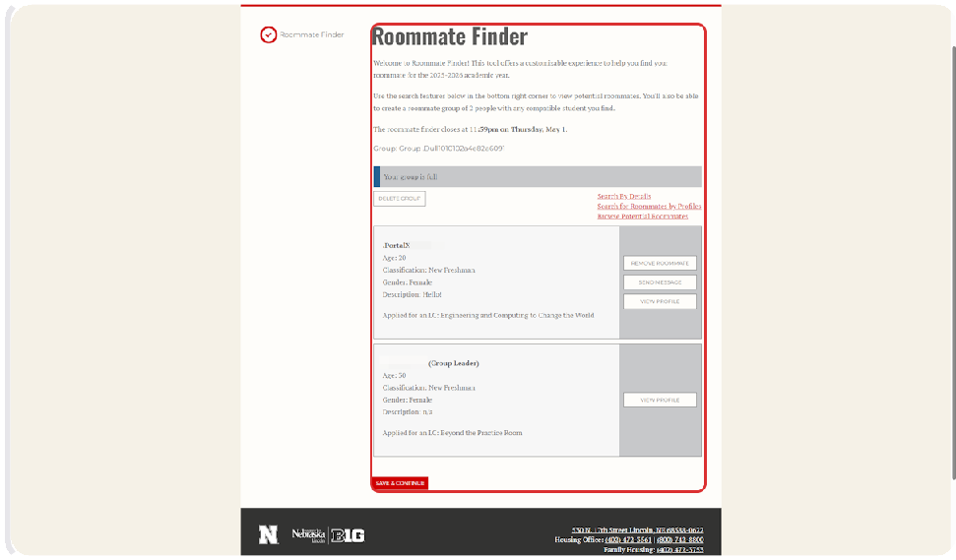

Once you are satisfied with your roommate group, you can click on Save & Continue to be taken back to the Home Page.
20

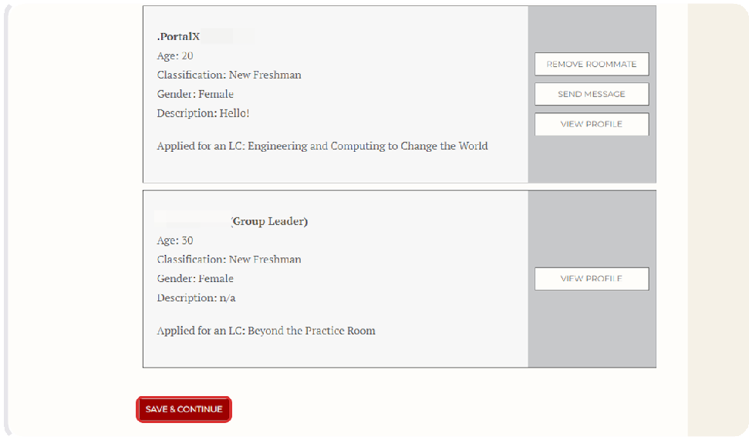

Depending on your situation, you may see different buttons on your home page. Please review all information to make sure you are all set for housing next year. You can see messages others send you by clicking on the hamburger menu on the top left.
21
Please email housing@unl.edu with any questions!

